**MINISTRY OF EDUCATION AND TRAINING**

**FPT UNIVERSITY**

Capstone Project Document

The Traffic Sign Recognition and Training

|  |  |
| --- | --- |
| **Group 2** | |
| **Group member** | Mai Văn Tân – Team Leader – SE90061  Bùi Việt Phong – Team Member - SE60747  Hồ Đắc Nghĩa – Team Member - SE60628 (Drop out)  Trần Lê Tuấn – Team Member – 60350 (Drop out) |
| **Supervisor** | Mr. Kiều Trọng Khánh |
| **Ext. Supervisor** | N/A |
| **Capstone Project code** | TSRT |

-Ho Chi Minh City, 01/2014-

*This page is intentionally left blank*

***ACKNOWLEDGEMENTS***

We wish to thank various people for their contribution to this project: Our teachers for their advices and participant in the final review, our friend for the valuable technical support.

Special thanks should be given to Mr.Kiều Trọng Khánh, our research supervisor for his professional guidance and the useful, constructive recommendations throughout the course of this project.

# Table of Contents

Table of Contents 4

List of Tables 8

List of Figures 10

Definitions, Acronyms, and Abbreviations 13

A. Project Management Plan 14

1. Project Information 14

2. Introduction 14

3. The Current Solutions 14

4. Proposed Solution 14

4.1 Feature functions 14

4.2 Advantage and disadvantage 15

5. Functional Requirement 15

5.1 Detect and recognize traffic sign 15

5.2 Account management 15

5.3 Traffic Sign Management 15

5.4 Report Management 15

6. Role and Responsibility 16

B. Software Project Management Plan 17

1. Problem Definition 17

1.1 Name of this Capstone Project 17

1.2 Problem Abstract 17

1.3 Project Overview 17

2. Project organization 19

2.1 Software Process Model 19

2.2 Roles and responsibilities 19

2.3 Tools and Techniques 20

3. Project Management Plan 21

3.1 Iteration 21

3.2 Iteration Detail 22

3.3 All Meeting Minutes 24

4. Coding Convention 25

C. Software Requirement Specification 28

1. User Requirement Specification 28

1.1 Guest Requirement 28

1.2 User Requirement 28

1.3 Staff Requirement 28

1.4 Admin Requirement 28

1.5 System Requirement 28

2. System Requirement Specification 28

2.1 External Interface Requirement 28

2.2 System Overview Use Case 30

2.3 List of Use Case 30

3. Software System Attribute 75

3.1 Usability 75

3.2 Reliability 75

3.3 Availability 75

3.4 Security 75

3.5 Maintainability 75

3.6 Portability 76

3.7 Performance 76

4. Conceptual Diagram 76

**Data Dictionary** 76

D. Software Design Description 77

1. Design Overview 77

2. System Architectural Design 78

3. Component Diagram 79

**Data Dictionary** 79

4. Detailed Description of Components 80

4.1 Class Diagram 80

4.2 Class Diagram Explanation 81

4.3 Sequence Diagram 84

5. User Interface Design 89

5.1 User Interface Design 89

5.2 Admin Interface Design 97

5.3 Staff Interface Design 102

5.5 Mobile Interface Design 107

6. Database Design 117

6.1 Entity Relationship Diagram 117

6.2 Data Dictionary 118

7. Algorithms 120

7.1 Traffic sign detection 120

7.2 Traffic sign recognition 125

7.3 Synchronize favorite list 129

E. System Implementation & Test 131

1. Introduction 131

1.1 System Overview 131

1.2 Test Approach 131

2. Database Relationship Diagram 132

3. Performance measures 135

3.1 Traffic Sign Detection Performance 135

3.2 Traffic Sign Recognition Performance 135

4. Test Plan 136

4.1 Features to be tested 136

4.2 Features not to be tested 136

5. System Testing Test Case 137

6. Module Test Case 140

6.1 Manage Traffic Sign 140

6.2 Manage Report 141

6.3 Search auto 142

F. Software User’s Manual 145

1. Installation Guide 145

1.1 Setting up environment at server site 145

1.2 Deployment at server side 145

1.3 Setting up the environment at client side 147

2. User Guide 149

2.1 Login 149

2.3 Admin 150

2.5 Staff 151

2.6 User – Mobile 156

2.7 User - Website 163

3. User Notice 169

3.1 Image Data Notice 169

3.2 Take image to search 170

G. Appendix 173

# List of Tables

Table 1: Roles and Responsibility 16

Table 2: Hardware Requirement for Server 18

Table 3: Hardware Requirement for Web User 18

Table 4: Hardware Requirement for Mobile User 18

Table 5: Roles and Responsibility Details 20

Table 6: Iteration 21

Table 7: Phase 1: Preliminary Investigation or Analysis 22

Table 8: Phase 2: Traffic Sign Detect & Recognize 23

Table 9: Phase 3: Account Management 23

Table 10: Phase 4: Traffic sign mange 23

Table 11: Phase 5: Search traffic sign 24

Table 12: Phase 6: Favorite, history and report manage 24

Table 13: <Guest> Register account 33

Table 14: <Guest> Login 34

Table 15: <Guest, User> Search manually using web application 36

Table 16: <Guest, User> Search manually using mobile application 37

Table 17: <Guest, User> Search auto using web application 39

Table 18: <Guest, User> Search auto using web application 41

Table 19: <User, Staff, Admin> Logout 43

Table 20: <User> Report traffic sign wrong information using mobile application 45

Table 21: <User> Report traffic sign wrong information using web application 46

Table 22: <User> Report traffic sign wrong recognize using mobile application 47

Table 23: <User> Report traffic sign wrong recognize using mobile application 48

Table 24: <User> Delete history using web application 50

Table 25: <User> Delete history using mobile application 51

Table 26: <User> Add favorite using web application 53

Table 27: <User> Add favorite using mobile application 54

Table 28: <User> Remove favorite using web application 56

Table 29: <User> Remove favorite using mobile application 57

Table 30: <Staff> Add traffic sign 60

Table 31: <Staff> Edit traffic sign 62

Table 32: <Staff> Export to file 63

Table 33: <Staff> Import from file 65

Table 34: <Staff> View report 67

Table 35: <Staff> Delete report 69

Table 36: <Staff, Admin> Active Account 70

Table 37: <Staff, Admin> Deactivate Account 72

Table 38: <Staff, Admin> Make statistic 73

Table 39: <Admin> Configure system 75

Table 40: Data Dictionary 118

Table 41: Attribute Data Dictionary 119

Table 42: Attribute Data Dictionary 134

Table 43: Core Workflow Test Case 140

Table 44: Manage Traffic Sign Test Case 141

Table 45: Manage Report Test Case 142

Table 46: Search auto Test Case 144

Table 47: Login Step 149

Table 48: Set staff 150

Table 49: Login Step 156

Table 50: Register Step 157

Table 51: Search auto step 157

Table 52: Search auto result step 158

Table 53: Search manual step 159

Table 54: Search manual result Step 160

Table 55: View traffic detail step 161

Table 56: View favorite step 161

Table 57: View history step 162

Table 58: Send report step 162

Table 59: Setting step 163

Table 60: Search auto step 163

Table 61: Search manual step 164

Table 62: View favorite step 165

Table 63: View list history step 166

Table 64: View history detail step 167

Table 65: View traffic sign detail step 168

Table 66: Send report step 169

# List of Figures

Figure 1: Agile Development Model 19

Figure 2: System Overview Use Case 30

Figure 3: <Guest> Overview Use Case 31

Figure 4: <Guest> Register account 31

Figure 5: <Guest> Login 33

Figure 6: <Guest, User> Search manually 35

Figure 7: <Guest, User> Search auto 38

Figure 8: <User> User over view 42

Figure 9: <User, Staff, Admin> Logout 42

Figure 10: <User> Report traffic sign wrong information 44

Figure 11: <User> Report traffic sign wrong recognize 46

Figure 12: <User> Delete history 49

Figure 13: <User> Add favorite 52

Figure 14: <User> Remove favorite 55

Figure 15: <Staff> Staff overview 58

Figure 16: <Staff> Add traffic sign 58

Figure 17: <Staff> Edit traffic sign 60

Figure 18: <Staff> Export to file 62

Figure 19: <Staff> Import from file 64

Figure 20: <Staff>View report 66

Figure 21: <Staff> Delete report 67

Figure 22: <Staff, Admin> Active Account 69

Figure 23: <Staff, Admin> Deactivate Account 70

Figure 24: <Staff, Admin> Make statistic 72

Figure 25: <Admin> Admin overview 73

Figure 26: <Admin> Configure system 74

Figure 27: Conceptual Diagram 76

Figure 28: N-tier Architecture 78

Figure 29: Component Diagram 79

Figure 30: Class Diagram 80

Figure 31: Add Traffic Sign Sequence Diagram 84

Figure 32: Add Train Image Sequence Diagram 85

Figure 33: Import Data From File Sequence Diagram 86

Figure 34: Search Traffic Sign Auto Sequence Diagram 87

Figure 35: Search Traffic Sign Manual Sequence Diagram 88

Figure 36: User Home Page 89

Figure 37: User – Search auto 90

Figure 38: User – Search manual 91

Figure 39: User – Favorite list 92

Figure 40: User – History list 94

Figure 41: User – Traffic sign detail 95

Figure 42: User – Send report 96

Figure 43: Admin - Home Page 97

Figure 44: Admin - Account Manager Page 98

Figure 45: Admin - Statistic Page 100

Figure 46: Admin - Configure Page 101

Figure 47: Staff – Traffic Sign Manager Page 102

Figure 48: Staff – Report Manager Page 104

Figure 49: Staff – Account Manager Page 105

Figure 50: Login Activity 107

Figure 51: Main Activity 108

Figure 52: Camera Activity 109

Figure 53: List result Activity 110

Figure 54: Category Activity 111

Figure 55: Category Activity 112

Figure 56: Traffic sign detail Activity 113

Figure 57: Favorite Activity 114

Figure 58: Favorite Activity 115

Figure 59: Entity Relationship Diagram 117

Figure 60: Four basic types 121

Figure 61: Integral Image 121

Figure 62: Attentional Cascade 122

Figure 63: Viola-Jones flow chart 123

Figure 64: Triangle Traffic Sign Train Sample Image 124

Figure 65: Circle Traffic Sign Train Sample Image 124

Figure 66: Negative Train Sample Image 125

Figure 67: HOG features 127

Figure 68: SVM classifier 127

Figure 69: Classifier flow chart 128

Figure 70: Synchronize favorite flow chart 130

Figure 71: Database Relationship Diagram 132

Figure 72: Traffic Sign Detection Accuracy 135

Figure 73: Traffic Sign Recognition Accuracy 135

Figure 74: Core Workflow 137

Figure 75: Prepare deployment package 146

Figure 76: Deploy database 146

Figure 77: Run tomcat server 146

Figure 78: Copy war file to tomcat server 146

Figure 79: Set console application path 146

Figure 80: Set Web service address 147

Figure 81: Restart tomcat 147

Figure 82: Change Settings 147

Figure 83: Install App 148

Figure 84: Login Page 149

Figure 85: Account Manage Page 150

Figure 86: Traffic Sign Manage Page 151

Figure 87: Add New Traffic Sign Modal 152

Figure 88: Report Manage Page 153

Figure 89: Report Detail Modal 154

Figure 90: Edit Wrong Recognition Page 155

Figure 91: Login Screen 156

Figure 92: Register Screen 157

Figure 93: Search Auto Screen 157

Figure 94: Search auto result screen 158

Figure 95: Search manual Screen 159

Figure 96: Search manual result Screen 160

Figure 97: View traffic detail screen 161

Figure 98: View favorite screen 161

Figure 99: View history screen 162

Figure 100: Send report screen 162

Figure 101: Setting screen 163

Figure 102: Search auto page 163

Figure 103: Search manual page 164

Figure 104: Favorite page 165

Figure 105: History page 166

Figure 106: History detail page 167

Figure 107: Traffic sign detail popup 168

Figure 108: Send report popup 169

Figure 109: Position and angle 1 170

Figure 110: Position and angle 2 171

# Definitions, Acronyms, and Abbreviations

|  |  |
| --- | --- |
| TSRT | Traffic Sign Recognition and Training |
| TS | Traffic sign |
| Traffic Sign Detection | Determines the locations and sizes of traffic signs in images. |
| Traffic Sign Recognition | Identify the name of traffic sign from detected area in an image. |
| Train Image | Image use to train to recognition traffic sign. |
| Model | The result after train, use to classify, recognize traffic sign. |

# Project Management Plan

## Project Information

* Project name: **The Traffic Sign Recognition and Training**
* Project Code: **TSRT**
* Product Type: **Website, Phone Application**
* Start Date: **January 6th, 2013**
* End Date: **April 19th, 2013**

## Introduction

Now a day, the traffic system is expand more than before. Beside that the traffic sign use to control traffic is developed to help people when join in the traffic. In Vietnam, we have more than 200 traffic signs, this may cause the difficult to people when meet a new traffic sign. On the other hand, internet and smartphone is more popular in Vietnam. Now it’s easy to have a smartphone with internet connection. That is the reason we want to build a system to help people find information about any traffic sign easily. So people can know more about the sign and traffic rule in each traffic sign, help them join in traffic easier and safer.

## The Current Solutions

Below are some current solutions:

* Search using book:

+Advantages: clearly, accurate information.

+Disadvantages: slow and not update regularly.

* Current application:

+ Advantage: update regularly, easy to use.

+ Disadvantages: few information (just have basic information about traffic sign), search slowly.

* Using internet:

+ Advantages: provide updated information.

+ Disadvantages: search slowly, need internet connection, too many useless information.

## Proposed Solution

* Develop a recognition system that support auto detect and recognize traffic sign using smartphone’s camera.
* Support more information about the traffic sign: penalty fee, view history.
* Support user learn traffic sign.

### Feature functions

* + Admin

Admin can manage the system: configure system.

Admin can manage account:

* Manage Staffs: provide permission role, set/unset staffs.
* Manage users: active/deactivate users.
* Make the statistic.
  + System
* Detect and recognize traffic sign.
* Provide information about traffic sign.
* Support user learning traffic sign: favorite list.
* Support staff training new traffic sign.
  + Staff
* Manage users: deactivate users, active users.
* Training new traffic sign.
* Add/update/delete traffic sign.
* Make the statistic: statistic register, statistic search.
* Import/export database.
* Manage user’s report: check and view report, view log.
  + Users
* Search/view traffic sign.
* Make report wrong information, wrong recognition.
* View/delete history traffic sign.
* Add/view/remove favorite traffic sign.
  + Guest
* Search/View traffic sign.

### Advantage and disadvantage

The advantage and disadvantage of the proposed solution:

* Advantage:

+ Easy to search traffic sign by take camera picture.

+ Provide more information about traffic sign like penalty fee.

+ Support user learn traffic sign.

* Disadvantage:

+ Recognition accuracy not reach 100 percent.

## Functional Requirement

Function requirement of the system are listed as below:

### Detect and recognize traffic sign

* Detect candidate area from upload image.
* Recognize traffic sign from detected area.

### Account management

* Normal users can register new account.
* Staff accounts are set by admin.
* Admin can manage account: active/deactivate users.
* Staff can manage user account: active/deactivate users.

### Traffic Sign Management

* Staff can add/update/delete traffic sign.
* Staff can import/export traffic sign.

### Report Management

* Users can send report about traffic sign.
* Staff can check/view report.

## Role and Responsibility

|  |  |  |  |  |
| --- | --- | --- | --- | --- |
| **No** | **Full Name** | **Role** | **Position** | **Contact** |
| 1 | Kiều Trọng Khánh | Project Manager | Instructor | khanhkt@fpt.edu.vn |
| 2 | Mai Văn Tân | Developer | Team Leader | tanmvse90061@fpt.edu.vn |
| 3 | Bùi Việt Phong | Developer | Team Member | phongbvse60747@fpt.edu.vn |
| 4 | Hồ Đắc Nghĩa | Developer | Team Member | nghiahdse60628@fpt.edu.vn |
| 5 | Trần Lê Tuấn | Developer | Team Member | tuantl60350@fpt.edu.vn |

Table 1: Roles and Responsibility

# Software Project Management Plan

## Problem Definition

### Name of this Capstone Project

The Traffic Sign Recognition and Training (TSRT)

### Problem Abstract

Now a day, the traffic system is expand more than before. Beside that the traffic sign use to control traffic is developed to help people when join in the traffic. In Vietnam, we have more than 200 traffic signs, this may cause the difficult to people when meet a new traffic sign. On the other hand, internet and smartphone is more popular in Vietnam. Now it is easy to have a smartphone with internet connection. That is the reason we want to build a system to help people find information about any traffic sign easily. Therefore, people can know more about the sign and traffic rule in each traffic sign, help them join in traffic easier and safer.

### Project Overview

#### The Current System

Below are some current system:

* Search using book:

+ Advantages: clearly, accurate information.

+ Disadvantages: slow and not update regularly.

* Current application:

+ Advantage: update regularly, easy to use.

+ Disadvantages: few information (just have basic information about traffic sign), search slow.

* Using internet:

+ Advantages: provide updated information.

+ Disadvantages: search slowly, need internet connection, too many useless information.

#### The Proposed System

* Develop a recognition system that support auto detect and recognize traffic sign using smartphone’s camera.
* Support more information about the traffic sign: penalty fee, view history.
* Support user learn traffic sign.

##### Web

* The admin can manage information about system, staff and user.
* The system provides a method for admin to set permission for staff, select user to set permission.
* The system provides a method for admin configure system.
* The admin can make statistic about register and search.
* Staff can manager traffic sign: add/edit/delete traffic sign.
* Staff can manager report.
* The system will make a traffic sign take note for user. Support sticker to learn traffic sign.
* The system will provide a method for user upload image to website. Then, the system will recognize the image and give information for user.
* The system will provide a method for user view user’s history, user can send report if have any errors happen.

##### Mobile

* The mobile version also allow guest to register a new account.
* The user or guest can take a photo of traffic sign to make auto search about its information.
* In case the result is wrong, user can send a report about this result.
* Allow user to add traffic sign into favorite list for learning purpose.

#### Boundaries of the System

* The system is intended for almost Vietnam’s land traffic sign.
* Using in normal weather condition (sunny, cloudy...) and traffic sign must be in good state (In original shape, isn’t covered by other objects...)
* The system is intended for learning purpose only.
* The language of the system is Vietnamese.
* The complete product includes:

+ The website for admin, staff, user and guest to interactive with the system.

+ Mobile application for user and guest.

+ All the process involved document.

#### Development Environment

##### Hardware requirements

**For server**

|  |  |  |
| --- | --- | --- |
| Windows | Minimum Requirements | Recommended |
| Internet Connection | 4Mbps | 8 Mbps |
| Operating System | Ubuntu 12 | Ubuntu 13.10 |
| Computer Processor | Intel® Core 2 Duo 2GHz | Intel® Core(TM) i5 CPU , M 460 @ 2.53GHz |
| Computer Memory | 512MB RAM | 3GB or more |

Table 2: Hardware Requirement for Server

**For Web User**

|  |  |  |
| --- | --- | --- |
| Web | Minimum Requirements | Recommended |
| Internet Connection | 2Mbps | 4Mbps |
| Web Browser | Firefox 26 | Firefox 28 |

Table 3: Hardware Requirement for Web User

**For Mobile User**

|  |  |  |
| --- | --- | --- |
| Mobile | Minimum Requirements | Recommended |
| Internet Connection | 2Mbps | 4Mbps |
| Operating System | Android 4.0 | Android 4.0 |
| Hardware | Touchscreen, Camera 5.0 MP or above | Touchscreen, Camera 5.0 MP or above |
| Memory | 512 MB or more | 1 GB or more |

Table 4: Hardware Requirement for Mobile User

##### Software requirements

* Microsoft Windows 7 Service Pack 1, Ubuntu 13.10: operating system and platform for development.
* MySql 5.5.20: use for database system.
* StarUML 5.0, Visio 2010: used to create models and diagrams
* Skype: used for communication and meeting
* Eclipse Juno, Android SDK, ADT 22.0.5 & JDK 1.7.0_51: used to implement mobile application.
* Eclipse Kepler: use to implement web application and web service.
* Netbean: use to implement console application in C++ (detect and recognize module).
* Google Code & TortoiseSVN: used for source control.

## Project organization

### Software Process Model

Project is developed under agile model.



Figure 1: Agile Development Model

[<http://masokotanzania.com/5-steps-to-making-agile-development-work>]

### Roles and responsibilities

|  |  |  |  |
| --- | --- | --- | --- |
| **No** | **Full name** | **Role in Group** | **Responsibilities** |
| **1** | Kiều Trọng Khánh | Project manager | * Specify user requirement * Control the development process * Give out technique and business analysis support |
| **2** | Mai Văn Tân | Team Leader, BA, DEV, Tester | * Managing process * Designing database * Clarifying requirements * Prepare documents * GUI Design * Create test plan * Coding * Testing |
| **3** | Bùi Việt Phong | Team Member, BA, DEV, Tester | * Designing database * Clarifying requirements * Prepare documents * GUI Design * Create test plan * Coding * Testing |
| **4** | Hồ Đắc Nghĩa | Team Member, BA, DEV, Tester | * Designing database * Clarifying requirements * Prepare documents * GUI Design * Create test plan * Coding * Testing |
| **5** | Trần Lê Tuấn | Team Member, BA, DEV, Tester | * Designing database * Clarifying requirements * Prepare documents * GUI Design * Create test plan * Coding * Testing |

Table 5: Roles and Responsibility Details

### Tools and Techniques

- Front-end technologies: HTML5, CSS3, JavaScript, jQuery, AJAX.

- Web application: Java servlet.

- Web Service: rest full Jersey.

- Mobile App: Android - Java.

- Web Server: Tomcat 7.0.

- Database Management System: MySql 5.5.20

## Project Management Plan

### Iteration

|  |  |  |  |  |  |
| --- | --- | --- | --- | --- | --- |
| **Phase**  **/Iteration** | **Description** | **Deliverables** | **Resource needed** | **Dependencies and Constrains** | **Risks** |
| **Preliminary Investigation or Analysis** | - Study similar existing systems.  -Identify and clarify requirements for the system in general. | -Introduction of proposed system.  -Main functions.  -Project Iteration Plan. | 30 man-days | N/A | Project may  not be feasible  for developing  because lack of technologies  and/or data |
| **Traffic Sign Detect & Recognize** | - Study traffic sign detect and recognize algorithm.  - Implement, testing and statistic result.  - Optimize algorithm. | Traffic sign detect and recognize console app. | 25 man-days | N/A | Lack of experience.  The implemented algorithm is not the best.  Lack of test data |
| **Account Manage** | Implement code for manage account | Account manage functions | 30 man-days | N/A |  |
| **Traffic sign manage** | Implement code for traffic sign manage | Traffic sign manage functions | 30 man-days | N/A |  |
| **Search traffic sign** | Implement code for search traffic sign | Traffic sign search functions (auto search and manually search) | 30 man-days | Traffic sign detect and recognize |  |
| **Favorite, history and report manage** | Implement code for manage favorite, history and report manage | Favorite, history and report manage functions | 30 man-days | Search traffic sign |  |

Table 6: Iteration

### Iteration Detail

#### Phase 1: Preliminary Investigation or Analysis

|  |  |  |
| --- | --- | --- |
| **Task** | **Description** | **Author** |
| **1. Identifying and studying existing systems** | Find which systems currently provide similar service, their strengths and weakness. | TanMV, PhongBV, NghiaHD, TuanTL |
| **2. Identifying and clarifying main functions** | Define which main functions system should provide. | TanMV, PhongBV, NghiaHD, TuanTL |
| **3. Introduction.** | Complete Introduction Report. | TanMV, PhongBV, NghiaHD, TuanTL |
| **4. Project Management**  **Plan.** | Prepare Project  Management Plan. | TanMV |
| **5. Website Prototype** | Build a prototype of proposed system (Website). | TuanTL |
| **6. Mobile Prototype** | Build a prototype of proposed system (Mobile App). | PhongBV |
| **7. Design diagram** | Design diagram. | TanMV, PhongBV, NghiaHD, TuanTL |
| **8. Document** | Add SRS, SDD | TanMV, PhongBV, NghiaHD, TuanTL |

Table 7: Phase 1: Preliminary Investigation or Analysis

#### Phase 2: Traffic Sign Detect & Recognize

|  |  |  |
| --- | --- | --- |
| **Task** | **Description** | **Author** |
| **1. Identifying Requirement and Planning** | Which feature this function should have and how to implement. | TanMV |
| **2. Studying Traffic Sign Detection & Recognition Algorithm** | Studying algorithm, implement by using library OpenCV, SVM | TanMV |
| **3. Extract candidate area from Image** | Find the candidate area in images, extract them for later use | TanMV |
| **4. Recognize traffic sign** | Recognize traffic sign from candidate area | TanMV |
| **5. Optimize** | Optimize the implement for more performance and accuracy | TanMV |
| **6. Implement API** | Create the interface for extracting and storing traffic sign | TanMV |
| **7. Testing** | Test system behavior and  performance | TanMV, PhongBV, NghiaHD, TuanTL |
| **8. Document** | Update SRS, SDD, Manual  Guide | TanMV, PhongBV, NghiaHD, TuanTL |

Table 8: Phase 2: Traffic Sign Detect & Recognize

#### Phase 3: Account manage

|  |  |  |
| --- | --- | --- |
| **Task** | **Description** | **Author** |
| 1. **Identifying Requirement and Planning** | Which feature this function should have and how to implement | TanMV, PhongBV, NghiaHD |
| 1. **Implement service for manage account** | Implement account functions | NghiaHD, TanMV |
| 1. **Implement web app to manage account** | Implement account functions | NghiaHD, TanMV |
| 1. **Testing** | Test system behavior and  performance  Test user behavior and  performance | TanMV, PhongBV, NghiaHD |
| 1. **Document** | Update SRS, SDD, Manual  Guide | TanMV, PhongBV, NghiaHD |

Table 9: Phase 3: Account Management

#### Phase 4: Traffic sign manage

|  |  |  |
| --- | --- | --- |
| **Task** | **Description** | **Author** |
| 1. **Identifying Requirement and Planning** | Which feature this function should have and how to implement | TanMV, PhongBV, NghiaHD |
| 1. **Implement service for manage traffic sign** | Implement traffic sign mange functions | NghiaHD, TanMV |
| 1. **Implement web app to manage traffic sign** | Implement traffic sign mange functions | NghiaHD, TanMV |
| 1. **Testing** | Test system behavior and  performance  Test user behavior and  performance | TanMV, PhongBV, NghiaHD |
| 1. **Document** | Update SRS, SDD, Manual  Guide | TanMV, PhongBV, NghiaHD |

Table 10: Phase 4: Traffic sign mange

#### Phase 5: Search traffic sign

|  |  |  |
| --- | --- | --- |
| **Task** | **Description** | **Author** |
| 1. **Identifying Requirement and Planning** | Which feature this function should have and how to implement | TanMV, PhongBV, NghiaHD |
| 1. **Implement service to search traffic sign** | Implement traffic sign search | NghiaHD, TanMV |
| 1. **Implement web app to search traffic sign** | Implement traffic sign search | PhongBV |
| 1. **Implement mobile app to search traffic sign** | Implement traffic sign search | PhongBV |
| 1. **Testing** | Test system behavior and  performance  Test user behavior and  performance | TanMV, PhongBV, NghiaHD |
| 1. **Document** | Update SRS, SDD, Manual  Guide | TanMV, PhongBV, NghiaHD |

Table 11: Phase 5: Search traffic sign

#### Phase 6: Favorite, history and report manage

|  |  |  |
| --- | --- | --- |
| **Task** | **Description** | **Author** |
| 1. **Identifying Requirement and Planning** | Which feature this function should have and how to implement. | TanMV, PhongBV, NghiaHD |
| 1. **Implement service to manage favorite, history and report** | Implement manage favorite, history and report functions | NghiaHD, TanMV |
| 1. **Implement web app to manage favorite, history and report** | Implement manage favorite, history and report functions | PhongBV, TanMV |
| 1. **Implement mobile app to manage favorite, history and make report** | Implement manage favorite, history and make report | PhongBV |
| 1. **Testing** | Test system behavior and  performance  Test user behavior and  performance | TanMV, PhongBV, NghiaHD |
| 1. **Document** | Update SRS, SDD, Manual  Guide | TanMV, PhongBV, NghiaHD |

Table 12: Phase 6: Favorite, history and report manage

### All Meeting Minutes

Refer to Meeting Minutes folder.

## Coding Convention

**Java: Using to develop Android App, Website and Web service.**

Summary:

* Naming conventions: Using Camel type for naming conventions.
* Commenting Convention: Using // for single line comment and /**/ for block comment

/**

* block comment

* …

* …

* …

*/

public static String getAbstractService()

{

//single line comment

if (abstractService == null)

{

throw new RuntimeException( "abstractService isn't initialized !");

}

return abstractService;

}

* Code formatting:

+ Blocks of code MUST be indented 4 characters, case statements aligned with their associated switch, and continuation lines 8 characters

+ Declarations and statements MUST NOT contain unnecessary white-space. A single-white space character is permitted between a comma and the following parameter in parameter lists, but that's all

+ There MUST be at most one statement per line

void foo()

{

while(bar > 0)

{

System.out.println();

bar--;

}

if(oatmeal == tasty)

{

System.out.println("Oatmeal is good and good for you");

}

else if(oatmeal == yak)

{

System.out.println("Oatmeal tastes like sawdust");

}

switch(suckFactor)

{

case 1:

System.out.println("This sucks");

break;

case 2:

System.out.println("This really sucks");

break;

default:

System.out.println("whatever");

break;

}

}

* Coding and class design

+ Empty blocks of code MUST be commented, e.g. empty uncommented catch clauses are not allowed

+ Strings MUST be checked for equality using equals

+ Utility classes MUST NOT have a public constructor

+ Interfaces MUST define a type. A utility class SHOULD be used for constants

**C++: Using to develop traffic sign detect and recognize console app.**

Summary:

* Naming Convention: using Pascal type
* Commenting Convention: Using // for single line comment and /**/ for block comment

/** Comments on function

...

...

*/

void classA::function_1( int variable1, //Comment on variable goes here.

float variable2, //Comment on variable goes here.

... ,

... )

{

...

* Code formatting:

+ Blocks of code MUST be indented 4 characters, case statements aligned with their associated switch, and continuation lines 8 characters

+ Declarations and statements MUST NOT contain unnecessary white-space. A single-white space character is permitted between a comma and the following parameter in parameter lists, but that's all

+ There MUST be at most one statement per line

vector<person> people;

//fill the vector somehow

int field_one_width = 0, field_two_width = 0;

//get the max widths

for ( vector<person>::iterator iter = people.begin(); iter != people.end();++iter )

{

if ( iter->firstname.length() > field_one_width )

{

field_one_width = iter->firstname.length();

}

if ( iter->lastname.length() > field_two_width )

{

field_two_width = iter->lastname.length();

}

}

//print the elements of the vector

for ( vector<person>::iterator iter = people.begin(); iter != people.end();++iter )

{

cout<<setw(field_one_width)<<left<<iter->firstname;

cout<<" ";

cout<<setw(field_two_width)<<left<<iter->lastname;

}

# Software Requirement Specification

## User Requirement Specification

### Guest Requirement

Guest, who is not have account or not login system. Guest can use the basic functions of system like search auto and search manually

### User Requirement

User is normal user of the system. When login system, use can search auto, search manually beside that user have favorite, store favorite traffic sign and history store old requests. When view traffic sign information and search auto use also can report to help system work more accurate.

### Staff Requirement

Staff is the main manager of the system. Staff’s account is set by admin. Staff can use system with these functions:

* Manage user account: Active/Inactive account
* Manage traffic sign: add/delete/edit/import/export traffic sign
* Manage report that user submit: view/delete report
* Make statistic

### Admin Requirement

Admin is highest manage in system. Admin can do functions:

* Manage account: set/unset staff account, active/inactive
* Manage system: configure system
* Make statistic

### System Requirement

System is also an important part. System can do functions:

* Detect traffic sign
* Recognize traffic sign
* Store user history
* Store user favorite

## System Requirement Specification

### External Interface Requirement

#### User Interface

* + - The interface of website must be clear.
    - The interface of mobile app must be clear, compatible with touch screen. The size of controls must be big enough to touch on smartphone.
    - The error, warning messages must be make clear, easy to understand.

#### Software Interface

* Firefox with Resolution (1024x768) or bigger and support JavaScript and HTML5
* Smartphone with Android 4.0. Screen size 4 inch or bigger.

#### Communication Protocol

* Website using HTTP protocol for communication between the web browser and the web server.
* Mobile app using HTTP protocol for communicating between app and web service.

### System Overview Use Case



Figure 2: System Overview Use Case

### List of Use Case

#### <Guest>Overview Use Case



Figure 3: <Guest> Overview Use Case

##### <Guest>Register account

Use Case Diagram



Figure 4: <Guest> Register account

Use Case Specification

|  |  |  |  |
| --- | --- | --- | --- |
| **USE CASE – GU001** | | | |
| **Use Case No.** | GU001 | **Use Case Version** | 2.0 |
| **Use Case Name** | Register | | |
| **Author** | Tran Le Tuan, Mai Van Tan | | |
| **Date** | 15/01/2014 | **Priority** | Normal |
| **Actor:** Guest  **Summary:**  Guest uses this case to register account.  **Goal:**  Allow guest register account.  **Triggers:**   * Guest wants to register account. * To register: Guest go to the register page, guest enter username, password, email, address then click on “Đăng ký” button to register.   **Preconditions:** N/A  **Post Conditions:**   * **Success:** System will show success message on current page * **Fail:** System will show error message on current page   **Main Success Scenario:**   |  |  |  | | --- | --- | --- | | Step | Actor Action | System Response | | 1 | Guest click on “Đăng ký” button | System redirect to register page, contain a register form:   * “Tên đăng nhập”: Textbox * “Mật khẩu”: Textbox * “Nhập lại mật khẩu”: Textbox * “Email”: Textbox   - In format: ^([a-zA-Z0-9_\-\.]+)@((\[[0-9]{1,3}\.[0-9]{1,3}\.[0-9]{1,3}\.)|(([a-zA-Z0-9\-]+\.)+))([a-zA-Z]{2,4}|[0-9]{1,3})(\]?)$   * “Đăng ký”: Button | | 2 | Guest enters register information.  Press “Đăng ký” button. | System send verify email and show the success message: “Bạn đã đăng ký thành công, vui lòng xác nhận email để kích hoạt tài khoản”.  [Exception 1, 2, 3, 4, 5] | | 3 | Guest verify account | System show message “Chúc mừng bạn kích hoạt thành công” and redirect to homepage  [Exception 6] |   **Alternative Scenario:** N/A  **Exceptions:**   |  |  |  | | --- | --- | --- | | No | Actor Action | System Response | | 1 | Missing information | Show error message: “Vui lòng nhập đầy đủ thông tin”. | | 2 | Username/Password not in range [6,30] | Show error message: “Tên đăng nhập và mật khẩu phải từ 6-30 ký tự”. | | 3 | Input invalid retype password. | Show error message: “Thông tin nhập vào không đúng”. | | 4 | Input invalid email. | Show error message: “Email không hợp lệ” | | 5 | Existed username/email | Show error message: “Tên đăng nhập hoặc email đã được sử dụng” | | 6 | Verify link is expired | Show error message: “Đã hết hạn kích hoạt. Liên lạc với admin để có thêm thông tin” |   **Relationships:** N/A  **Business Rules:**   * Each user can register one account. * Password use MD5 code type when save in database. | | | |

Table 13: <Guest> Register account

##### <Guest> Login

Use Case Diagram



Figure 5: <Guest> Login

Use Case Specification

|  |  |  |  |
| --- | --- | --- | --- |
| **USE CASE – GU002** | | | |
| **Use Case No.** | GU002 | **Use Case Version** | 2.0 |
| **Use Case Name** | Login | | |
| **Author** | Tran Le Tuan, Mai Van Tan | | |
| **Date** | 15/01/2014 | **Priority** | Normal |
| **Actor:** Guest  **Summary:**  Guest uses this case to login into system.  **Goal:**  Allow authentication and authorization of the system.  **Triggers:**   * Guest want to login into system * To login: Guest go to the login page, guest enters username and password, then click on “Đăng Nhập” button to login.   **Preconditions:** N/A  **Post Conditions:**   * **Success:** Guest login successful, redirect to corresponding page * **Fail:** System will show error on current page   **Main Success Scenario:**   |  |  |  | | --- | --- | --- | | Step | Actor Action | System Response | | 1 | Guest click on “Đăng nhập” button | System show a login form, includes:   * Tên đăng nhập: Textbox * Mật khẩu: Textbox * Đăng nhập: Button | | 1 | Guess enter username and password into textboxes.  Press “Đăng nhập” button. | Guest log into system, authorized with corresponding role. Redirect to home page.  [Exception 1,2] |   **Alternative Scenario:** N/A  **Exceptions:**   |  |  |  | | --- | --- | --- | | No | Actor Action | System Response | | 1 | No input in “Tên đăng nhập” or “Mật khẩu” textbox | Show error message: “Vui lòng nhập thông tin đăng nhập”. | | 2 | Input invalid username or password | Show error message: “Tên đăng nhập hoặc mật khẩu không đúng”. |   **Relationships:** N/A  **Business Rules:**   * Each user, staff, admin has an account. * Only active account can log in. | | | |

Table 14: <Guest> Login

##### <Guest, User>Search manually

Use Case Diagram



Figure 6: <Guest, User> Search manually

Use Case Specification

|  |  |  |  |
| --- | --- | --- | --- |
| **USE CASE – GU003** | | | |
| **Use Case No.** | GU003 | **Use Case Version** | 2.0 |
| **Use Case Name** | Search manually using web application | | |
| **Author** | Mai Van Tan | | |
| **Date** | 15/01/2014 | **Priority** | High |
| **Actor:** Guest, User  **Summary:**   * User use this case to search manually   **Goal:**   * Allow user to search a traffic sign   **Triggers:**   * User want to search traffic sign in manually * User can search manually by input a key work or view a list and choice the traffic sign. * User select “Tra cứu biển báo” in menu bar, input keyword in “Tên biển báo” textbox then press “Tìm kiếm”. The system will return a list of traffic sign, guest select the traffic sign to view information.   **Preconditions:** N/A  **Post Conditions:**   * **Success**: System will show the information of the traffic sign * **Fail:** Show the error to user   **Main Success Scenario:**   |  |  |  | | --- | --- | --- | | Step | Actor Action | System Response | | 1 | User select “Tra cứu biển báo” in menu bar | System redirect to search traffic sign page, contain:   * + “Tên biển báo”: Textbox   + “Loại biển báo”: Dropdown list   + “Tìm kiếm”: Button | | 2 | User input keyword in “Tên biển báo” and press “Tìm kiếm”  [Alternative 1] | System receives the input, process. After done, system return a list of traffic sign match with the input keyword  [Exception 1] | | 3 | User select a traffic sign in list | System redirect to traffic sign information contain:   * “Hình ảnh”: Image * “Tên biển báo”: Label * “Số hiệu”: Label * “Nội dung biển báo”: Label * “Mức phạt tham khảo”: Label |   **Alternative Scenario: N/A**  **Exceptions:**   |  |  |  | | --- | --- | --- | | No | Actor Action | System Response | | 1 | No result match with keyword | Show message: “Không có dữ liệu” |   **Relationships: N/A**  **Business Rules:**   * Search result is listed in alphabet order * Search accept Vietnamese without accent marks | | | |

Table 15: <Guest, User> Search manually using web application

|  |  |  |  |
| --- | --- | --- | --- |
| **USE CASE – GU004** | | | |
| **Use Case No.** | GU004 | **Use Case Version** | 2.0 |
| **Use Case Name** | Search manually using mobile application | | |
| **Author** | Mai Van Tan | | |
| **Date** | 15/01/2014 | **Priority** | High |
| **Actor:** Guest, User  **Summary:**   * User use this case to search manually   **Goal:**   * Allow user to search a traffic sign   **Triggers:**   * User want to search traffic sign in manually * User can search manually by input a key work or view a list and choice the traffic sign. * User select search traffic sign in manually item, input keyword in “Từ khóa” textbox then press “Tìm kiếm”. The system will return a list of traffic sign, guest select the traffic sign to view information.   **Preconditions:** N/A  **Post Conditions:**   * **Success**: System will show the information of the traffic sign * **Fail:** Show the error to user   **Main Success Scenario:**   |  |  |  | | --- | --- | --- | | Step | Actor Action | System Response | | 1 | User select search traffic sign in manually item | System redirect to search traffic in manually screen, contain:   * “Từ khóa”: Textbox * “Tìm kiếm”: Button * List of main type traffic sign | | 2 | User input keyword in “Từ khóa” and press “Tìm kiếm”  [Alternative 1] | System receives the input, process. After done, system return a list of traffic sign match with the input keyword  [Exception 1] | | 3 | User select a traffic sign in list | System redirect to traffic sign information contain:   * “Hình ảnh”: Image * “Tên biển báo”: Label * “Số hiệu”: Label * “Nội dung biển báo”: Label * “Mức phạt tham khảo”: Label |   **Alternative Scenario:**  **1.**   |  |  |  | | --- | --- | --- | | Step | Actor Action | System Response | | 1 | User select a type in list main traffic sign type | Show the list of traffic sign of type that user selected. | | 2 | User select a traffic sign in list | System redirect to traffic sign information contain:   * “Hình ảnh”: Image * “Tên biển báo”: Label * “Số hiệu”: Label * “Nội dung biển báo”: Label * “Mức phạt tham khảo”: Label |   **Exceptions:**   |  |  |  | | --- | --- | --- | | No | Actor Action | System Response | | 1 | No result match with keyword | Show message: “Không tìm thấy” |   **Relationships: N/A**  **Business Rules:**   * Search result is listed in alphabet order * Search accept Vietnamese without accent marks | | | |

Table 16: <Guest, User> Search manually using mobile application

##### <Guest, User> Search auto

Use Case Diagram



Figure 7: <Guest, User> Search auto

Use Case Specification

|  |  |  |  |
| --- | --- | --- | --- |
| **USE CASE – GU005** | | | |
| **Use Case No.** | GU005 | **Use Case Version** | 2.0 |
| **Use Case Name** | Search auto using web application | | |
| **Author** | Mai Van Tan | | |
| **Date** | 15/01/2014 | **Priority** | High |
| **Actor:** Guest, User  **Summary:**   * User use this case to auto search traffic sign   **Goal:**   * Allow user to search traffic sign automatically   **Triggers:**   * User want to search traffic sign automatically * User select “Nhận dạng tự động” in menu bar, press “Tải hình ảnh” button and select an image. System will return a list of result. User select a traffic sign to view information of it.   **Preconditions:** N/A  **Post Conditions:**   * **Success**: System will show the information of the traffic sign * **Fail:** Show the error to user.   **Main Success Scenario:**   |  |  |  | | --- | --- | --- | | Step | Actor Action | System Response | | 1 | User click on “Nhận dạng tự động” in menu bar | System redirect to search traffic sign page, contain:   * + “Tải hình ảnh”: File picker – image file jpg, png, bmp | | 2 | User press “Tải hình ảnh” and select an image | System receives the image, process. After done, redirect to result page contain:   * Image uploaded * List of traffic sign recognized   [Exception 1][Exception 2] | | 3 | User select a traffic sign to view detail | System redirect to view traffic sign information page, contain:   * “Hình ảnh”: Image * “Tên biển báo”: Label * “Số hiệu”: Label * “Nội dung biển báo”: Label * “Mức phạt tham khảo”: Label |   **Alternative Scenario:** N/A  **Exceptions:**   |  |  |  | | --- | --- | --- | | No | Actor Action | System Response | | 1 | No result match with keyword | Show message: “Không tìm thấy” | | 2 | Image is not matches format or size | Show message: “Chỉ chấp nhận ảnh jpg, png, bmp” |   **Relationships: N/A**  **Business Rules:**   * The image is only in jpg, png, bmp format. * If the image have width more than 700px, resize it. | | | |

Table 17: <Guest, User> Search auto using web application

|  |  |  |  |
| --- | --- | --- | --- |
| **USE CASE – GU006** | | | |
| **Use Case No.** | GU006 | **Use Case Version** | 2.0 |
| **Use Case Name** | Search auto using mobile application | | |
| **Author** | Mai Van Tan | | |
| **Date** | 15/01/2014 | **Priority** | High |
| **Actor:** Guest, User  **Summary:**   * User use this case to auto search traffic sign in mobile   **Goal:**   * Allow user to search traffic sign automatically   **Triggers:**   * User want to search traffic sign automatically * User select search auto item, system opens a camera screen. User takes a photo and submits to server. System will return a list of result. User selects a traffic sign to view information of it.   **Preconditions:** N/A  **Post Conditions:**   * **Success**: System will show the information of the traffic sign * **Fail:** Show the error to user.   **Main Success Scenario:**   |  |  |  | | --- | --- | --- | | Step | Actor Action | System Response | | 1 | User select “Nhận dạng biển báo” in main screen | System will open camera screen,   * Preview image screen * Camera button : take and submit the image * Upload button: upload image | | 2 | User take a photo and submit to the server  [Alternative 1][Alternative 2] | System receive the photo, after process system redirect to result screen contain a list of traffic sign  [Exception 1] | | 3 | User select a traffic sign to view information | System redirect to traffic sign information screen contain:   * “Hình ảnh”: Image * “Tên biển báo”: Label * “Số hiệu”: Label * “Nội dung biển báo”: Label * “Mức phạt tham khảo”: Label |   **Alternative Scenario:**  **1.**   |  |  |  | | --- | --- | --- | | Step | Actor Action | System Response | | 1 | User press upload button and select an image  [Alternative 2] | System receive the photo, after process system redirect to result page contain a list of traffic sign  [Exception 1] | | 2 | User select a traffic sign to view information | System redirect to traffic sign information page contain:   * “Hình ảnh”: Image * “Tên biển báo”: Label * “Số hiệu”: Label * “Nội dung biển báo”: Label * “Mức phạt tham khảo”: Label |   **2.**   |  |  |  | | --- | --- | --- | | Step | Actor Action | System Response | | 1 | No internet connection | Show message: “Không có kết nối internet, chương trình sẽ tự động tìm kiếm khi có internet” | | 2 | When internet available | System receive the photo, after process system notify user | | 3 | User view the notification | System show the list result  [Exception 1][Exception 2] | | 4 | User select a traffic sign to view information | System redirect to traffic sign information screen contain:   * “Hình ảnh”: Image * “Tên biển báo”: Label * “Số hiệu”: Label * “Nội dung biển báo”: Label * “Mức phạt tham khảo”: Label |   **Exceptions:**   |  |  |  | | --- | --- | --- | | No | Actor Action | System Response | | 1 | No result match with keyword | Show message: “Không tìm thấy” | | 2 | Image is not matches format or size | Show message: “Chỉ chấp nhận ảnh jpg, png, bmp” |   **Relationships: N/A**  **Business Rules:**   * The image is only in jpg, png, bmp format * If the image have width more than 700px, resize it. | | | |

Table 18: <Guest, User> Search auto using web application

#### <User> User over view

Use Case Diagram



Figure 8: <User> User over view

##### <User, Staff, Admin> Logout

Use Case Diagram



Figure 9: <User, Staff, Admin> Logout

Use Case Specification

|  |  |  |  |
| --- | --- | --- | --- |
| **USE CASE – UU001** | | | |
| **Use Case No.** | UU001 | **Use Case Version** | 2.0 |
| **Use Case Name** | Logout | | |
| **Author** | Mai Van Tan | | |
| **Date** | 15/01/2014 | **Priority** | Normal |
| **Actor:** User, Staff, Admin  **Summary:**  User use this case to logout  **Goal:**  Allow user to logout  **Triggers:**  User want to logout  User click on “Đăng xuất” button  **Preconditions:**   * Guest must logged in the system with the role is user, staff, or admin   **Post Conditions:**  **Success:** User logout and redirect to home  **Fail:** System show the error  **Main Success Scenario:**   |  |  |  | | --- | --- | --- | | Step | Actor Action | System Response | | 1 | User click on “Đăng xuất” button | System delete user session and redirect to home page  [Exception 1] |   **Alternative Scenario:** N/A  **Exceptions:**   |  |  |  | | --- | --- | --- | | No | Actor Action | System Response | | 1 | Session timeout | System show message “Bạn chưa đăng nhập”, redirect to login page |   **Relationships:** N/A  **Business Rules:**   * Session timeout: 30mins | | | |

Table 19: <User, Staff, Admin> Logout

##### <User> Report traffic sign wrong information

Use Case Diagram



Figure 10: <User> Report traffic sign wrong information

Use Case Specification

|  |  |  |  |
| --- | --- | --- | --- |
| **USE CASE – UU002** | | | |
| **Use Case No.** | UU002 | **Use Case Version** | 2.0 |
| **Use Case Name** | Report wrong information using mobile application. | | |
| **Author** | Bui Viet Phong, Ho Dac Nghia | | |
| **Date** | 15/01/2014 | **Priority** | Normal |
| **Actor:** User  **Summary:**  User uses this case to report traffic sign  **Goal:**  Allow user to report traffic sign  **Triggers:**   * User want to report wrong traffic sign(wrong information) * When user view traffic sign detail and think that result is wrong then user can click on report item on traffic sign detail information screen.   **Preconditions:**   * User must log in the system with role user.   **Post Conditions:**  **Success:** The report of a traffic sign will be save on server  **Fail:** Show error message  **Main Success Scenario:**   |  |  |  | | --- | --- | --- | | Step | Actor Action | System Response | | 1 | While view traffic sign detail, user click on the report button | System transfer to report screen:   * “Nội dung phản hồi”: Textbox – Min length: 50, Max length: 4000. * “Gửi ý kiến”: Button | | 2 | User input report content and select “Gửi ý kiến” button [Alternative 1] | System send report to server and transfer to traffic sign detail screen. |   **Alternative Scenario:**   |  |  |  | | --- | --- | --- | | No | Actor Action | System Response | | 1 | User press “back” button | System back to traffic sign detail screen. |   **Exceptions:** N/A  **Relationships:** N/A  **Business Rules:**   * The text box must not be empty. * The report sent to server have pending status. | | | |

Table 20: <User> Report traffic sign wrong information using mobile application

|  |  |  |  |
| --- | --- | --- | --- |
| **USE CASE – UU003** | | | |
| **Use Case No.** | UU003 | **Use Case Version** | 2.0 |
| **Use Case Name** | Report wrong information using web application. | | |
| **Author** | Bui Viet Phong, Ho Dac Nghia | | |
| **Date** | 15/01/2014 | **Priority** | Normal |
| **Actor:** User  **Summary:**  User uses this case to report traffic sign  **Goal:**  Allow user to report traffic sign  **Triggers:**   * User want to report wrong traffic sign(wrong information) * When user view traffic sign detail and think that result is wrong then user can click on report item on traffic sign detail information screen.   **Preconditions:**   * User must log in the system with role user.   **Post Conditions:**  **Success:** The report of a traffic sign will be save on server  **Fail:** Show error message.  **Main Success Scenario:**   |  |  |  | | --- | --- | --- | | Step | Actor Action | System Response | | 1 | While view traffic sign detail, user click on the “Gửi ý kiến” button | System show the report popup:   * “Nội dung phản hồi”: Textbox – Min length: 50, Max length: 4000. * “Gửi ý kiến”: Button * “Đóng” : Button | | 2 | User input report content and click on “Gửi ý kiến” button [Alternative 1] | System send report to server and close the popup. |   **Alternative Scenario:**   |  |  |  | | --- | --- | --- | | No | Actor Action | System Response | | 1 | User press “Đóng” button | System close the popup. |   **Exceptions:** N/A  **Relationships:** N/A  **Business Rules:**   * The text box must not be empty. * The report sent to server have pending status. | | | |

Table 21: <User> Report traffic sign wrong information using web application

##### <User> Report traffic sign wrong recognize

Use Case Diagram



Figure 11: <User> Report traffic sign wrong recognize

Use Case Specification

|  |  |  |  |
| --- | --- | --- | --- |
| **USE CASE – UU004** | | | |
| **Use Case No.** | UU004 | **Use Case Version** | 2.0 |
| **Use Case Name** | Report Wrong Recognize using mobile application | | |
| **Author** | Bui Viet Phong, Ho Dac Nghia | | |
| **Date** | 15/01/2014 | **Priority** | Normal |
| **Actor:** User  **Summary:**  User uses this case to report traffic sign recognize  **Goal:**  Allow user to report wrong traffic sign recognize.  **Triggers:**   * User want to report wrong traffic sign(wrong recognize traffic sign) * When user wants to recognize a traffic sign but the system cannot show the result of that traffic sign. * User can click report item on auto search result page   **Preconditions:**  User must logged in the system with the role is user  **Post Conditions:**  **Success:** The report of a traffic sign will be save on server  **Fail:** Show error message  **Main Success Scenario:**   |  |  |  | | --- | --- | --- | | Step | Actor Action | System Response | | 1 | In the search auto result screen, press menu button then select “Báo nhận diện sai” | System transfer to report screen:   * “Nội dung phản hồi”: Textbox – Min length: 50, Max length: 4000. * “Gửi ý kiến”: Button | | 2 | User input report content and select “Gửi ý kiến” button [Alternative 1] | System send report to server and go back to result screen |   **Alternative Scenario:**   |  |  |  | | --- | --- | --- | | No | Actor Action | System Response | | 1 | User press “back” button | System back to result screen. | | | | |
| **Exception:** N/A  **Relationships:** N/A  **Business Rules:**   * The text box must not be empty. * The report sent to server have pending status. | | | |

Table 22: <User> Report traffic sign wrong recognize using mobile application

|  |  |  |  |
| --- | --- | --- | --- |
| **USE CASE – UU005** | | | |
| **Use Case No.** | UU005 | **Use Case Version** | 2.0 |
| **Use Case Name** | Report Wrong Recognize using web application | | |
| **Author** | Bui Viet Phong, Ho Dac Nghia | | |
| **Date** | 15/01/2014 | **Priority** | Normal |
| **Actor:** User  **Summary:**  User uses this case to report traffic sign recognize  **Goal:**  Allow user to report wrong traffic sign recognize.  **Triggers:**   * User want to report wrong traffic sign(wrong recognize traffic sign) * When user wants to recognize a traffic sign but the system cannot show the result of that traffic sign. * User can click report item on auto search result page   **Preconditions:**   * User must logged in the system with the role is user   **Post Conditions:**   * **Success**: The report of a traffic sign will be save on server * **Fail**: Show error message   **Main Success Scenario:**   |  |  |  | | --- | --- | --- | | Step | Actor Action | System Response | | 1 | In the search auto result page, press menu button then select “Sai kết quả” | System show the report popup:   * “Nội dung phản hồi”: Textbox – Min length: 50, Max length: 4000. * “Gửi ý kiến”: Button * “Đóng” : Button | | 2 | User input report content and click on “Gửi ý kiến” button [Alternative 1] | System send report to server and close the popup |   **Alternative Scenario:**   |  |  |  | | --- | --- | --- | | No | Actor Action | System Response | | 1 | User press “Đóng” button | System close the popup. | | | | |
| **Exception:** N/A  **Relationships:** N/A  **Business Rules:**   * The text box must not be empty. * The report sent to server have pending status. | | | |

Table 23: <User> Report traffic sign wrong recognize using mobile application

##### <User> Delete history

Use Case Diagram



Figure 12: <User> Delete history

Use Case Specification

|  |  |  |  |
| --- | --- | --- | --- |
| **USE CASE – UU006** | | | |
| **Use Case No.** | UU006 | **Use Case Version** | 2.0 |
| **Use Case Name** | Delete history using web application | | |
| **Author** | Mai Van Tan | | |
| **Date** | 15/01/2014 | **Priority** | Normal |
| **Actor:** User  **Summary:**   * User use this case to delete search history in web application   **Goal:**   * Allow user delete their search history   **Triggers:**   * User want to delete history of search result * User view list of history or view history detail then select “Xóa” button. Confirm to delete by press “Đồng ý”   **Preconditions:**   * Guest must log in the system with role user   **Post Conditions:**   * **Success**: The history will be deleted from system * **Fail:** Show the error to user   **Main Success Scenario:**   |  |  |  | | --- | --- | --- | | Step | Actor Action | System Response | | 1 | User select “Lịch sử” in menu bar | System redirect to history page contain a list of search history   * List of search history * “Xóa”: Button - on each row | | 2 | User select “Xóa” button  [Alternative 1] | System shows message: “Bạn có chắc chắn muốn xóa?” | | 3 | User select “Đồng ý” | System delete the history and refresh the list  [Exception 1] |   **Alternative Scenario:**   |  |  |  | | --- | --- | --- | | No | Actor Action | System Response | | 1 | User select to view history detail | System redirect to view history detail page, like result page when make search auto [reference to Use case GU005]   * “Xóa”: Button | | 2 | User select “Xóa” button | System shows message: “Bạn có chắc chắn muốn xóa?” | | 3 | User select “Đồng ý” | System delete the history and refresh the list  [Exception 1] |   **Exceptions:**   |  |  |  | | --- | --- | --- | | No | Actor Action | System Response | | 1 | Cannot delete history | Show message: “Xóa không thành công”. |   **Relationships: Search auto in web application use case**  **Business Rules:**   * When delete history, only change history’s active into false | | | |

Table 24: <User> Delete history using web application

|  |  |  |  |
| --- | --- | --- | --- |
| **USE CASE – UU007** | | | |
| **Use Case No.** | UU007 | **Use Case Version** | 2.0 |
| **Use Case Name** | Delete history using mobile application | | |
| **Author** | Mai Van Tan | | |
| **Date** | 15/01/2014 | **Priority** | Normal |
| **Actor:** User  **Summary:**   * User use this case to delete search history in mobile application   **Goal:**   * Allow user deletes their search history.   **Triggers:**   * User want to delete history of search result * User view list of history or view history detail then select “Xóa” button. Confirm to delete by press “Đồng ý”.   **Preconditions:**   * Guest must log in the system with role user   **Post Conditions:**   * **Success**: The history will be deleted from system * **Fail:** Show the error to user.   **Main Success Scenario:**   |  |  |  | | --- | --- | --- | | Step | Actor Action | System Response | | 1 | User select “Xem lịch sử tìm kiếm” | System redirect to history screen contain a list of search history   * List of search history | | 2 | User press and hold for 1s in a history item, then select “Xóa”  [Alternative 1] | System shows message: “Bạn có chắc chắn muốn xóa?” | | 3 | User select “Đồng ý” | System delete the history and refresh the list  [Exception 1] |   **Alternative Scenario:**   |  |  |  | | --- | --- | --- | | Step | Actor Action | System Response | | 1 | User select to view history detail | System redirect to view history detail screen, like result screen when make search auto [reference to Use case GU006]   * “Xóa”: Button | | 2 | User select “Xóa” button | System shows message: “Bạn có chắc chắn muốn xóa?” | | 3 | User select “Đồng ý” | System delete the history and refresh the list  [Exception 1] |   **Exceptions:**   |  |  |  | | --- | --- | --- | | No | Actor Action | System Response | | 1 | Cannot delete history | Show message: “Xóa không thành công”. |   **Relationships: Search auto in mobile application use case**  **Business Rules:**   * When delete history, only change history’s active into false | | | |

Table 25: <User> Delete history using mobile application

##### <User> Add favorite

Use Case Diagram



Figure 13: <User> Add favorite

Use Case Specification

|  |  |  |  |
| --- | --- | --- | --- |
| **USE CASE – UU008** | | | |
| **Use Case No.** | UU008 | **Use Case Version** | 2.0 |
| **Use Case Name** | Add favorite (Using web application) | | |
| **Author** | Bui Viet Phong | | |
| **Date** | 15/01/2014 | **Priority** | Normal |
| **Actor:** User  **Summary:**  This use case allows user to add a traffic sign into favorite list  **Goal:**  Add a traffic sign into favorite list  **Triggers:**   * In our system, each user has a favorite list to bookmark traffic signs for viewing later again * To add a traffic sign into favorite list, user must: * View traffic sign details by auto search or manually search * On the traffic sign details popup, click button “Lưu biển báo”   **Preconditions:**   * Guest must log in the system with role user   **Post Conditions:**   * **Success:** The popup inform that the traffic sign has been added to favorite list * **Fail:** No traffic sign is added to favorite list   **Main Success Scenario:**   |  |  |  | | --- | --- | --- | | Step | Actor Action | System Response | | 1 | View the traffic sign detail by search manual on web in [GU003]  [Alternative 1] | Show the Traffic details popup, contains detail of traffic sign, include:   * Traffic sign Image * Traffic sign content * Penalty fee. * “Lưu biển báo”: Button   [reference to Use case [GU003] for details] | | 2 | Click “Lưu biển báo” button | Add the traffic sign to favorite list and change button to “Xóa biển báo”. |   **Alternative Scenario 1:**   |  |  |  | | --- | --- | --- | | Step | Actor Action | System Response | | 1 | View a traffic sign details by search auto on web in Use case [GU005] | Show the Traffic details popup, contains detail of traffic sign, include:   * Traffic sign Image * Traffic sign content * Penalty fee. * “Lưu biển báo”: Button   [reference to Use case [GU005]for details] | | 2 | Click “Lưu biển báo” button | Add the traffic sign to favorite list and change button to “Xóa biển báo”. |   **Exceptions:** N/A  **Relationships:** Search auto, search manual.  **Business Rules:** - The favorite list cannot contain more than one traffic signs have same ID. | | | |

Table 26: <User> Add favorite using web application

|  |  |  |  |
| --- | --- | --- | --- |
| **USE CASE – UU009** | | | |
| **Use Case No.** | UU009 | **Use Case Version** | 2.0 |
| **Use Case Name** | Add to favorite (Using mobile application) | | |
| **Author** | Bui Viet Phong | | |
| **Date** | 15/01/2014 | **Priority** | Normal |
| **Actor:** User  **Summary:**  This user case allow user to add a traffic sign into favorite list  **Goal:**  Add a traffic sign into favorite list  **Triggers:**   * In our system, each user has a favorite list to bookmark traffic signs for viewing later again * To add a traffic sign into favorite list, user must: * View traffic sign details by auto search or manually search * On the traffic sign details screen, select favorite button   **Preconditions:**   * Guest must log in the system with role user.   **Post Conditions:**   * **Success:** The button change color from “gray” to “yellow” * **Fail:** No traffic sign is added to favorite list   **Main Success Scenario:**   |  |  |  | | --- | --- | --- | | Step | Actor Action | System Response | | 1 | View a traffic sign details by search manual on mobile in Use case [GU004]  [Alternative 1] | Transfer to traffic sign detail screen, include:   * Report : Image button * Add favorite : Image button * Traffic sign Image * Traffic sign content * Penalize fee.   [reference to Use case [GU004] for details] | | 2 | Select add favorite button | Add the traffic sign to favorite list and change button’s color to yellow |   **Alternative Scenario 1:**   |  |  |  | | --- | --- | --- | | Step | Actor Action | System Response | | 1 | View a traffic sign details by search auto on mobile in Use case [GU006] | Transfer to traffic sign detail screen, include:   * Report : Image button * Add favorite : Image button * Traffic sign Image * Traffic sign content * Penalize fee.   [reference to Use case [GU006] for details] | | 2 | Select add favorite button | Add the traffic sign to favorite list and change button’s color to yellow |   **Exceptions:** N/A  **Relationships:** Search auto, Search manual  **Business Rules:** - The favorite list cannot contain more than one traffic signs have same ID.  - User can add favorite even if there is no connection to server. | | | |

Table 27: <User> Add favorite using mobile application

##### <User> Remove favorite

Use Case Diagram



Figure 14: <User> Remove favorite

Use Case Specification

|  |  |  |  |
| --- | --- | --- | --- |
| **USE CASE – UU010** | | | |
| **Use Case No.** | UU010 | **Use Case Version** | 2.0 |
| **Use Case Name** | Remove favorite (Using web application) | | |
| **Author** | Bui Viet Phong | | |
| **Date** | 15/01/2014 | **Priority** | Normal |
| **Actor:** User  **Summary:**  This user case allow user to remove a traffic sign from favorite list  **Goal:**  Remove a traffic sign from favorite list  **Triggers:**   * In our system, each user has a favorite list to bookmark traffic signs for viewing later again. Items in the list can be deleted by user.   **Preconditions:**   * Guest must log in the system with role user.   **Post Conditions:**   * **Success:** The traffic sign has been remove from favorite list * **Fail:** No traffic sign has been remove from favorite list   **Main Success Scenario:**   |  |  |  | | --- | --- | --- | | Step | Actor Action | System Response | | 1 | - Click ‘Danh sách đã lưu’ link in the main menu | Redirect to favorite page, include:   * List of traffic signs in the favorite list * Each row in the list include:   + Traffic sign name   + Traffic sign ID number   + Traffic sign image   + “Xóa”: Button | | 2 | Click button “Xóa” in the row contain the traffic sign tend to remove  [Alternative 1] | Remove the traffic sign from favorite list |   **Alternative 1:**   |  |  |  | | --- | --- | --- | | Step | Actor Action | System Response | | 1 | View a traffic sign details by search auto on web in Use case [GU005] or by search manually on web in Use case [GU003] | Show the Traffic details popup, contains detail of traffic sign, include:   * Traffic sign Image * Traffic sign content * Penalty fee. * “Xóa biển báo”: Button   [reference to Use case [GU005]or [GU003] for details] | | 2 | Click “Xóa biển báo” button | Remove the traffic sign from favorite list and change button to “Lưu biển báo”. |   **Exceptions:** N/A  **Relationships:** Search auto, Search manual  **Business Rules: -** When the traffic sign is removed from favorite list, it is also removed from database | | | |

Table 28: <User> Remove favorite using web application

|  |  |  |  |
| --- | --- | --- | --- |
| **USE CASE – UU011** | | | |
| **Use Case No.** | UU011 | **Use Case Version** | 2.0 |
| **Use Case Name** | Remove favorite (Using mobile application) | | |
| **Author** | Bui Viet Phong | | |
| **Date** | 15/01/2014 | **Priority** | Normal |
| **Actor:** User  **Summary:**  This user case allow user to remove a traffic sign from favorite list  **Goal:**  Remove a traffic sign from favorite list  **Triggers:**   * In our system, each user has a favorite list to bookmark traffic signs for viewing later again. Items in the list can be deleted by user.   **Preconditions:**   * Guest must log in the system   **Post Conditions:**   * **Success:** The traffic sign has been remove from favorite list * **Fail:** No traffic signs has been remove from favorite list   **Main Success Scenario:**   |  |  |  | | --- | --- | --- | | Step | Actor Action | System Response | | 1 | - Select ‘Danh sách yêu thích’ button in the main screen  [Alternative 1] | Show the list of traffic signs in the favorite list, each row in the list include:   * Traffic sign’s name * Traffic sign image | | 2 | Select and hold on one traffic sign in the list for 1 second. | Show the menu, contains below items:   * “Xóa”: Menu items | | 3 | Select “Xóa” | Remove the traffic sign from favorite list. |   **Alternative 1:**   |  |  |  | | --- | --- | --- | | Step | Actor Action | System Response | | 1 | View a traffic sign details by search auto in Use case [GU006] or by search manually on mobile in Use case [GU004] | Transfer to traffic sign detail screen, include:   * Report : Image button * Remove favorite : Image button * Traffic sign Image * Traffic sign content * Penalize fee.   [reference to Use case [GU004]or [GU006]for details] | | 2 | Select the remove favorite button. | Remove the traffic sign from favorite list and change button’s color to gray |   **Exceptions:** N/A  **Relationships:** Search auto, Search manual  **Business Rules: -** When the traffic sign is removed from favorite list, it is deactived in the database. | | | |

Table 29: <User> Remove favorite using mobile application

#### <Staff> Staff overview

Use Case Diagram

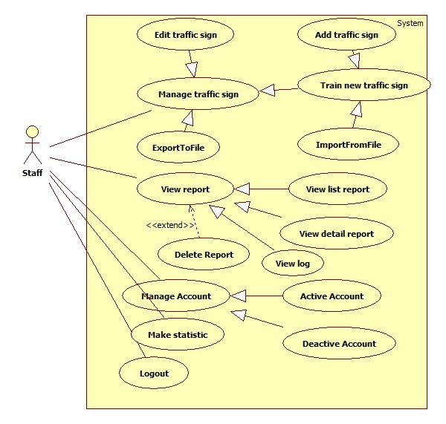

Figure 15: <Staff> Staff overview

##### <Staff> Add Traffic sign

Use Case Diagram



Figure 16: <Staff> Add traffic sign

Use Case Specification

|  |  |  |  |
| --- | --- | --- | --- |
| **USE CASE SU001** | | | |
| **Use Case No.** | SU001 | **Use Case Version** | 2.0 |
| **Use Case Name** | Add traffic sign | | |
| **Author** | Tran Le Tuan, Mai Van Tan | | |
| **Date** | 15/01/2014 | **Priority** | Normal |
| **Actor:** Staff  **Summary:**  Staff use this case to add new traffic sign  **Goal:**  New traffic sign will be added into database  **Triggers:**   * We want to add a new traffic sign into database * To add new sign, staff must: * From the staff Home Page, click the menu item “Quản lí biển báo” * Select “Thêm mới” button   **Preconditions:**   * Guest must login as role Staff.   **Post Conditions:**   * **Success:** The sign will be added * **Fail:** No sign added. Transfer to error page   **Main Success Scenario:**   |  |  |  | | --- | --- | --- | | Step | Actor Action | System Response | | 1 | Click menu item “Quản lí biển báo”. | Redirect to Traffic management page, contains:   * “Thêm mới”: Button. * “Nhập từ tập tin” : Button. * “Xuất ra tập tin” : Button. * “Tạo mẫu” : Button. * List of the current traffic signs, each row include:   + “STT”   + Image   + “Số hiệu”   + “Tên biển báo”   + “Loại biển báo”   + “Sửa”: Button   + “Xóa”: Button | | 2 | Click on “Thêm mới button” | Add new traffic sign modal popup   * Text view: Traffic sign number – not editable * Text field: Traffic sign name * File Upload Control: file type “.jpg” – Maximum size: 1MB * Text field: Traffic sign content * Text field: Penalize fee * File Upload Control: Train Image * “Lưu”: Button * “Đóng” : Button | | 2 | Fill information of the traffic sign and press “Lưu” button.  [Alternative 1] | The new sign will be added. System shows message “Đã Thêm Biển Báo Thành Công”  [Exception 1, 2] |   **Alternative Scenario:**   |  |  |  | | --- | --- | --- | | No | Actor Action | System Response | | 1 | Click on “Đóng” button | The form is emptied |   **Exceptions:**   |  |  |  | | --- | --- | --- | | No | Actor Action | System Response | | 1 | Not enter enough require information. | Display error message: “Thông tin khai báo chưa đầy đủ.” | | 2 | Traffic sign name existed in database | Display error message:  “Biển báo đã tồn tại.” |   **Relationships:** Manage Account  **Business Rules:**   * Added traffic sign must difference with other traffic sign in database. | | | |

Table 30: <Staff> Add traffic sign

##### <Staff> Edit traffic sign

Use Case Diagram



Figure 17: <Staff> Edit traffic sign

Use Case Specification

|  |  |  |  |
| --- | --- | --- | --- |
| **USE CASE – SU002** | | | |
| **Use Case No.** | SU002 | **Use Case Version** | 2.0 |
| **Use Case Name** | Edit traffic sign | | |
| **Author** | Bui Viet Phong | | |
| **Date** | 15/01/2014 | **Priority** | Normal |
| **Actor:** Staff  **Summary:**  This use case allow staff to edit traffic sign information or traffic images  **Goal:**  Edit traffic sign information or traffic images**.**  **Triggers:**   * For recognize or view traffic signs details, the system must store traffic signs information and images for recognition * To edit traffic signs, staff must: * Select ‘Quản lý biển báo’ * Click “Sửa” * Edit information or add image then click “Lưu”   **Preconditions:**   * Guest must log in the system with role staff   **Post Conditions:**   * **Success:** The new traffic sign’s information or image will be updated * **Fail: T**raffic sign’s information or image will not be updated   **Main Success Scenario:**   |  |  |  | | --- | --- | --- | | Step | Actor Action | System Response | | 1 | - Click ‘Quản lý biển báo’ | Redirect to Traffic management page, contains:   * “Thêm mới”: Button * “Nhập từ tập tin” : Button. * “Xuất từ tập tin” : Button * “Tạo mẫu” : Button * List traffic sign: Table. | | 2 | Click “Sửa” button match with traffic sign want to edit. | Show the popup, include:   * “Số hiệu biển báo”: Text box. * “Tên biển báo” : Text box * “Hình ảnh” : Label * “Hình ảnh” :File Upload Control: file type “.jpg” * “Loại biển báo”: Select box * “Thông tin” : Text area * “Mức phạt tham khảo” : Text area * “Ảnh nhận diện” : File Upload Control: file type “.jpg | | 3 | Edit information in text box or select file to upload from File Upload Control to add more image then click “Lưu”.  [Alternative 1] | * Update traffic sign information or images. * Redirect to Traffic management page.   [Exception 1] |   **Alternative Scenario:**   |  |  |  | | --- | --- | --- | | No | Actor Action | System Response | | 1 | [Alternative 1]  - Click “Hủy” button | Close the popup. |   **Exceptions:**   |  |  |  | | --- | --- | --- | | No | Actor Action | System Response | | 1 | Select wrong file. | Display error message: “ Tập tin không đúng định dạng” | | 2 | File structure is wrong. | Display error message: “ Tập tin không đúng cấu trúc” |   **Relationships:** Manage traffic signs  **Business Rules:**   * Staff can add many train images in one time. * Do not allow edit traffic ID. | | | |

Table 31: <Staff> Edit traffic sign

##### <Staff> Export to file

Use Case Diagram



Figure 18: <Staff> Export to file

Use Case Specification

|  |  |  |  |
| --- | --- | --- | --- |
| **USE CASE – SU003** | | | |
| **Use Case No.** | SU003 | **Use Case Version** | 2.0 |
| **Use Case Name** | Export To File. | | |
| **Author** | Tran Le Tuan, Mai Van Tan | | |
| **Date** | 15/01/2014 | **Priority** | Normal |
| **Actor:** Staff  **Summary:**  Staff uses this case to export to file  **Goal:**  Allow staff to export to file  **Triggers:**   * Staff wants to export to file. * To export file, we must :   + Staff login system  + On manage traffic sign page, click on button “Xuất ra tập tin” to export  **Preconditions:**   * Guest must login with role Staff.   **Post Conditions:**   * **Success**: Staff can export to file * **Fail:** Show message error alert   **Main Success Scenario:**   |  |  |  | | --- | --- | --- | | Step | Actor Action | System Response | | 1 | Click on “Xuất ra tập tin” to request export on “Quản lí biển báo” page | System will export report to file excel.  [Exception 1] |   **Alternative Scenario:** N/A  **Exceptions:**   |  |  |  | | --- | --- | --- | | No | Actor Action | System Response | | 1 | Cannot export file | Display error message: “Xuất tập tin thất bại.” |   **Relationships:** N/A  **Business Rules:**   * The export file will be a excel file with the structure like the sample file in Info.xlsx | | | |

Table 32: <Staff> Export to file

##### <Staff> Import from file

Use Case Diagram



Figure 19: <Staff> Import from file

Use Case Specification

|  |  |  |  |
| --- | --- | --- | --- |
| **USE CASE – SU004** | | | |
| **Use Case No.** | SU004 | **Use Case Version** | 2.0 |
| **Use Case Name** | Import traffic sign from file | | |
| **Author** | Bui Viet Phong | | |
| **Date** | 15/01/2014 | **Priority** | Normal |
| **Actor:** Staff  **Summary:**  This use case allow staff to train new traffic signs from existing file  **Goal:**  Train new traffic signs from existing file  **Triggers:**   * For recognize or view traffic signs details, the system must store traffic signs information and images for recognition * To train new traffic signs from existing file, staff must: * Select ‘Quản lý biển báo’ * Click “Thêm biển báo từ tập tin” * Select file to upload then click “Tải lên”   **Preconditions:**   * Guest must log in the system with role staff * Staff has the file to upload   **Post Conditions:**   * **Success:** The new traffic sign has been added to database * **Fail:** No traffic sign has been has been added to database   **Main Success Scenario:**   |  |  |  | | --- | --- | --- | | Step | Actor Action | System Response | | 1 | - Click ‘Quản lý biển báo’ | Redirect to Traffic management page, contains:   * “Tạo mới biển báo”: Button * “Thêm biển báo từ tập tin” : Button. * List of the current traffic signs, each row include:   + Traffic name   + Traffic image   + “Chỉnh sửa” : Button | | 2 | Click “Thêm biển báo từ tập tin” button | Redirect to Import traffic sign page, contains:   * File Upload Control: zip file * “Tải lên”: Button. * “Hủy” : Button | | 3 | Select file to upload from File Upload Control then click “Tải lên” button.  [Alternative 1] | Upload file and add new traffic signs to database.  Redirect to Traffic management page  [Exception 1][Exception 2] |   **Alternative Scenario 1:**   |  |  |  | | --- | --- | --- | | Step | Actor Action | System Response | | 1 | [Alternative 1]  - Click “Hủy” button | Redirect to Traffic management page. |   **Exceptions:**   |  |  |  | | --- | --- | --- | | No | Actor Action | System Response | | 1 | Not select file, click “Tải lên” button | Display error message: “Vui lòng chọn file để tải lên” | | 2 | Upload wrong file. | Display error message: “ Tập tin không đúng định dạng” |   **Relationships:** Manage traffic signs  **Business Rules:** N/A | | | |

Table 33: <Staff> Import from file

##### <Staff> View report

Use Case Diagram



Figure 20: <Staff>View report

Use Case Specification

|  |  |  |  |
| --- | --- | --- | --- |
| **USE CASE – SU005** | | | |
| **Use Case No.** | SU005 | **Use Case Version** | 2.0 |
| **Use Case Name** | View Report | | |
| **Author** | Bui Viet Phong, Ho Dac Nghia | | |
| **Date** | 15/01/2014 | **Priority** | Normal |
| **Actor:** Staff  **Summary:**  Staff use this case to view report  **Goal:**   * Allow staff to view list of report or detail of report   **Triggers:**   * In our system, user can send report. Staffs can view these reports.   **Preconditions:**   * User must login system with role Staff.   **Post Conditions:**   * **Success:** The list of report will show. Staff can view details of report. * **Fail:** No report list displayed. Staff cannot view details of report.   **Main Success Scenario:**   |  |  |  | | --- | --- | --- | | Step | Actor Action | System Response | | 1 | Click menu item “Quản lí phản hồi” on menu bar. | Redirect to Report List Page, contains:   * “Loại phản hồi” : Select box * Table with 7 columns:   + STT: Label   + Nội dung: Label   + Người gửi: Label   + Loại phản hồi: Label   + Thời gian gửi: Label   + Chi tiết: Button   + Xóa : Button | | 2 | For report’s detail view  Staff click “Chi tiết” button beside each report. | System show the popup, include:   * Sửa thông tin : Link * Loai phản hồi : Label * Người gửi : Label * Thời gian gửi : Label * Nội dung: Label * Xóa phản hồi : Button * Đóng : Button |   **Alternative Scenario:** N/A  **Exception**: N/A  **Relationships:** N/A  **Business Rules:** N/A | | | |

Table 34: <Staff> View report

##### <Staff> Delete report

Use Case Diagram



Figure 21: <Staff> Delete report

Use Case Specification

|  |  |  |  |
| --- | --- | --- | --- |
| **USE CASE – SU006** | | | |
| **Use Case No.** | SU006 | **Use Case Version** | 2.0 |
| **Use Case Name** | Delete Report | | |
| **Author** | Bui Viet Phong, Ho Dac Nghia | | |
| **Date** | 15/01/2014 | **Priority** | Normal |
| **Actor:** Staff  **Summary:**  Staff uses this case to delete report  **Goal:**  Allow staff to delete report.  **Triggers:**   * In our system, user can send report. These reports can be deleted by staff. * To delete report, staff go to manage report page, then click “Xóa” link.   **Preconditions:**   * User must log in the system with role Staff. * There must be at least one report in the report list   **Post Conditions:**   * **Success**: The report of a traffic sign will be removed. * **Fail**: Report isn’t removed   **Main Success Scenario:**   |  |  |  | | --- | --- | --- | | Step | Actor Action | System Response | | 1 | Click menu item “Quản lí phản hồi” on menu bar. | Redirect to Report List Page, contains:   * “Loại phản hồi” : Dropdown list * Table with 7 columns:   + “STT”: Label   + “Nội dung”: Label   + “Người gửi”: Label   + “Loại phản hồi”: Label   + “Thời gian gửi”: Label   + “Chi tiết”: Button   + “Xóa” : Button | | 2 | Click on the “Xóa” button  [Alternative 1] | System delete report and refresh page. |   **Alternative Scenario 1**:   |  |  |  | | --- | --- | --- | | Step | Actor Action | System Response | | 1 | Click on “Chi tiết” button | System show the popup, include:   * “Sửa thông tin” : Link * “Loai phản hồi“: Label * “Người gửi” : Label * “Thời gian gửi” : Label * “Nội dung”: Label * “Xóa phản hồi” : Button * “Đóng” : Button | | 2 | Click on the “Xóa phản hồi” button | System delete report and refresh page. |   **Exceptions:** N/A **Relationships:** View Report  **Business Rules:** N/A | | | |

Table 35: <Staff> Delete report

##### <Staff, Admin> Active Account

Use Case Diagram



Figure 22: <Staff, Admin> Active Account

Use Case Specification

|  |  |  |  |
| --- | --- | --- | --- |
| **USE CASE – SU007** | | | |
| **Use Case No.** | SU007 | **Use Case Version** | 2.0 |
| **Use Case Name** | Active Account | | |
| **Author** | Tran Le Tuan, Mai Van Tan | | |
| **Date** | 15/01/2014 | **Priority** | Normal |
| **Actor:** Admin, Staff  **Summary:**  This use case allow admin to active an account  **Goal:**  An inactive account will be activated  **Triggers:**   * In our system, when we do not want user to login, we inactive his/her account. We can active the inactivated account so they can login again. * To active an account, admin must: * From the admin Home Page, click the menu item “Quản lí người dùng”. * Check the Select checkbox of the account record, then select “Kích hoạt” on the drop down list, and press “Đồng ý” button   **Preconditions:**   * User must log in the system with the role admin * There must be at least one inactive account in database   **Post Conditions:**   * **Success:** The selected accounts will be activated * **Fail:** No account activated.Transfer to error page   **Main Success Scenario:**   |  |  |  | | --- | --- | --- | | Step | Actor Action | System Response | | 1 | Click menu item“Quản lí người dúng”. | Redirect to Account Manager Page, includes a table:   * Danh sách tài khoản   Table with columns:   * + Tên tài khoản: Label   + Email: Label   + Tên: Label   + Loại tài khoản: Label   + Thời gian tao: Label   + Tình Trạng: Label   + Khóa/Kích hoạt: Button | | 2 | Find the account and press ”Kích hoạt” button | The selected account will be activated  [Exception 1] |   **Alternative Scenario:** N/A  **Exceptions:**   |  |  |  | | --- | --- | --- | | No | Actor Action | System Response | | 1 | The account has already been activated by another admin | Nothing happen, the account(s) status is active |   **Relationships:** Manage Account  **Business Rules:**   * Admin cannot active/inactive account of themselves or other admin * Staff cannot active/inactive account of themselves, other Staff or Admin | | | |

Table 36: <Staff, Admin> Active Account

##### <Staff, Admin> Deactivate Account

Use Case Diagram



Figure 23: <Staff, Admin> Deactivate Account

Use Case Specification

|  |  |  |  |
| --- | --- | --- | --- |
| **USE CASE – SU008** | | | |
| **Use Case No.** | SU008 | **Use Case Version** | 2.0 |
| **Use Case Name** | Inactive Account | | |
| **Author** | Tran Le Tuan, Mai Van Tan | | |
| **Date** | 15/01/2014 | **Priority** | Normal |
| **Actor:** Admin  **Summary:**  This use case allow admin to active an account  **Goal:**  A active account will be inactivated  **Triggers:**   * In our system, when we do not want a user to login, we inactive his/her account. The account can be activated later * To active an account, admin must: * From the admin Home Page, click the menu item “Quản lí người dùng” * Find the account and press “Khóa” button   **Preconditions:**   * User must logged in the system with the role is admin * There must be at least 1 active account in database   **Post Conditions:**   * **Success:** The selected account(s) will be inactivated * **Fail:** No account inactivated.Transfer to error page   **Main Success Scenario:**   |  |  |  | | --- | --- | --- | | Step | Actor Action | System Response | | 1 | Click menu item“Quản lí người dùng”. | Redirect to Account Manager Page, includes a table:   * Danh sách tài khoản   Table with columns:   * + Tên tài khoản: Label   + Email: Label   + Tên: Label   + Loại tài khoản: Label   + Thời gian tao: Label   + Tình Trạng: Label * Khóa/Kích hoạt: Button | | 2 | Find the account and press ”Khóa” button | The selected account(s) will be inactivated.  [Exception 1] |   **Alternative Scenario:** N/A  **Exceptions:**   |  |  |  | | --- | --- | --- | | No | Actor Action | System Response | | 1 | The account have been inactivated by another admin | Nothing happen, the account(s) status is inactive |   **Relationships:** Manage Account  **Business Rules:**   * Admin cannot active/inactive account of themselves or other admin * Staff cannot active/inactive account of themselves, other Staff or Admin | | | |

Table 37: <Staff, Admin> Deactivate Account

##### <Staff, Admin> Make statistic

Use Case Diagram



Figure 24: <Staff, Admin> Make statistic

Use Case Specification

|  |  |  |  |
| --- | --- | --- | --- |
| **USE CASE – SU009** | | | |
| **Use Case No.** | SU009 | **Use Case Version** | 2.0 |
| **Use Case Name** | Make statistic | | |
| **Author** | Bui Viet Phong, Ho Dac Nghia | | |
| **Date** | 15/01/2014 | **Priority** | Normal |
| **Actor:** Staff  **Summary:**  This use case allow staff to make Statistics about User and Report  **Goal:**   * Make Statistics information about user or search.   **Triggers:**  - To make statistic, staff go to statistic page, choose statistic type, time then click “Thống kê” button.  **Preconditions:**   * User must logged in the system with the role is staff   **Post Conditions:**   * **Success:** Statistics is displayed as a graph * **Fail:** No statistics info displayed   **Main Success Scenario:**   |  |  |  | | --- | --- | --- | | Step | Actor Action | System Response | | 1 | Click link “Thống kê” on main menu. | Redirect to statistic page, include :   * “Loại thống kê” : Drop down list * “Từ ngày” : Date picker * “Đến ngày” : Date picker | | 1 | Choose statistic type, “from” date and “to” date then click “Thống kê” button | System make statistic and show the graph below. |   **Alternative Scenario:** N/A  **Exceptions:**   |  |  |  | | --- | --- | --- | | No | Actor Action | System Response | | 1 | The time start more than end time. | Display error message: “Vui lòng chọn ‘Từ ngày’ sau ‘Đến ngày’” | | 2 | The time start does not pick. | Display error message:”Vui lòng nhập thêm thông tin” |   **Relationships:** N/A  **Business Rules:**   * User statistic based on the number of register. * Report statistic based on the number of report that sent to the system. day | | | |

Table 38: <Staff, Admin> Make statistic

#### <Admin> Admin overview

Use Case Diagram

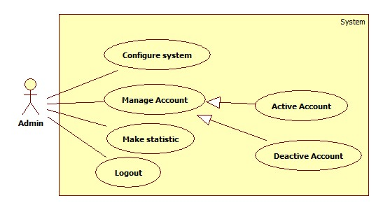

Figure 25: <Admin> Admin overview

##### <Admin> Configure system

Use Case Diagram



Figure 26: <Admin> Configure system

Use Case Specification

|  |  |  |  |
| --- | --- | --- | --- |
| **USE CASE – AD001** | | | |
| **Use Case No.** | AD001 | **Use Case Version** | 2.0 |
| **Use Case Name** | Configure system | | |
| **Author** | Mai Van Tan | | |
| **Date** | 15/01/2014 | **Priority** | Normal |
| **Actor:** Admin  **Summary:**  Admin use this case configure system  **Goal:**  Allow to configure system  **Triggers:**   * When admin want to configure system * Admin click on “Thiết lập cấu hình” in menu   **Preconditions:**   * Guest must log in the system with role admin   **Post Conditions:**   * **Success:** The new configuration is applied to system * **Fail:** System show the message   **Main Success Scenario:**   |  |  |  | | --- | --- | --- | | Step | Actor Action | System Response | | 1 | Click menu item “Thiết lập cấu hình”. | System redirect to configure system page:   * “Số ngày giới hạn kích hoạt tài khoản”: Textbox * “Tạo mẫu mới khi số lượng ảnh nhận dạng đạt”: Textbox * “Lưu thiết lập”: Button | | 2 | Admin input the information and click “Lưu thiết lập” | System apply new configuration  [Exception 1, 2] |   **Alternative Scenario:** N/A  **Exceptions:**   |  |  |  | | --- | --- | --- | | No | Actor Action | System Response | | 1 | Not valid information | System show message “Thông số nhập vào không hợp lệ” | | 2 | Cannot apply new configuration | System show message “Có lỗi, thiết lập cấu hình thất bại” |   **Relationships:** N/A  **Business Rules:**   * Configure must be integer and not less than 1 | | | |

Table 39: <Admin> Configure system

## Software System Attribute

### Usability

#### Graphic User Interface

* All the text, label and image should be in Vietnamese.

#### Usability

* Website admin, staff should need only two days of training to use the system.
* The guest, user can use the system easily without training.

#### Installation

* The system must be easy to deploy. Customer can deploy successfully and learn to configure, maintain the system within one day of training.
* The mobile app must be easy to install. Compatible with Android OS 4.0.
* The attached manual guide must be clear.

### Reliability

* System have recognition accuracy about 60-80 percent

### Availability

* The user search, view favorite and history offline, using mobile in case of network or server unavailable.

### Security

* Privacy: Each role of user has a specific permission to interact with system.
* Only admin can grant permission to staff.

### Maintainability

* The codes is easy to maintain and upgrade.

### Portability

* N/A

### Performance

- The traffic detection and recognition take less than 5 minutes to search traffic in an image with 4Mbs internet connection.

## Conceptual Diagram

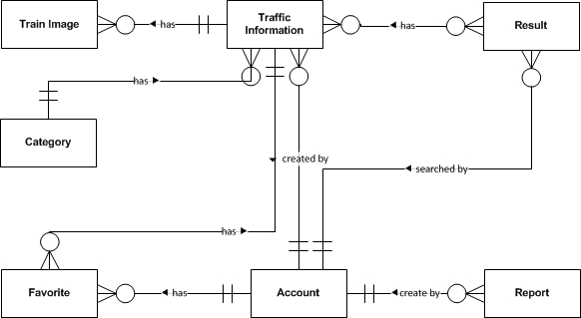

Figure 27: Conceptual Diagram

**Data Dictionary**

|  |  |
| --- | --- |
| **Entity Data dictionary: describe content of all entities** | |
| **Entity Name** | **Description** |
| Traffic Information | Describe information about traffic sign |
| Train Image | Describe information about image to support recognize traffic sign |
| Category | Describe all type of traffic sign |
| Report | Describe information about report of user. Contain content when user though the search result or traffic information wrong. |
| Account | Describe all information about user in the system |
| Result | Describe information about search auto result (user’s history) |
| Favorite | Describe information about favorite traffic sign of user |

# Software Design Description

## Design Overview

* This document describes the technical and user interface design of TSRT using website and mobile device. It includes the architectural design, the detailed design of common functions and business functions and the design of database model.
* The architectural design describes the overall architecture of the system and the architecture of each main component and subsystem.
* The detailed design describes static and dynamic structure for each component and functions. It includes class diagrams, class explanations and sequence diagrams for each Use Cases.
* The database design describes the relationships between entities and details of each entity.
* Document overview:
* Section 2: gives an overall description of the system architecture design.
* Section 3: gives component diagrams that describe the connection and integration of the system.
* Section 4: gives the detail design description include class diagram, class explanation, and sequence diagram to details the application functions.
* Section 5: describe user interface design.
* Section 6: describe an ERD.
* Section 7: describe algorithms.

## System Architectural Design



Figure 28: N-tier Architecture

<http://www.cardisoft.gr/frontend/article.php?aid=87&cid=96>

* **Client Tier**: The client tier interacts with the users for the solution. Since the application conforms to a three layered services application it hosts the presentation layer components.
* **Application Tier**: The servers used in the application tier are responsible for host­ing all the application's business components and, in the case of Web applications, the Web services as well.
* **Data Tier**: The servers in the data tier host the databases that the application requires; it is within this tier that the data layer is hosted.

## Component Diagram



Figure 29: Component Diagram

**Data Dictionary**

|  |  |
| --- | --- |
| **Name** | **Description** |
| TS Detect And Recognize | Provide functions to detect and recognize traffic sign |
| Traffic | Provide functions about traffic sign: manage, search |
| Manage | Provide functions to manage account, favorite |
| Statistic And Configure | Provide functions to statistic and configure server |
| Web service | Provide service interface using http protocol |
| Mobile client | Provide functions in mobile |
| Web Module | Provide functions in web |

## Detailed Description of Components

### Class Diagram

–

Figure 30: Class Diagram

### Class Diagram Explanation

#### TrafficInfo

Attribute

|  |  |  |  |
| --- | --- | --- | --- |
| **Attribute** | **Type** | **Visibility** | **Description** |
| trafficID | String | Private | Traffic sign label |
| name | String | Private | Name of traffic sign |
| image | String | Private | Traffic sign image link |
| categoryID | Integer | Private | Category ID of traffic sign |
| information | String | Private | Content of traffic sign |
| penaltyfee | String | Private | Penalty fee of traffic sign |
| creator | String | Private | Creator of traffic sign |
| createDate | Date | Private | Create date |
| modifyDate | Date | Private | Modify date |
| isActive | Boolean | Private | Status of traffic sign |

Method

|  |  |  |  |
| --- | --- | --- | --- |
| **Method** | **Return Type** | **Visibility** | **Description** |
| searchTraffic() | ArrayList<TrafficInfo> | Public | Search traffic by input parameter: name, cateID, limit |
| getDetail() | TrafficInfo | Public | Get traffic sign detail |

#### Account

Attribute

|  |  |  |  |
| --- | --- | --- | --- |
| **Attribute** | **Type** | **Visibility** | **Description** |
| userID | String | Private | UserID |
| password | String | Private | User’s password in MD5 form |
| email | String | Private | User’s email |
| name | String | Private | User’s name |
| role | String | Private | Role in system |
| createDate | Date | Private | Create date |
| isActive | Boolean | Private | Status |

Method

|  |  |  |  |
| --- | --- | --- | --- |
| **Method** | **Return Type** | **Visibility** | **Description** |
| getAccount() | Account | Public | Get user information |

#### Category

Attribute

|  |  |  |  |
| --- | --- | --- | --- |
| **Attribute** | **Type** | **Visibility** | **Description** |
| categoryID | Integer | Private | ID of category |
| categoryName | String | Private | Name of category |

Method

|  |  |  |  |
| --- | --- | --- | --- |
| **Method** | **Return Type** | **Visibility** | **Description** |
| listAllCategory() | ArrayList<Category> | Public | Get list all category |

#### TrainImage

Attribute

|  |  |  |  |
| --- | --- | --- | --- |
| **Attribute** | **Type** | **Visibility** | **Description** |
| trafficID | String | Private | TrafficID of Image |
| imageID | String | Private | ID of image |
| imageName | String | Private | Name of image |

Method

|  |  |  |  |
| --- | --- | --- | --- |
| **Method** | **Return Type** | **Visibility** | **Description** |
| add() | Boolean | Public | Add a train image |
| listByTrafficID() | ArrayList<TrainImage> | Public | List all train image of a traffic sign |

#### Favorite

Attribute

|  |  |  |  |
| --- | --- | --- | --- |
| **Attribute** | **Type** | **Visibility** | **Description** |
| creator | String | Private | Creator of favorite |
| trafficID | String | Private | Traffic ID of favorite |
| createDate | Date | Private | Create date |
| modifyDate | Date | Private | Modify date |
| isActive | Boolean | Private | Status |

Method

|  |  |  |  |
| --- | --- | --- | --- |
| **Method** | **Return Type** | **Visibility** | **Description** |
| listFavorite() | ArrayList<Favorite> | Public | List all favorite of an user |

#### Result

Attribute

|  |  |  |  |
| --- | --- | --- | --- |
| **Attribute** | **Type** | **Visibility** | **Description** |
| resultID | Integer | Private | Unique ID for result |
| uploadedImage | String | Private | Result image link |
| listTraffic | String | Private | List result contain trafficID and their location in image |
| creator | String | Private | Creator of result |
| createDate | Date | Private | Create date |
| isActive | Boolean | Private | Status of result |

Method

|  |  |  |  |
| --- | --- | --- | --- |
| **Method** | **Return Type** | **Visibility** | **Description** |
| getResultByID() | Result | Public | Get result detail by ID |
| getResultByCreator() | ArrayList<Result> | Public | Get all result of an user |

#### Report

Attribute

|  |  |  |  |
| --- | --- | --- | --- |
| **Attribute** | **Type** | **Visibility** | **Description** |
| reportID | Integer | Private | Unique id for report |
| referenceID | String | Private | Reference Id of report, this ID reference to TrafficInfo or Result depend on type of report |
| content | String | Private | Content of report |
| creator | String | Private | Creator of report |
| type | Integer | Private | Type of report. 1 for wrong recognize, 2 for wrong traffic information |
| createDate | Date | Private | Create date |
| isActive | Boolean | Private | Status |

Method

|  |  |  |  |
| --- | --- | --- | --- |
| **Method** | **Return Type** | **Visibility** | **Description** |
| getReportDetail() | Report | Public | Get detail of report |
| getReportByType | ArrayList<Report> | Public | Get all report by type |

### Sequence Diagram

#### Add Traffic Sign

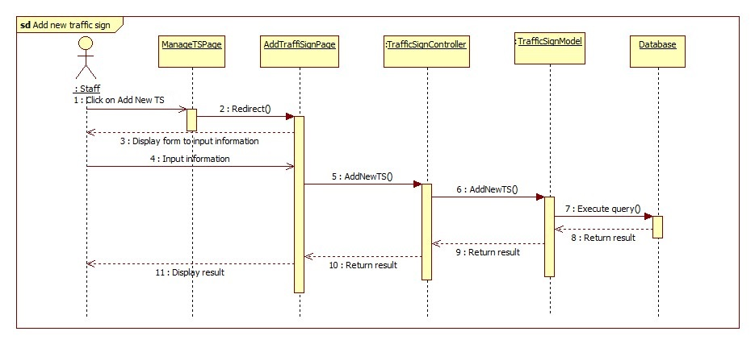

Figure 31: Add Traffic Sign Sequence Diagram

#### Add Train Image

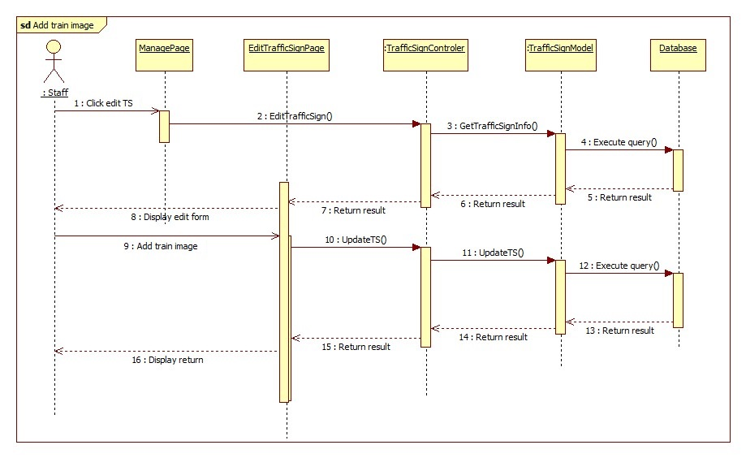

Figure 32: Add Train Image Sequence Diagram

#### Import Data From File

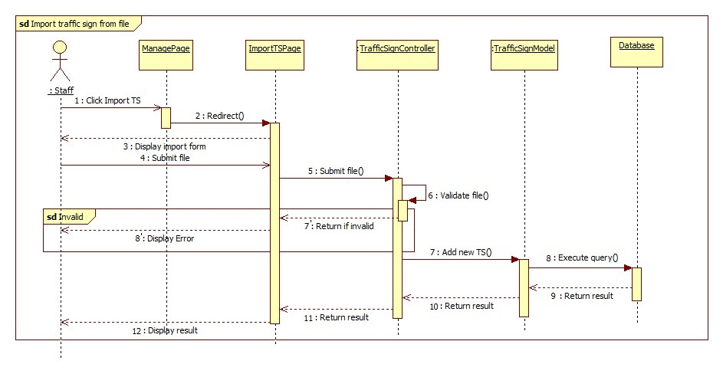

Figure 33: Import Data From File Sequence Diagram

#### Search Traffic Sign Auto

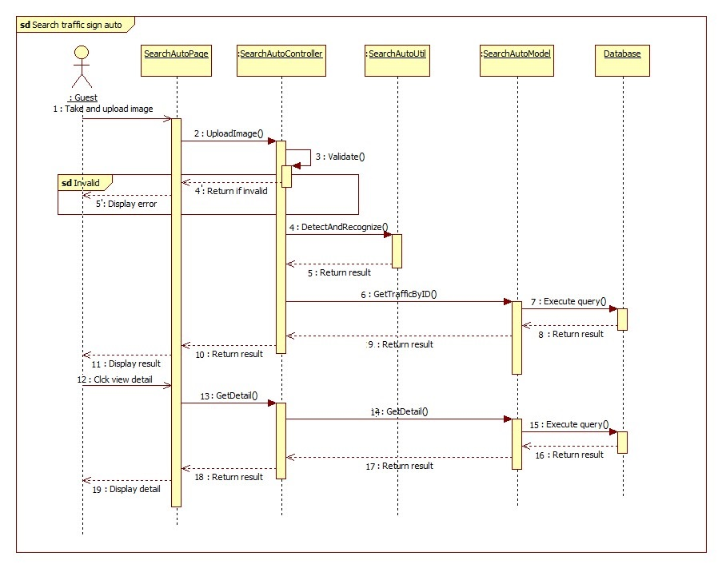

Figure 34: Search Traffic Sign Auto Sequence Diagram

#### Search Traffic Sign Manual

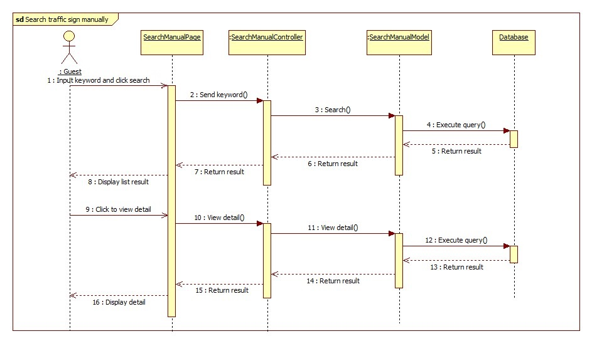

Figure 35: Search Traffic Sign Manual Sequence Diagram

## User Interface Design

### User Interface Design

#### User - Home Page

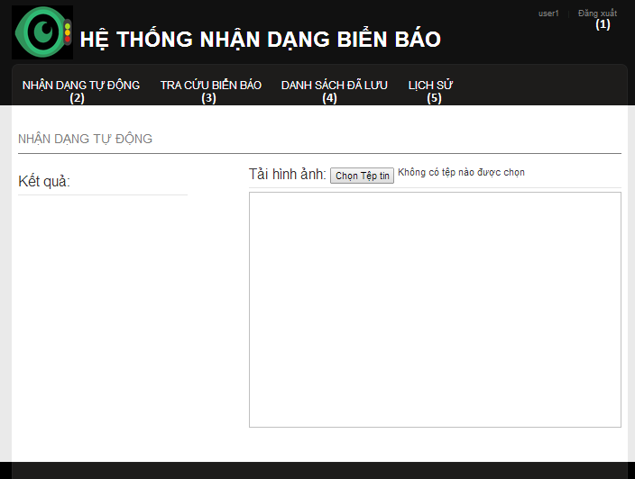

Figure 36: User Home Page

**Button/ Hyperlink**

|  |  |  |  |  |
| --- | --- | --- | --- | --- |
| **No** | **Function** | **Description** | **Validation** | **Outcome** |
| 1 | Logout | Click to logout | No | Delete session and return to Home page |
| 2 | Search auto | Click to go to search auto page | No | Search auto Page |
| 3 | Search manual | Click to go to search manual page | No | Search manual page |
| 4 | Favorite | Click to View favorite list | No | Get the favorite list from service and return to Favorite page |
| 5 | History | Click to view history list | No | Get the history list from service and return to history page |

#### User – Search auto

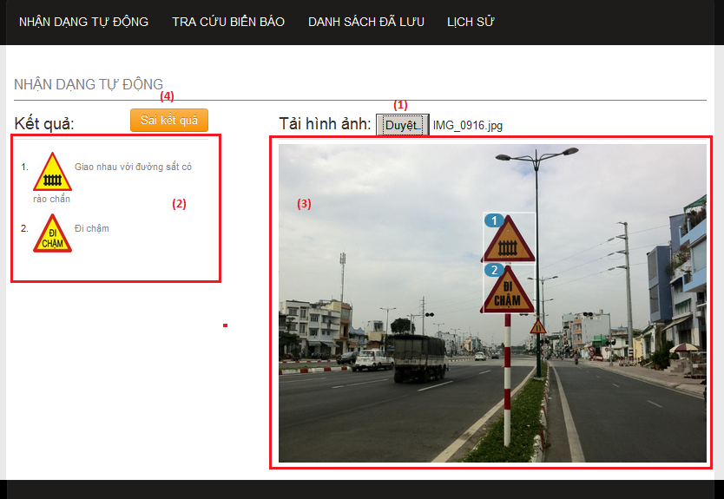

Figure 37: User – Search auto

**Fields**

|  |  |  |  |  |  |  |  |
| --- | --- | --- | --- | --- | --- | --- | --- |
| **No** | **Field Name** | **Description** | **Read only** | **Mand-atory** | **Control Type** | **Data Type** | **Length** |
| 3 | Image preview | Show image was upload by user. | Y | Y | Image tag | Image | N/A |

**Button/ Hyperlink**

|  |  |  |  |  |
| --- | --- | --- | --- | --- |
| **No** | **Function** | **Description** | **Validation** | **Outcome** |
| 1 | Select image for upload | Click to select an image to upload for search traffic signs | No | Upload image to service and show the result |
| 2 | Traffic sign detail link | Show list result matching with number in the image. Click one item to view traffic sign detail | No | Show popup to view traffic sign details |
| 4 | Send report | Click to show popup to send report | No | Show popup to send report |

#### User – Search manual

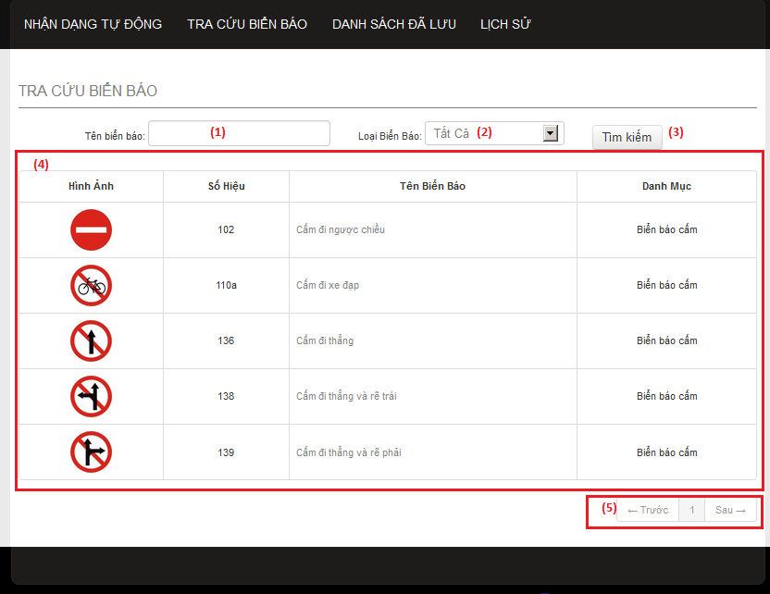

Figure 38: User – Search manual

**Fields**

|  |  |  |  |  |  |  |  |
| --- | --- | --- | --- | --- | --- | --- | --- |
| **No** | **Field Name** | **Description** | **Read only** | **Mand-atory** | **Control Type** | **Data Type** | **Length** |
| 1 | Search key | Enter traffic name to search. | N | N | Input tag | Strin-g | N/A |
| 2 | Category | Select one category type to search | N | Y | Select tag | N/A | N/A |
| 4 | List result | Display result after search manual | Y | Y | Table | N/A | N/A |

**Button/ Hyperlink**

|  |  |  |  |  |
| --- | --- | --- | --- | --- |
| **No** | **Function** | **Description** | **Validation** | **Outcome** |
| 3 | Search manual | Click to search traffic sign by traffic sign’s name and category. | No | Show list result to the table below. |
| 4 | Paging | Select number or “Trước”, “Sau” to view others records in the table. | No | Change page in the table |

**Table List Result includes**

|  |  |  |  |  |  |
| --- | --- | --- | --- | --- | --- |
| **Field Name** | **Description** | **Read only** | **Control Type** | **Data Type** | **Length** |
| “Hình ảnh” | Traffic sign’s image. Click to view traffic sign detail | Y | Image | N/A | N/A |
| “Số hiệu” | Traffic sign’s ID number | Y | Label | String | N/A |
| “Tên biển báo” | Traffic sign’s name. Click to view traffic sign detail | Y | Label | String | N/A |
| “Danh mục” | Traffic sign’s category | Y | Label | String | N/A |

#### User – Favorite list

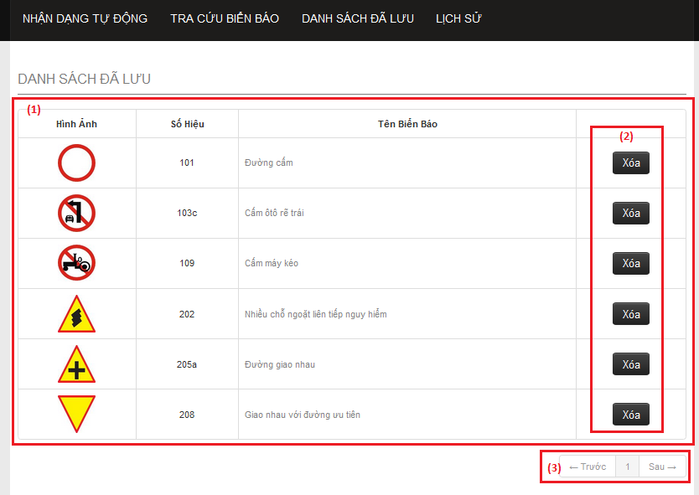

Figure 39: User – Favorite list

**Fields**

|  |  |  |  |  |  |  |  |
| --- | --- | --- | --- | --- | --- | --- | --- |
| **No** | **Field Name** | **Description** | **Read only** | **Mandatory** | **Control Type** | **Data Type** | **Length** |
| 1 | Favorite List Table | The list of traffic signs in the favorite. | N | Y | Table | N/A | N/A |

**Button/ Hyperlink**

|  |  |  |  |  |
| --- | --- | --- | --- | --- |
| **No** | **Function** | **Description** | **Validation** | **Outcome** |
| 2 | Delete favorite | Click to delete traffic sign from favorite list. | No | Send delete request to service and delete a row in table. |
| 3 | Paging | Select number or “Trước”, “Sau” to view others records in the table. | No | Change page in the table |

**Table Favorite list includes**

|  |  |  |  |  |  |
| --- | --- | --- | --- | --- | --- |
| **Field Name** | **Description** | **Read only** | **Control Type** | **Data Type** | **Length** |
| “Hình ảnh” | Traffic sign’s image. Click to view traffic sign detail | Y | Image | Image | N/A |
| “Số hiệu” | Traffic sign’s ID number | Y | Label | String | N/A |
| “Tên biển báo” | Traffic sign’s name. Click to view traffic sign detail | Y | Label | String | N/A |
| Action | Button to delete traffic sign from favorite list. | Y | Button | N/A | N/A |

#### User – History list

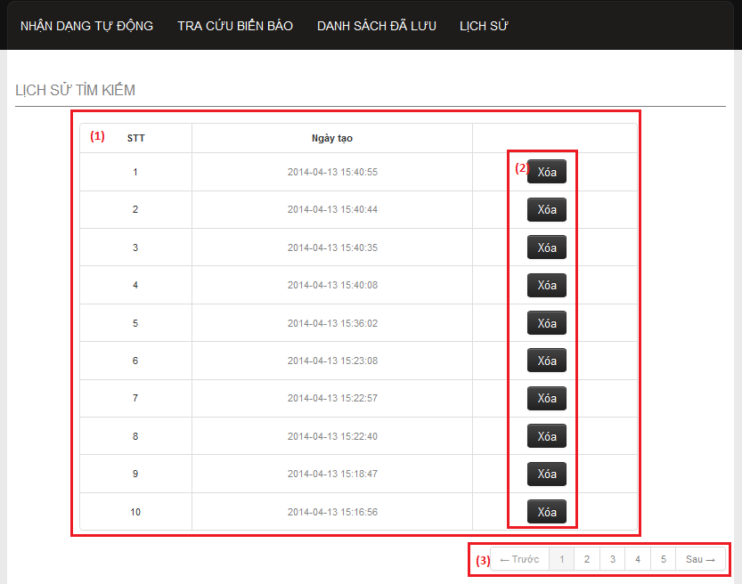

Figure 40: User – History list

**Fields**

|  |  |  |  |  |  |  |  |
| --- | --- | --- | --- | --- | --- | --- | --- |
| **No** | **Field Name** | **Description** | **Read only** | **Mandatory** | **Control Type** | **Data Type** | **Length** |
| 1 | History list | The list history. | N | Y | Table | N/A | N/A |

**Button/ Hyperlink**

|  |  |  |  |  |
| --- | --- | --- | --- | --- |
| **No** | **Function** | **Description** | **Validation** | **Outcome** |
| 2 | Delete history | Click to delete one history record in the table. | No | Send delete request to service and delete a row in table. |
| 3 | Paging | Select number or “Trước”, “Sau” to view others records in the table. | No | Change page in the table |

**Table History list includes**

|  |  |  |  |  |  |
| --- | --- | --- | --- | --- | --- |
| **Field Name** | **Description** | **Read only** | **Control Type** | **Data Type** | **Length** |
| “STT” | Display row’s position in table. | Y | Label | String | N/A |
| “Ngày tạo” | Display history ‘s create time | Y | Label | String | N/A |
| Action | Button to delete history. | Y | Button | N/A | N/A |

#### User – Traffic sign detail

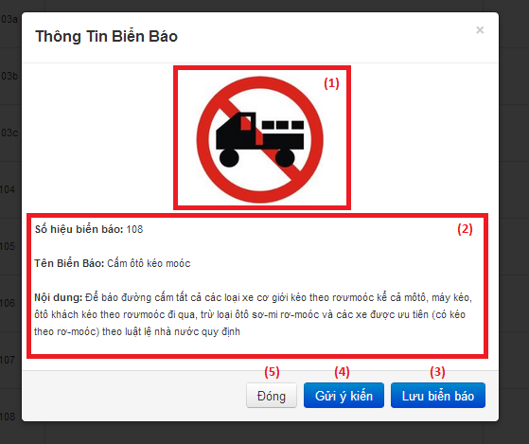

Figure 41: User – Traffic sign detail

**Fields**

|  |  |  |  |  |  |  |  |
| --- | --- | --- | --- | --- | --- | --- | --- |
| **No** | **Field Name** | **Description** | **Read only** | **Mandatory** | **Control Type** | **Data Type** | **Length** |
| 1 | Traffic sign’s image | Display traffic sign’s image. | Y | Y | Image tag | Image | N/A |
| 2 | Traffic sign information | Display traffic sign detail information | Y | Y | Label | String | N/A |

**Button/ Hyperlink**

|  |  |  |  |  |
| --- | --- | --- | --- | --- |
| **No** | **Function** | **Description** | **Validation** | **Outcome** |
| 3 | Add favorite | Click to add traffic sign to favorite list. | No | Send add favorite request to service and change button to “Xóa biển báo”. |
| 4 | Send report | Click to show popup for send report. | No | Show popup send report |
| 5 | Close popup | Click to close popup | No | Popup close. |

**Table History list includes**

|  |  |  |  |  |  |
| --- | --- | --- | --- | --- | --- |
| **Field Name** | **Description** | **Read only** | **Control Type** | **Data Type** | **Length** |
| “STT” | Display row’s position in table. | Y | Label | String | N/A |
| “Ngày tạo” | Display history ‘s create time | Y | Label | String | N/A |
| Action | Button to delete history. | Y | Button | N/A | N/A |

#### User – Send report

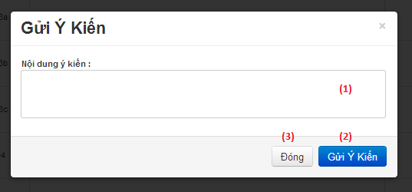

Figure 42: User – Send report

**Fields**

|  |  |  |  |  |  |  |  |
| --- | --- | --- | --- | --- | --- | --- | --- |
| **No** | **Field Name** | **Description** | **Read only** | **Mandatory** | **Control Type** | **Data Type** | **Length** |
| 1 | Report content | Enter report content to this field. | N | Y | Textbox | String | N/A |

**Button/ Hyperlink**

|  |  |  |  |  |
| --- | --- | --- | --- | --- |
| **No** | **Function** | **Description** | **Validation** | **Outcome** |
| 2 | Submit report | Click to send report. | No | Send report to server and close popup. |
| 3 | Close popup | Click to close popup | No | Popup close. |

### Admin Interface Design

#### Admin - Home Page

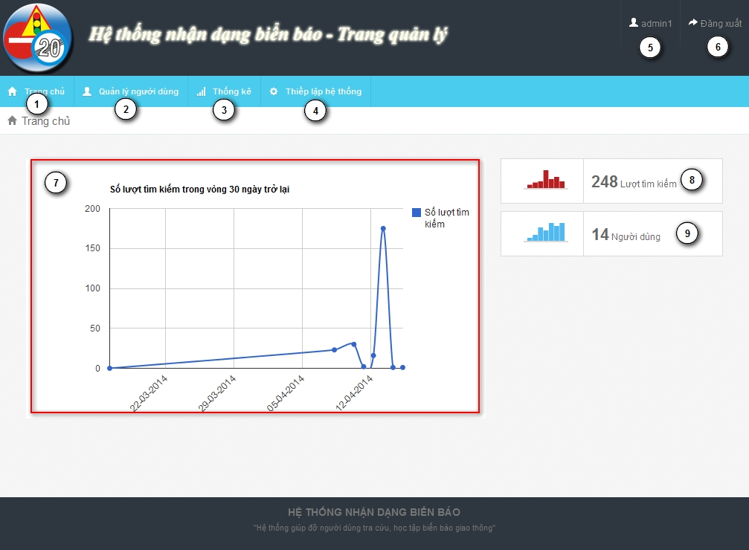

Figure 43: Admin - Home Page

**Fields**

|  |  |  |  |  |  |  |  |
| --- | --- | --- | --- | --- | --- | --- | --- |
| **No** | **Field Name** | **Description** | **Read only** | **Mand-atory** | **Control Type** | **Data Type** | **Length** |
| 5 | Username | username of user | Y | Y | Label | String | N/A |
| 7 | Statistic | Statistic of last 30 days search times | Y | Y | N/A | N/A | N/A |
| 8 | Total search times | Total search auto times | Y | Y | N/A | N/A | N/A |
| 9 | Total user | Total user registered in system | Y | Y | N/A | N/A | N/A |

**Button/ Hyperlink**

|  |  |  |  |  |
| --- | --- | --- | --- | --- |
| **No** | **Function** | **Description** | **Validation** | **Outcome** |
| 1 | Home page | Click to go to home page | No | Home page |
| 2 | Account manager page | Click to go to account manage page | No | Account manage page |
| 3 | Statistic page | Click to go to statistic page | No | Statistic page |
| 4 | Configure page | Click to go to configure page | No | Configure page |
| 6 | Log out button | Click to log out | No | Login page |

#### Admin - Account Manager Page

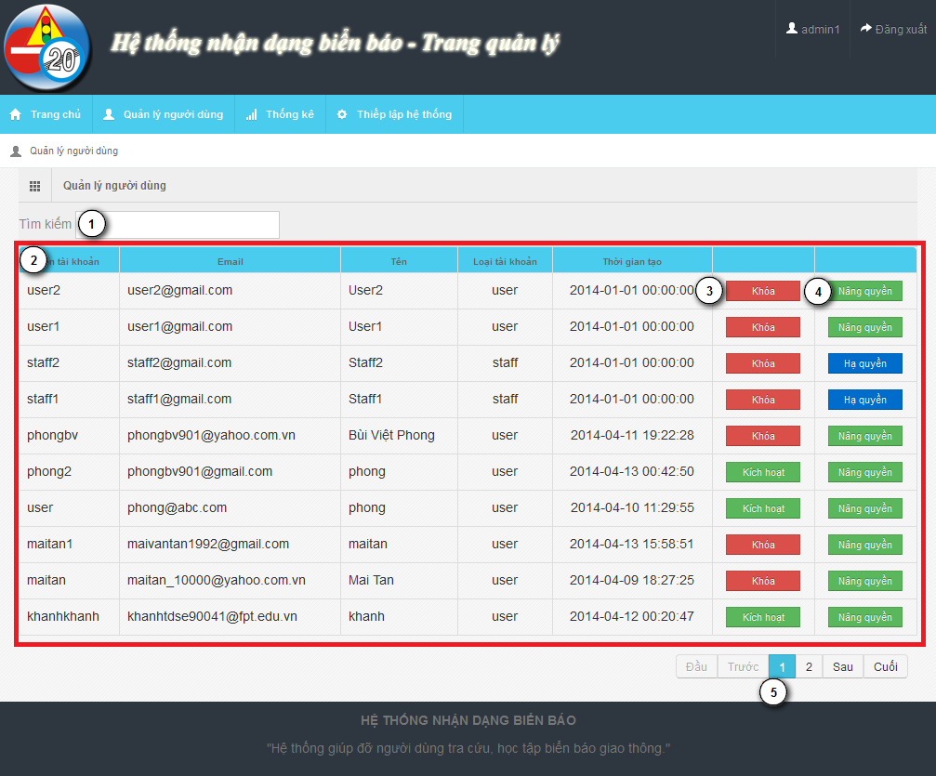

Figure 44: Admin - Account Manager Page

**Fields**

|  |  |  |  |  |  |  |  |
| --- | --- | --- | --- | --- | --- | --- | --- |
| **No** | **Field Name** | **Description** | **Read only** | **Mand-atory** | **Control Type** | **Data Type** | **Length** |
| 1 | Search field | Search textbox for the table | N | Y | Textbox | String | N/A |
| 2 | Account list | List account in system | Y | Y | Table | N/A | N/A |

**Button/ Hyperlink**

|  |  |  |  |  |
| --- | --- | --- | --- | --- |
| **No** | **Function** | **Description** | **Validation** | **Outcome** |
| 3 | Active/Deactivate | Active/deactivate account | No | Change text of button |
| 4 | Set/Unset staff role | Use to set or unset staff role | No | Change text of button |
| 5 | Paging | Paging area of the student table | No | Change page of the table |

**Table Account List includes**

|  |  |  |  |  |  |
| --- | --- | --- | --- | --- | --- |
| **Field Name** | **Description** | **Read only** | **Control Type** | **Data Type** | **Length** |
| UserID | UserID of account | Y | Label | String | N/A |
| Email | Email of account | Y | Label | String | N/A |
| Name | Name of account | Y | Label | String | N/A |
| Role | Role of account | Y | Label | String | N/A |
| Create date | Create date of account | Y | Label | String | N/A |
| Function | Active/Deactivate account | N | Button | N/A | N/A |
| Function | Set/Unset staff role | N | Button | N/A | N/A |

#### Admin - Statistic Page

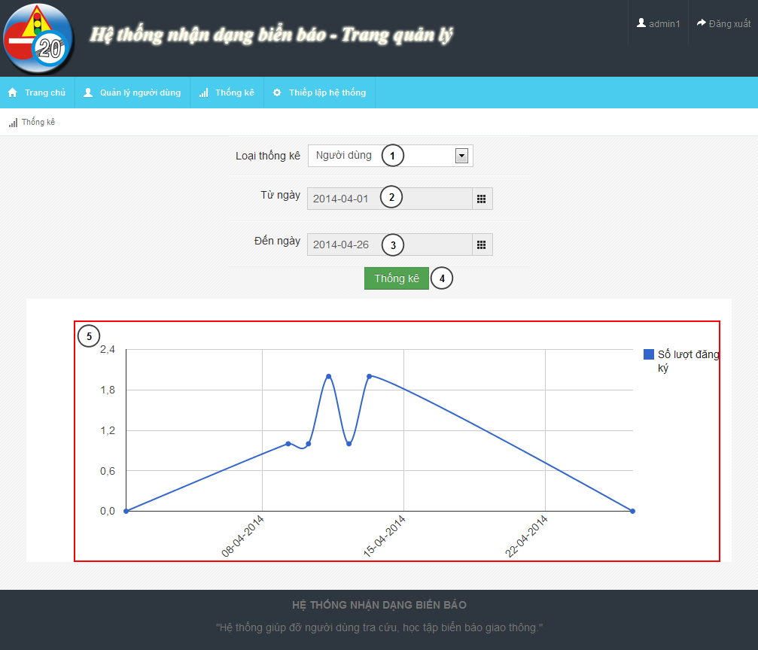

Figure 45: Admin - Statistic Page

**Fields**

|  |  |  |  |  |  |  |  |
| --- | --- | --- | --- | --- | --- | --- | --- |
| **No** | **Field Name** | **Description** | **Read only** | **Mand-atory** | **Control Type** | **Data Type** | **Length** |
| 1 | Statistic type | Type of statistic | N | Y | Dropdown-list | String | N/A |
| 2 | From date | From date to begin statistic | N | Y | Date picker | N/A | N/A |
| 3 | To date | To date to end of statistic | N | Y | Date picker | N/A | N/A |
| 5 | Chart field | Line chart description of the statistic information | N/A | Y | N/A | N/A | N/A |

**Button/ Hyperlink**

|  |  |  |  |  |
| --- | --- | --- | --- | --- |
| **No** | **Function** | **Description** | **Validation** | **Outcome** |
| 4 | Show statistic | Shot statistic information in chart field | From date and to date not empty, from date not after to date | Chart field |

#### Admin - Configure Page

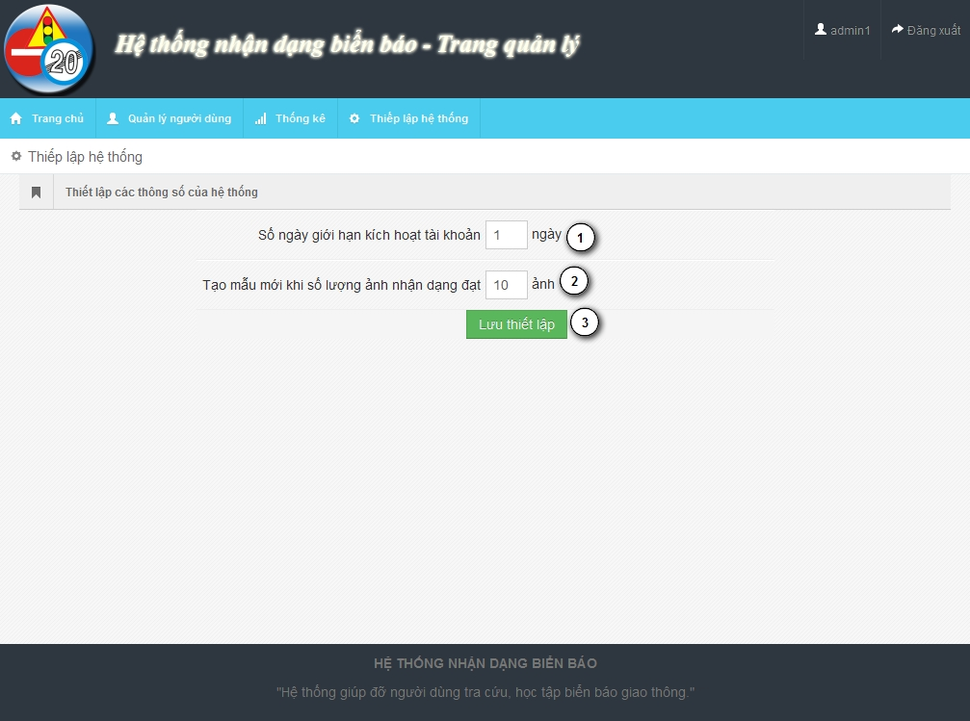

Figure 46: Admin - Configure Page

**Fields**

|  |  |  |  |  |  |  |  |
| --- | --- | --- | --- | --- | --- | --- | --- |
| **No** | **Field Name** | **Description** | **Read only** | **Mand-atory** | **Control Type** | **Data Type** | **Length** |
| 1 | Active day | The limit active day after register | N | Y | Textbox | Integer | [0..] |
| 2 | Retrain count | The train count limit after retrain model data | N |  | Textbox | Integer | [0..] |

**Button/ Hyperlink**

|  |  |  |  |  |
| --- | --- | --- | --- | --- |
| **No** | **Function** | **Description** | **Validation** | **Outcome** |
| 3 | Save configure | Save configure information | No | N/A |

### Staff Interface Design

#### Staff – Home Page

The same with Admin – Home page in 5.2.1

#### Staff – Traffic Sign Manager Page

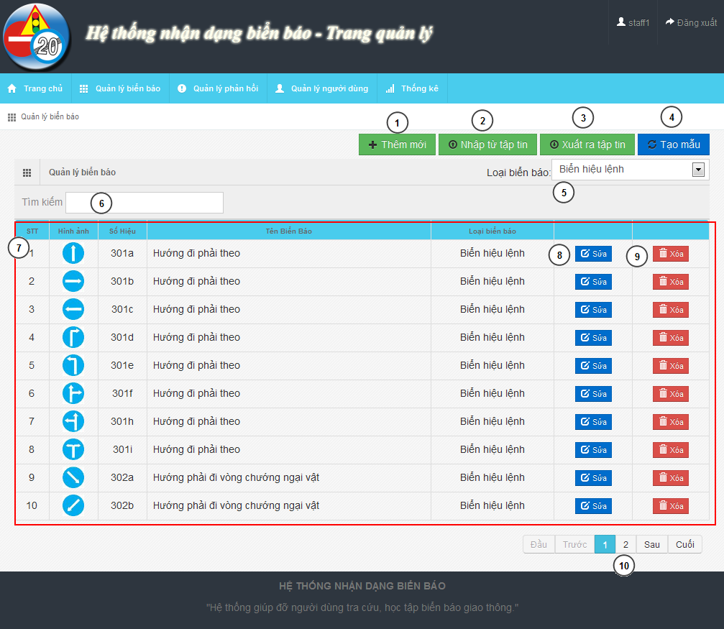

Figure 47: Staff – Traffic Sign Manager Page

**Fields**

|  |  |  |  |  |  |  |  |
| --- | --- | --- | --- | --- | --- | --- | --- |
| **No** | **Field Name** | **Description** | **Read only** | **Mand-atory** | **Control Type** | **Data Type** | **Length** |
| 5 | Traffic sign type | Filter traffic sign by type | N | Y | Dropdown-list | N/A | N/A |
| 6 | Search textbox | Search traffic sign | N | Y | Textbox | String | N/A |
| 7 | Traffic sign list | Traffic sign list | N/A | Y | Table | N/A | N/A |
| 10 | Paging | Paging for traffic sign table | N | Y | N/A | N/A | N/A |

**Button/ Hyperlink**

|  |  |  |  |  |
| --- | --- | --- | --- | --- |
| **No** | **Function** | **Description** | **Validation** | **Outcome** |
| 1 | Add new | Add new traffic sign | No | Traffic sign add new modal |
| 2 | Import data | Import data from file | No | Import data file modal |
| 3 | Export data | Export data to file | No | Zip file |
| 4 | Retrain model | Retrain model from data | No | New model create |
| 8 | Edit traffic sign | Edit traffic sign | No | Edit traffic sign modal |
| 9 | Delete traffic sign | Delete traffic sign | No | Refresh traffic table |

**Table Traffic Sign List includes**

|  |  |  |  |  |  |
| --- | --- | --- | --- | --- | --- |
| **Field Name** | **Description** | **Read only** | **Control Type** | **Data Type** | **Length** |
| No | Order of the row | Y | Label | Integer | N/A |
| Image | Image of traffic sign | Y | Image | Image | N/A |
| Label | Label of traffic sign | Y | Label | String | N/A |
| Name | Name of traffic sign | Y | Label | String | N/A |
| Type | Type of traffic sign | Y | Label | String | N/A |
| Function | Edit traffic sign | N | Button | N/A | N/A |
| Function | Delete traffic sign | N | Button | N/A | N/A |

#### Staff – Report Manager Page

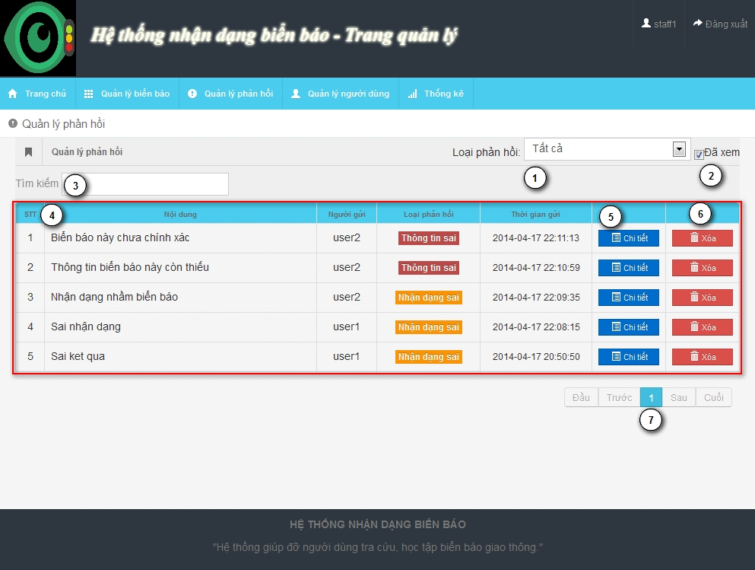

Figure 48: Staff – Report Manager Page

**Fields**

|  |  |  |  |  |  |  |  |
| --- | --- | --- | --- | --- | --- | --- | --- |
| **No** | **Field Name** | **Description** | **Read only** | **Mand-atory** | **Control Type** | **Data Type** | **Length** |
| 1 | Report type | Report type filter | N | Y | Dropdown-list | N/A | N/A |
| 2 | Show read report | Show report read before | N | Y | Check box | N/A | N/A |
| 3 | Search field | Search text box for report table | N | Y | Textbox | String | N/A |
| 4 | Report List | List of report | N | Y | Table | N/A | N/A |
| 7 | Paging | Paging for report list | N | Y | N/A | N/A | N/A |

**Button/ Hyperlink**

|  |  |  |  |  |
| --- | --- | --- | --- | --- |
| **No** | **Function** | **Description** | **Validation** | **Outcome** |
| 5 | View detail | View detail of report | No | Show detail report modal |
| 6 | Delete | Delete report | No | Refresh report table |

**Table Report List includes**

|  |  |  |  |  |  |
| --- | --- | --- | --- | --- | --- |
| **Field Name** | **Description** | **Read only** | **Control Type** | **Data Type** | **Length** |
| No | Order of the row | Y | Label | Integer | N/A |
| Content | Content of report | Y | Label | String | N/A |
| Creator | Creator of report | Y | Label | String | N/A |
| Type | Type of report | Y | Label | String | N/A |
| Create date | Create date of report | Y | Label | Date time | N/A |
| Function | View detail button | N | Button | String | N/A |
| Function | Delete button | N | Button | String | N/A |

#### Staff – Account Manager Page

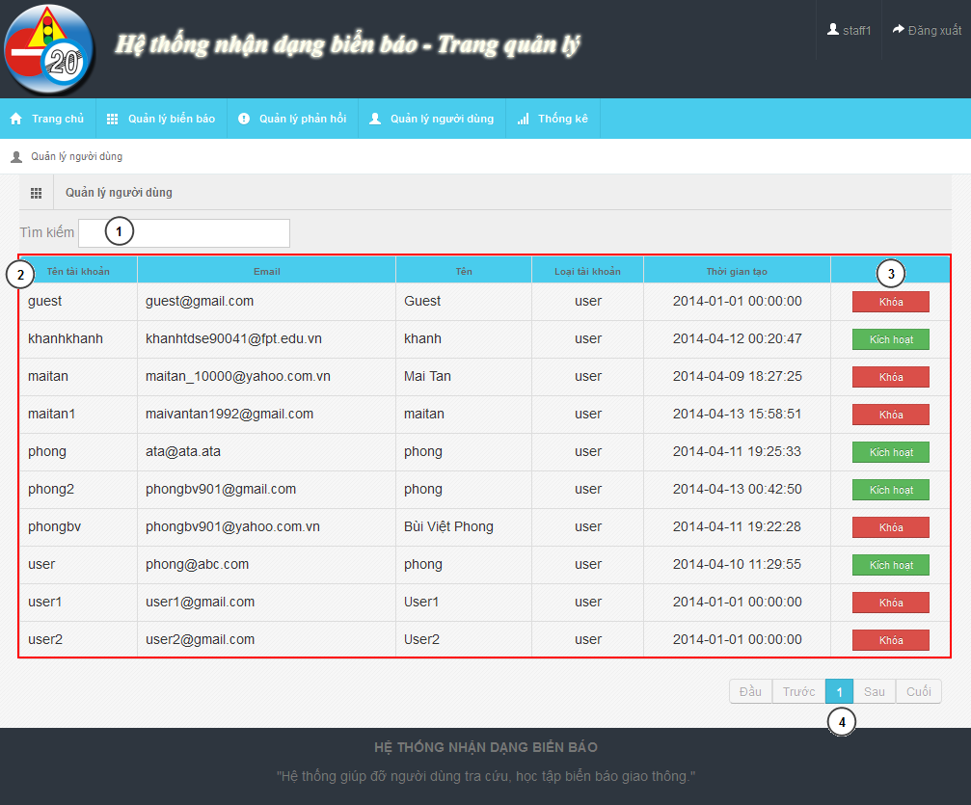

Figure 49: Staff – Account Manager Page

**Fields**

|  |  |  |  |  |  |  |  |
| --- | --- | --- | --- | --- | --- | --- | --- |
| **No** | **Field Name** | **Description** | **Read only** | **Mand-atory** | **Control Type** | **Data Type** | **Length** |
| 1 | Search field | Search textbox for the table | N | Y | Textbox | String | N/A |
| 2 | Account list | List account in system | Y | Y | Table | N/A | N/A |

**Button/ Hyperlink**

|  |  |  |  |  |
| --- | --- | --- | --- | --- |
| **No** | **Function** | **Description** | **Validation** | **Outcome** |
| 3 | Active/Deactivate | Active/deactivate account | No | Change text of button |
| 4 | Paging | Paging area of the student table | No | Change page of the table |

**Table Account List includes**

|  |  |  |  |  |  |
| --- | --- | --- | --- | --- | --- |
| **Field Name** | **Description** | **Read only** | **Control Type** | **Data Type** | **Length** |
| UserID | UserID of account | Y | Label | String | N/A |
| Email | Email of account | Y | Label | String | N/A |
| Name | Name of account | Y | Label | String | N/A |
| Role | Role of account | Y | Label | String | N/A |
| Create date | Create date of account | Y | Label | String | N/A |
| Function | Active/Deactivate account | N | Button | N/A | N/A |

#### Staff – Statistic Page

The same with Admin Statistic Page in 5.2.3

### 

### Mobile Interface Design

#### Login Activity

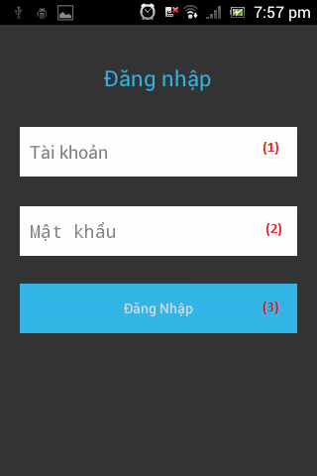

Figure 50: Login Activity

**Fields**

|  |  |  |  |  |  |  |  |
| --- | --- | --- | --- | --- | --- | --- | --- |
| **No** | **Field Name** | **Description** | **Read only** | **Mand-atory** | **Control Type** | **Data Type** | **Length** |
| 1 | Username | Fill user’s username | N | N | Textbox | String | [6, 30] |
| 2 | Password | Fill user’s password | N | N | Textbox | String | [6, 30] |

**Button/ Hyperlink**

|  |  |  |  |  |
| --- | --- | --- | --- | --- |
| **No** | **Function** | **Description** | **Validation** | **Outcome** |
| 3 | Login | Click to login the system | No | Transfer to Main activity |

#### Main Activity

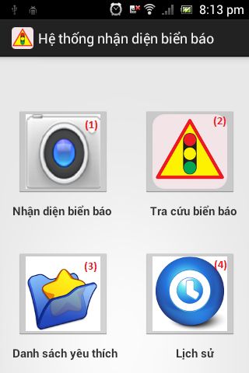

Figure 51: Main Activity

**Button/ Hyperlink**

|  |  |  |  |  |
| --- | --- | --- | --- | --- |
| **No** | **Function** | **Description** | **Validation** | **Outcome** |
| 1 | Search auto | Click transfer to camera activity | No | Transfer to Camera activity |
| 2 | Search manual | Click transfer to category activity | No | Transfer to Category activity |
| 3 | Show favorite list | Click transfer to favorite activity | No | Transfer to Favorite activity |
| 4 | Show history list | Click transfer to history activity | No | Transfer to History activity |

#### Camera Activity

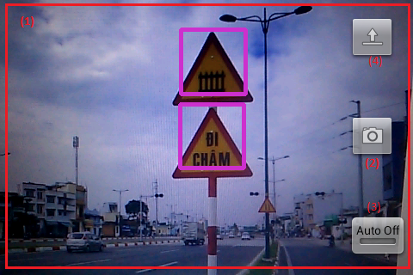

Figure 52: Camera Activity

**Fields**

|  |  |  |  |  |  |  |  |
| --- | --- | --- | --- | --- | --- | --- | --- |
| **No** | **Field Name** | **Description** | **Read only** | **Mandatory** | **Control Type** | **Data Type** | **Length** |
| 1 | Screen view | Show screen of camera on real time | Y | Y | Frame layout | N/A | N/A |

**Button/ Hyperlink**

|  |  |  |  |  |
| --- | --- | --- | --- | --- |
| **No** | **Function** | **Description** | **Validation** | **Outcome** |
| 2 | Capture | Click to capture image | No | Image on real time send to web service and transfer to List result activity |
| 3 | Turn on (off) auto capture mode | Click to turn on or off auto capture mode | No | Turn on (off) auto capture mode |
| 4 | Upload image | Click to select image for upload | No | Image on real time send to web service and transfer to List result activity |

#### List result Activity

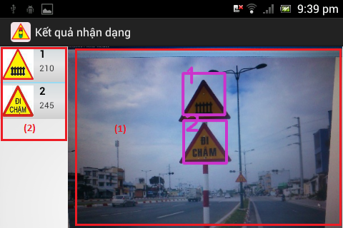

Figure 53: List result Activity

**Fields**

|  |  |  |  |  |  |  |  |
| --- | --- | --- | --- | --- | --- | --- | --- |
| **No** | **Field Name** | **Description** | **Read only** | **Mand-atory** | **Control Type** | **Date Type** | **Length** |
| 1 | Uploaded Image | Display image was uploaded by user. | Y | Y | Image view | Image | N/A |

**Button/ Hyperlink**

|  |  |  |  |  |
| --- | --- | --- | --- | --- |
| **No** | **Function** | **Description** | **Validation** | **Outcome** |
| 2 | View traffic sign detail | Click one to view traffic sign detail | No | Transfer to Traffic sign detail activity |

**List result includes**

|  |  |  |  |  |  |
| --- | --- | --- | --- | --- | --- |
| **Field Name** | **Description** | **Read only** | **Control Type** | **Data Type** | **Length** |
| Position | Display position of result match with image. | Y | Textview | String | N/A |
| Traffic ID | Display traffic’s ID number | Y | Textview | String | N/A |
| Traffic image | Display traffic’s image | Y | Imageview | Image | N/A |

#### Category Activity

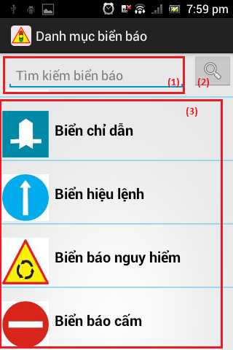

Figure 54: Category Activity

**Fields**

|  |  |  |  |  |  |  |  |
| --- | --- | --- | --- | --- | --- | --- | --- |
| **No** | **Field Name** | **Description** | **Read only** | **Mandatory** | **Control Type** | **Date Type** | **Length** |
| 1 | Search key | Key for search traffic sign by traffic’s name | N | N | Edit text | String | N/A |

**Button/ Hyperlink**

|  |  |  |  |  |
| --- | --- | --- | --- | --- |
| **No** | **Function** | **Description** | **Validation** | **Outcome** |
| 2 | Search traffic sign by name | Click to search traffic sign by traffic’s name | No | Search traffic sign then transfer to List traffic sign activity |
| 3 | Search traffic sign by category | Click to search traffic sign by category which was selected | No | Search traffic sign then transfer to List traffic sign activity |

**Category list includes**

|  |  |  |  |  |  |
| --- | --- | --- | --- | --- | --- |
| **Field Name** | **Description** | **Read only** | **Control Type** | **Data Type** | **Length** |
| Category image | Display category’s image | Y | Imageview | Image | N/A |
| Category name | Display category’s name | Y | Textview | String | N/A |

#### List traffic sign Activity

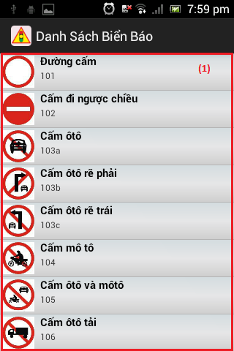

Figure 55: Category Activity

**Button/ Hyperlink**

|  |  |  |  |  |
| --- | --- | --- | --- | --- |
| **No** | **Function** | **Description** | **Validation** | **Outcome** |
| 1 | View traffic sign detail | Click view traffic sign detail | No | Transfer to Traffic sign detail activity |

**Traffic sign list includes**

|  |  |  |  |  |  |
| --- | --- | --- | --- | --- | --- |
| **Field Name** | **Description** | **Read only** | **Control Type** | **Data Type** | **Length** |
| Traffic sign image | Display traffic sign’s image | Y | Imageview | Image | N/A |
| Traffic sign name | Display traffic sign’s name | Y | Textview | String | N/A |
| Traffic sign ID | Display traffic sign’s ID number | Y | Textview | String | N/A |

#### Traffic sign detail Activity

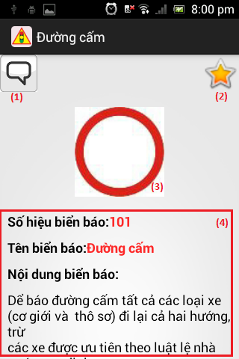

Figure 56: Traffic sign detail Activity

**Fields**

|  |  |  |  |  |  |  |  |
| --- | --- | --- | --- | --- | --- | --- | --- |
| **No** | **Field Name** | **Description** | **Read only** | **Mandatory** | **Control Type** | **Date Type** | **Length** |
| 3 | Traffic sign image | Display traffic sign’s image | Y | Y | Imageview | Image | N/A |
| 4 | Traffic sign information | Display traffic sign’s detail information | Y | Y | Textview | String | N/A |

**Button/ Hyperlink**

|  |  |  |  |  |
| --- | --- | --- | --- | --- |
| **No** | **Function** | **Description** | **Validation** | **Outcome** |
| 1 | Send report | Click to transfer to report activity | No | Transfer to Report activity |
| 2 | Add/Remove favorite | Click to add or remove traffic sign to favorite list. | No | Send request to service for add/delete traffic sign to favorite list. |

#### Favorite Activity

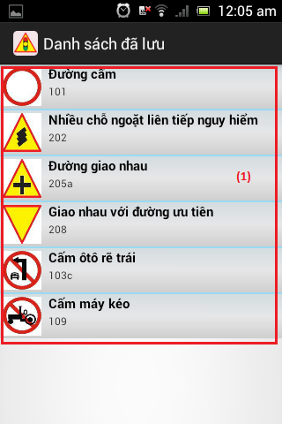

Figure 57: Favorite Activity

**Button/ Hyperlink**

|  |  |  |  |  |
| --- | --- | --- | --- | --- |
| **No** | **Function** | **Description** | **Validation** | **Outcome** |
| 1 | View traffic sign detail | Click to transfer to traffic sign detail activity | No | Transfer to Traffic sign detail activity |

**Favorite list includes**

|  |  |  |  |  |  |
| --- | --- | --- | --- | --- | --- |
| **Field Name** | **Description** | **Read only** | **Control Type** | **Data Type** | **Length** |
| Traffic sign image | Display traffic sign’s image | Y | Imageview | Image | N/A |
| Traffic sign name | Display traffic sign’s name | Y | Textview | String | N/A |
| Traffic sign ID | Display traffic sign’s ID number | Y | Textview | String | N/A |

#### History Activity

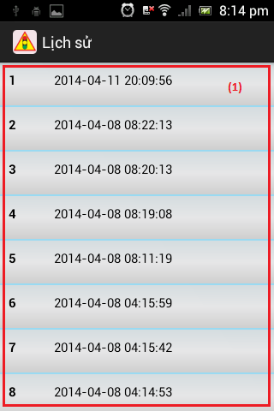

Figure 58: Favorite Activity

**Button/ Hyperlink**

|  |  |  |  |  |
| --- | --- | --- | --- | --- |
| **No** | **Function** | **Description** | **Validation** | **Outcome** |
| 1 | View history detail | Click to transfer to list result activity | No | Transfer to List result activity |

**History list includes**

|  |  |  |  |  |  |
| --- | --- | --- | --- | --- | --- |
| **Field Name** | **Description** | **Read only** | **Control Type** | **Data Type** | **Length** |
| Position | Display order number in the list | Y | Textview | String | N/A |
| Create date | Display history’s create date | Y | Textview | String | N/A |

## Database Design

### Entity Relationship Diagram

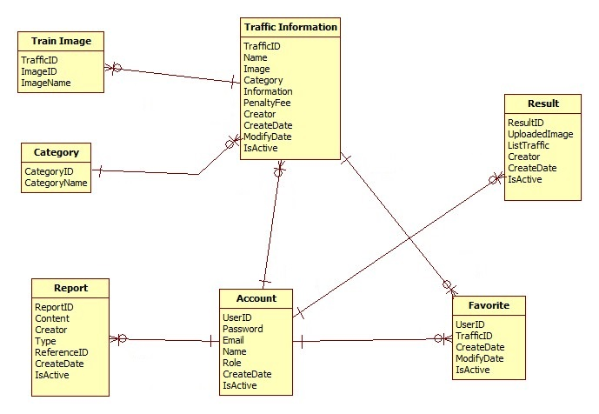

Figure 59: Entity Relationship Diagram

### Data Dictionary

|  |  |
| --- | --- |
| **Data dictionary: describe content of all entities** | |
| Name | Description |
| Traffic Information | Describe information about traffic sign |
| Train Image | Describe information about image use to train/recognize a traffic sign |
| Category | Describe all type of traffic sign |
| Report | Describe information about report of user. Contain wrong information report and wrong recognition report |
| Account | Describe all information about user in the system |
| Result | Describe information about search auto result |
| Favorite | Describe information about favorite traffic sign of user |

Table 40: Data Dictionary

|  |  |  |  |  |
| --- | --- | --- | --- | --- |
| **Name** | **Attributes** | **Description** | **Domain** | **Nulls** |
| trainimage | imageID {PK}  trafficID  imageName | ImageID of train image  Traffic ID of train image  Image name of train image | 255 nvar  11 nvar  255 nvar | No  No  No |
| category | categoryID {PK}  categoryName | Uniquely identifier  Name of category | Int  30 nvar | No  No |
| favorite | creator {PK}  trafficID {PK}  createDate  modifyDate  isActive | Creator of favorite  TrafficID of favorite  Create date  Modify date  Status | 11 nvar  11 nvar  Date  Date  Bit | No  No  Yes  Yes  Yes |
| trafficinformation | trafficID {PK}  name  image  categoryID  information  penaltyfee  creator  createDate  modifyDate  isActive | Uniquely identifies, auto increment  Name of traffic sign  Image of traffic sign  Category ID of traffic sign  Information of traffic sign  Penalty fee of traffic sign  Creator  Create date  Modify date  Status | 11 nvar  255 nvar  255 nvar  Int  4000nvar  255 nvar  30 nvar  Date  Date  Bit | No  No  No  No  Yes  Yes  No  Yes  Yes  Yes |
| account | userID {PK}  password  email  name  role  createDate  isActive | Uniquely identifies, ID of user  Password of user in MD5 form  Email of user  Name of user  Role of user  Create date  Status | 30 nvar  255 nvar  30 nvar  30 nvar  10 nvar  Date  Bit | No  No  No  Yes  No  No  No |
| result | resuitlID {PK}  uploadedImage  listTraffic  creator  createDate  isActive | Uniquely identifies, auto increment  Image link  List contain trafficID and location in image  Create of result  Create date  Status | Int  255 nvar  4000nvar  30 nvar  Date  Bit | No  No  Yes  Yes  Yes  Yes |
| report | reportID {PK}  referenceID  content  creator  type  createDate  isActive | Uniquely identifies, auto increment  ReferenceID depend on type report  Report content  Creator  Type of report  Create date  Status | Int  11 nvar  4000nvar  30 nvar  Int  Date  Bit | No  No  Yes  No  No  Yes  Yes |

Table 41: Attribute Data Dictionary

## Algorithms

### Traffic sign detection

#### Definition

Traffic Sign Detection is a technology that determines the locations and sizes of traffic signs in images.

#### Different method for traffic sign detection

There are many ways to detect traffic sign in an image:

* Color-based detect method
* Shape-based detect method
* Machine learning method:

+ Artificial Neural Network

+ Word bag

+ Classifier cascade

+…

#### The method we chose

We chose the Viola-Jones method (a classifier cascade method). Reason:

* Already implemented in OpenCV (that support many platforms: Linux, Windows, Android…)
* Easy to extend base on train cascade file.
* Easy to use and integrate in code.
* High accurate rate (base on testing with another method)

**Method Introduction**

The Viola-Jones (V-J) object detection framework is the first object detection framework to provide competitive object rates in real-time proposed. It can be trained to detect a variety of object classes. In OpenCV, it’s implemented as cvHaarDetectObjects() and the new method for multithread is cascadeClassifier()

Reference: <http://en.wikipedia.org/wiki/Viola%E2%80%93Jones_object_detection_framework>

Key ideas of Viola-Jones:

* Integral images for fast feature evaluation
* Boosting for feature selection
* Attentional cascade for fast rejection of non-object windows

Viola-Jones Technique:

* Feature extraction and feature evaluation
* Classifier training a feature selection using a method called AdaBoost.
* A degenerate decision tree of classifiers is formed.

**Feature extraction and feature evaluation:**

Feature extraction:

* Rectangle feature with four basic types. Value = sum( pixels in black area) – sum(pixels in white area)
* Each feature is related to a special location in the sub-window
* Each feature may have any size



Figure 60: Four basic types

**Feature evaluation**: using Integral Image for rapid computation of rectangular features.

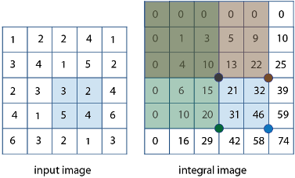

Figure 61: Integral Image

**Feature selection:** Using AdaBoost stands for “Adaptive” boost

* Constructs a “strong” classifier as a linear combination of weighted simple “weak” classifiers
* Features as weak classifiers: each single feature may be regarded as a simple weak classifier.
* An iterative algorithm: AdaBoost performs a series of trials, each time selecting a new weak classifier.
* Weights are being applied over the set of the example images: during each iteration, each example/image receives a weight determining it importance.

**Decision tree:** Attentional Cascade

* The reason the technique is fast.
* Quick rejection of sub windows.

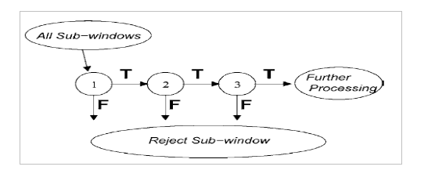

Figure 62: Attentional Cascade

**All Viola-Jones flow chart:**

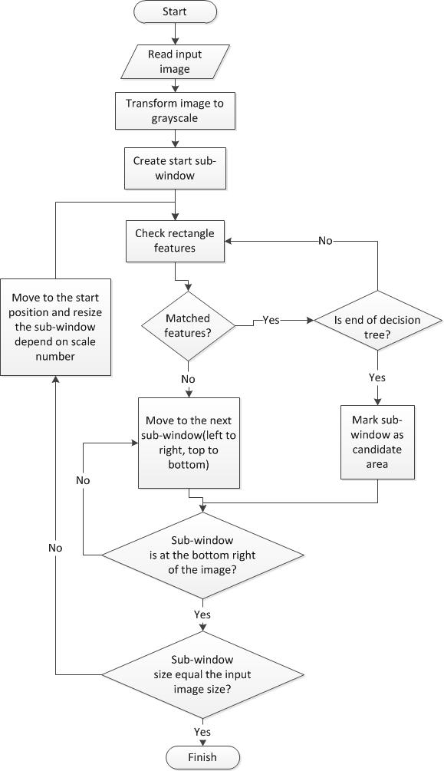

Figure 63: Viola-Jones flow chart

#### Train data to use Viola-Jones algorithm

To apply the algorithm in project, we device traffic sign into 2 main class: one for triangle traffic sign (warning traffic sign), one for circle traffic sign (prohibitory, mandatory traffic sign).

The image use to train each class contain 2 types:

Positive image: contain only traffic sign image clipped.

Negative image: contain what every image not have traffic sign, such as the image of street, market, tree…

Here is the example for the positive training sample:

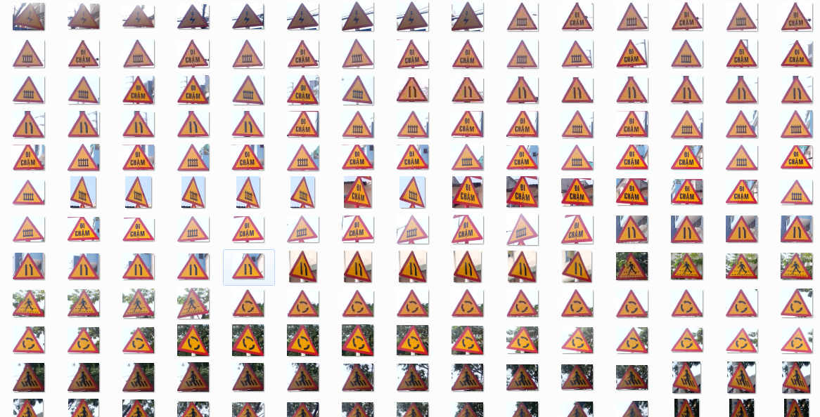

Figure 64: Triangle Traffic Sign Train Sample Image

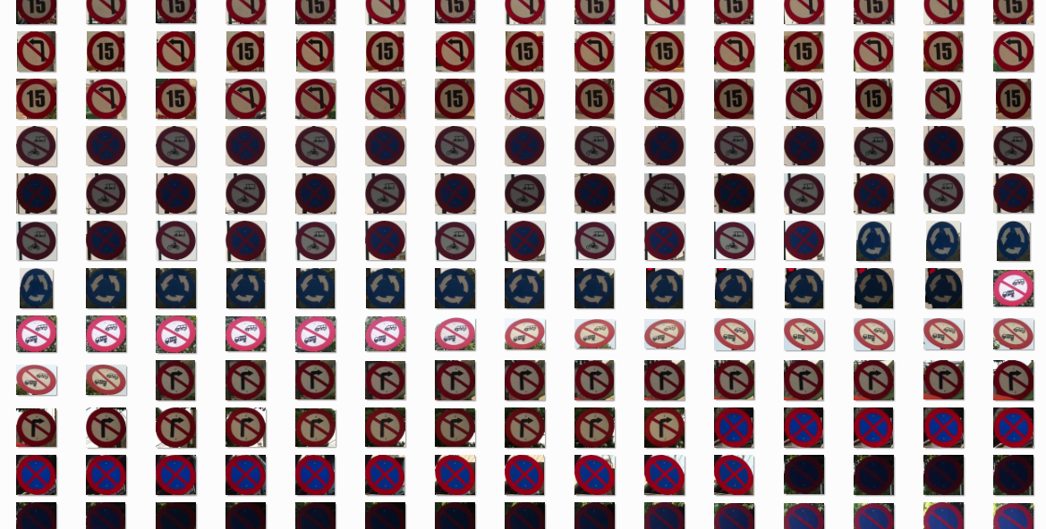

Figure 65: Circle Traffic Sign Train Sample Image

And negative sample:



Figure 66: Negative Train Sample Image

We trained the image many time and get the best detection rate with about 700 positive images and 1500 negative images to each class (see the performance measures about the detection accuracy chart). The time need to train each class is about 3 days with Core i3 M350 2.27 GHz, 2GB Ram available. The result of each train is a XML cascade file contain features to detect traffic sign.

### Traffic sign recognition

#### Definition

* Traffic sign recognition is identify the name of traffic sign from detected area in an image.

#### Method for traffic sign recognition

**There are many ways to recognize traffic sign from detect area in an image:**

* **Artificial neural network**
* **Nearest-Neighbor Classifiers**
* **Decision Trees**
* **…**

References: <http://sundog.stsci.edu/rick/SCMA/node2.html>

#### The Method we choose

**We chose SVM multi-class method, reason:**

* Implemented in many library
* Easy to integrate in project

**Method Introduction**

**Support vector machine (SVMs) are supervised learning models with associated learning algorithms what analyze data and recognize pattern used for classification and regression analysis.**

**Basic SVM only support to classify 2 classes.**

**Multiclass SVM: assign labels to instances by using support vector machines, where the labels are drawn from a finite set of several elements.**

**This approach is extend of basic SVM (binary classification):**

**One-versus-all: Using binary classifiers with between one of the labels and the rest. The result calculate by winner-takes-all, in which the classifier with the highest output function assigns the class.**

**One-versus-one: between every pair of classes. The result calculate by max-wins voting strategy, in which every classifier assigns the instance to one of the two classes, then the vote for assigned class is increased by one vote, and finally the class with the most votes determines the instance classification.**

**In this project, we use SVM multi-class with One-versus-all method.**

Reference:

<http://en.wikipedia.org/wiki/Support_Vector_Machine>

<http://www.cs.cornell.edu/people/tj/svm_light/svm_multiclass.html>

**Algorithm description:**

* Extract features of image
* Compare these features with the features of the model and get the best matched rate model (SVM multi-class One-versus-all)

**Extract feature of image**: Histogram of oriented gradients (HOG) features. The technique counts occurrences of gradient orientation in localized portions of an image.

Reference: <http://en.wikipedia.org/wiki/Histogram_of_oriented_gradients>



Figure 67: HOG features

**SVM classifier:** Base on features SVM classifier can calculate the rate that match with model and give the candidate model for object

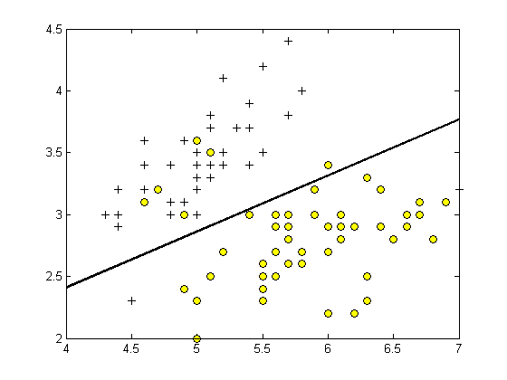

Figure 68: SVM classifier

**Classifier flow chart**

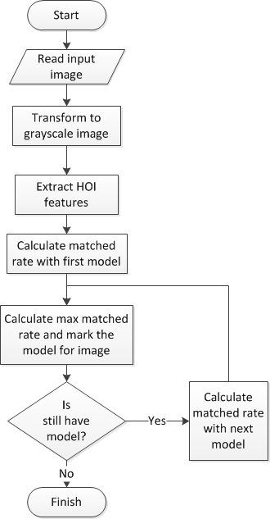

Figure 69: Classifier flow chart

### Synchronize favorite list

#### Definition

This system allows user to use in both mobile and website. Besides that, application in mobile can run normally even if there is no connection to server. Thus, there should be a solution to synchronize favorite between mobile and website.

#### Solution

**Algorithm description:**

It is suggested that there is a variable saving the final time being added or deleted for each favorite item. During synchronization process, each favorite in mobile will be sent to server in respond to action of adding or deleting. The server adds or deletes only if modifying time shown in mobile is later than the one in server. The last step is delete favorite list in mobile and replace by the one in server.

**Advantage:**

* + Allow sync favorite list between mobile and server by time order.
  + Avoid losing favorite items during synchronization process.

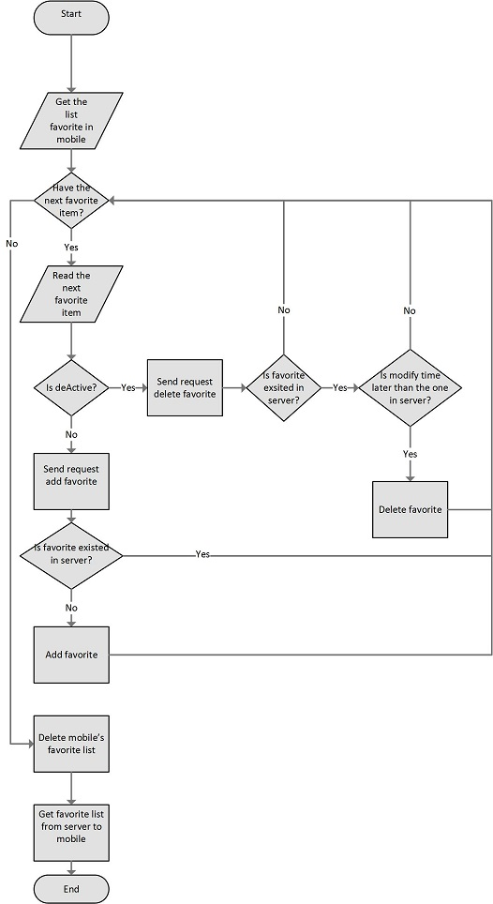

Figure 70: Synchronize favorite flow chart

# System Implementation & Test

## Introduction

### System Overview

This section provides in detail all necessary information about test plans, test cases, test result, test environments, pass/fail criteria and risks estimations as well as a checklist to cover all possible cases of TSRT.

### Test Approach

- Goal: To test the whole system based on the core workflow.

- Method: System Testing, Black-box Testing.

## Database Relationship Diagram

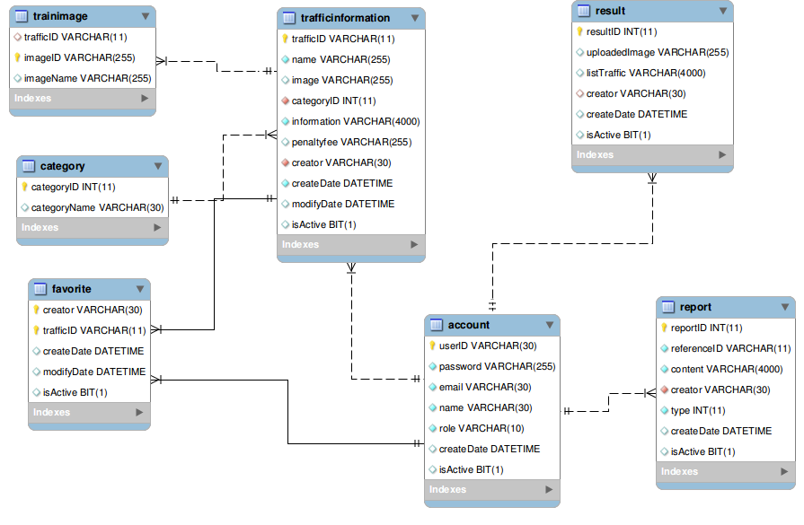

Figure 71: Database Relationship Diagram

|  |  |  |  |  |
| --- | --- | --- | --- | --- |
| **Name** | **Attributes** | **Description** | **Domain** | **Nulls** |
| trainimage | imageID {PK}  trafficID {FK}  imageName | ImageID of train image  Traffic ID of train image  Image name of train image | 255 nvar  11 nvar  255 nvar | No  No  No |
| category | categoryID {PK}  categoryName | Uniquely identifier  Name of category | Int  30 nvar | No  No |
| favorite | creator {PK, FK}  trafficID {PK, FK}  createDate  modifyDate  isActive | Creator of favorite  TrafficID of favorite  Create date  Modify date  Status | 11 nvar  11 nvar  Date  Date  Bit | No  No  Yes  Yes  Yes |
| trafficinformation | trafficID {PK}  name  image  categoryID {FK}  information  penaltyfee  creator {FK}  createDate  modifyDate  isActive | Uniquely identifies, auto increment  Name of traffic sign  Image of traffic sign  Category ID of traffic sign  Information of traffic sign  Penalty fee of traffic sign  Creator  Create date  Modify date  Status | 11 nvar  255 nvar  255 nvar  Int  4000nvar  255 nvar  30 nvar  Date  Date  Bit | No  No  No  No  Yes  Yes  No  Yes  Yes  Yes |
| account | userID {PK}  password  email  name  role  createDate  isActive | Uniquely identifies, ID of user  Password of user in MD5 form  Email of user  Name of user  Role of user  Create date  Status | 30 nvar  255 nvar  30 nvar  30 nvar  10 nvar  Date  Bit | No  No  No  Yes  No  No  No |
| result | resuitlID {PK}  uploadedImage  listTraffic  creator {FK}  createDate  isActive | Uniquely identifies, auto increment  Image link  List contain trafficID and location in image  Create of result  Create date  Status | Int  255 nvar  4000nvar  30 nvar  Date  Bit | No  No  Yes  Yes  Yes  Yes |
| report | reportID {PK}  referenceID  content  creator {FK}  type  createDate  isActive | Uniquely identifies, auto increment  ReferenceID depend on type report  Report content  Creator  Type of report  Create date  Status | Int  11 nvar  4000nvar  30 nvar  Int  Date  Bit | No  No  Yes  No  No  Yes  Yes |

Table 42: Attribute Data Dictionary

## Performance measures

### Traffic Sign Detection Performance

With image resolution: 800x460px

**Web module**: Ubuntu 13.10 with core i3 M350 2.27GHz, 3GB Ram

* Best traffic sign detected result: 60/84 traffic sign (02 classes). Percent: 71.4%
* Worst traffic sign detected result: 56/84 traffic sign (02 classes). Percent 66.7%

Detection rate of class 1st base on different train image data:

Figure 72: Traffic Sign Detection Accuracy

**Mobile module**: Android 4.0 with 2 cores 1GHz, 512MB Ram

* Average time to detect traffic sign: 0.357s (2.8 FPS)

### Traffic Sign Recognition Performance

With image resolution: 800x460px

**Web module**: Ubuntu 13.10 with core i3 M350 2.27GHz, 3GB Ram

* Best time to run traffic sign recognition: 0.013s
* Worst time to run traffic sign recognition: 0.016s

Recognition accuracy (good condition):

Figure 73: Traffic Sign Recognition Accuracy

## Test Plan

The purpose of this section is to verify and ensure that TSRT meets its design specification and other requirements from user. The following part will describe which features to be tested and which will not.

### Features to be tested

We will test the entire system based on the following core workflow (Reference: **Figure 72: Core Workflow**).

Based on the workflow, all following features will be tested, which can include one or more functions. These features will be focused and tested thoroughly during the test phase.

* Manage traffic sign
* Manage report
* Search auto: Search auto on both website and mobile (Include search by take picture or upload image).

### Features not to be tested

* Register
* Login, Logout
* Forgot Password
* User - View, delete history and favorite.
* Admin – Manage Account, Configure System, Make statistic
* Staff – Manage Account, Make statistic, Import, Export file.

## System Testing Test Case

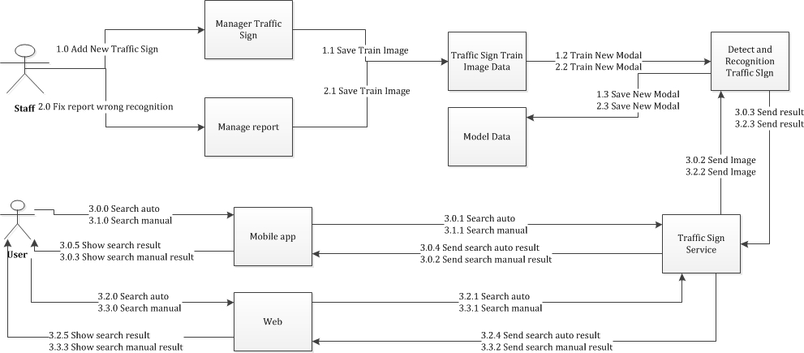

**Figure 74: Core Workflow**

|  |  |  |  |  |  |  |
| --- | --- | --- | --- | --- | --- | --- |
| **ID** | **Test Case Description** | **Test Case Procedure** | **Excepted output** | **Result** | **Test Date** | **Note** |
| ST01 | Staff add new traffic sign (In this case staff have information of traffic sign as well as image of traffic sign) | 1. Login into the system using a staff account 2. On the staff home page, click “Quản lý biển báo”, then click “Thêm mới” button. 3. Input traffic sign formation:   -Label  -Name  - Image  - Type  - Information  - Penalty fee  - Train image   1. Press “Lưu” button | -After step 2, the modal add new will popup.  -After step 3 the page will fresh and the new traffic now in table traffic sign list | Passed | 14/04/2014 |  |
| ST02 | Staff fix a wrong recognition from report | 1 - Login into the system using a staff account  2 - On the staff home page, click “Quản lý phản hồi”, select a wrong recognition row and press “Chi tiết” button  3 - Press in “Sửa” link  4 – On the new page, move the mouse to the detected area, and input name to find traffic sign  5 – Press “Xóa” button | * After step 2, a modal popup and show detail of the report * After step 3, the page will direct to Add train image from report * After step 5, the page will direct back to report manage page | Passed | 14/04/2014 |  |
| ST03 | User take a picture to search traffic sign automatically (Mobile) | 1 – Login to the mobile, using user account  2- Select the application’s icon to launch.  3 – On the main screen, select button “Nhận dạng biển báo”.  4 – Move the camera into traffic sign area with suitable angle (less than 30 degree).  5 – Select the “Camera” icon to take picture. | - After step 3, transfer to camera screen.  - After step 4, there will be a pink frame that surround the traffic sign  - After step 5, the popup will show “Vui lòng đợi trong giây lát”.  - After that screen will show the result of recognize, include: + Picture was taken. + Result of recognize. | Passed | 10/04/2014 |  |
| ST04 | User search manual by enter key word.(Mobile) | 1 – Login to the mobile, using user account  2 – Select the application’s icon to launch.  3 – On the main screen, select button “Tra cứu biển báo”.  4 – Enter the search key: “quay xe”  5 – Select search button.  6- On the result screen, select one traffic sign. | - After step 3, transfer to search manual screen, include:  + Text field to enter search key  + Search button  + 4 traffic sign’s category  - After step 5, transfer to result screen and display search result (Contain 3 traffic signs)  - After step 6, transfer to traffic sign detail screen, show all the information of traffic sign, include: Image, ID, name, information and penalty fee (if available). | Passed | 10/04/2014 |  |
| ST05 | User upload picture to search auto (Website). | 1 – Login to the website, using user account  2 – Click link “Nhận dạng tự động” in main menu.  3 –Select browse button to select image to upload. | - After step 2, redirect to search auto page.  - After step 3, display loading bar show the upload progress.  - After that, the search result display in the left column and uploaded image was display in the right. | Passed | 10/04/2014 |  |
| ST06 | User search manual in the web. | 1 – Login to the webstie, using user account  2 – Click link “Tra cứu biển báo” in main menu.  3 –Enter the search key in the text box : “quay xe”  4- Select type of category: “Tất cả”.  5- Click button”Tìm kiếm”.  6- Click one traffic sign’s name. | - After step 2, redirect to search manual page.  - After step 5, show the table contain search result (3 records).  - After step 6, show the popup, display all the information of traffic sign, include: Image, ID, name, information and penalty fee (if available). | Passed | 10/04/2014 |  |

**Table 43: Core Workflow Test Case**

## Module Test Case

### Manage Traffic Sign

|  |  |  |  |  |  |  |  |
| --- | --- | --- | --- | --- | --- | --- | --- |
| **ID** | **Test Case Description** | **Test Case Procedure** | **Excepted output** | **Inter-test Case Dependence** | **Result** | **Test Date** | **Note** |
| MT01 | View traffic list | 1 – Login into the system using a staff account  2 – Click the “Quản lý biển báo” in the menu bar | -A table traffic sign is showed |  | Passed | 14/04/2014 |  |
| MT02 | Edit a traffic sign information | 1 – Find the traffic sign need to edit information and click “Sửa” button  2 – Input new traffic sign information (if necessary):   * Name * Image * Type * Content * Penalty fee * Train image   3 – Press “Lưu” button | -After the step 1, a edit traffic sign modal popup with old information of traffic sign  -After the step 3, the page will refresh and the information of traffic sign is updated | MT01 | Passed | 14/04/2014 |  |
| MT03 | Delete a traffic sign | 1 – Find the traffic sign need to edit information and click “Xoá” button | -The page will refresh and the traffic disappear from the table | MT01 | Passed | 14/04/2014 |  |
| MT04 | Filter traffic sign by type | 1 – From traffic sign manage page, select traffic sign type in “Loại biển báo” dropdown list | -The page will refresh and the table of traffic sign list only contain the traffic sign have type match with selected type | MT01 | Passed | 14/04/2014 |  |

**Table 44: Manage Traffic Sign Test Case**

### Manage Report

|  |  |  |  |  |  |  |  |
| --- | --- | --- | --- | --- | --- | --- | --- |
| **ID** | **Test Case Description** | **Test Case Procedure** | **Excepted output** | **Inter-test Case Dependence** | **Result** | **Test Date** | **Note** |
| MR01 | View list report | 1 – Login the system with a staff account  2 – Click on “Quản lý phản hồi” menu | -A table contain list report is showed |  | Passed | 14/04/2014 |  |
| MR02 | View a report detail | 1 – From manage report page, find the report and click “Chi tiết” button | -A modal popup will show the detail of report | MR01 | Passed | 14/04/2014 |  |
| MR03 | Delete a report | 1 – From manage report page, find the report and click “Xóa” button | -Page will refresh and the report disappear | MR01 | Passed | 14/04/2014 |  |
| MR04 | Filter report by type | 1 – From manage report page, select a type in “Loại phản hồi” dropdown list | -Page will refresh and show the report table with only report type match with selected type | MR01 | Passed | 14/04/2014 |  |
| MR04 | Edit a report wrong information | 1 – From manage report page, find a wrong information report and click “Chi tiết”  2 – Click “Sửa” link in modal popup  3 – Input new information of traffic sign (if necessary):   * Name * Image * Type * Content * Penalty fee * Train image   4 – Press “Lưu” button | -Page will refresh and the information of traffic sign is changed | MR01 | Passed | 14/04/2014 |  |

**Table 45: Manage Report Test Case**

### Search auto

|  |  |  |  |  |  |  |  |
| --- | --- | --- | --- | --- | --- | --- | --- |
| **ID** | **Test Case Description** | **Test Case Procedure** | **Expected output** | **Inter-test Case Dependence** | **Result** | **Test Date** | **Note** |
| SA01 | Search auto by take picture by hand. (Mobile) | 1 – Select the application’s icon to launch.  2 – On the main screen, select button “Nhận dạng biển báo”.  3 – Move the camera into traffic sign area with suitable angle (less than 30 degree).  4 – Select the “Camera” icon to take picture. | - After step 2, transfer to camera screen.  - After step 3, there will be a pink frame that surround the traffic sign  - After step 4, the dialog will show “Vui lòng đợi trong giây lát”.  - After that screen will show the result of recognize, include: + Picture was taken. + Result of recognize. |  | Passed | 10/04/2014 |  |
| SA02 | Search auto by take picture auto.  (Mobile) | 1 – Select the application’s icon to launch.  2 – On the main screen, select button “Nhận dạng biển báo”.  3 – Select button “auto on” to turn on auto mode  4 – Move the camera into traffic sign area with suitable angle (less than 30 degree).  5 – Hold camera steady, until “Auto captured” message show. | - After step 2, transfer to camera screen.  - After step 4, there will be a pink frame that surround the traffic sign  - After step 5, the dialog will show “Vui lòng đợi trong giây lát”.  - After that screen will show the result of recognize, include: + Picture was taken. + Result of recognize. |  | Passed | 10/04/2014 |  |
| SA03 | Search auto by upload picture. (Mobile) | 1 – Select the application’s icon to launch.  2 – On the main screen, select button “Nhận dạng biển báo”.  3- Click “upload” button then select image. | - After step 3, transfer to camera screen.  - After step 3, the dialog will show “Vui lòng đợi trong giây lát”.  - After that screen will show the result of recognize, include: + Picture was taken. + Result of recognize.. |  | Passed | 10/04/2014 |  |
| SA04 | Search auto by upload picture. (Website) | 1 – Click link “Nhận dạng tự động” in main menu.  2 –Select browse button to select image to upload. | - After step 1, redirect to search auto page.  - After step 2, display loading bar show the upload progress.  - After that, the search result display in the left column and uploaded image was display in the right. |  | Passed | 10/04/2014 |  |

**Table 46: Search auto Test Case**

# Software User’s Manual

## Installation Guide

### Setting up environment at server site

The following software must be installed into the server machine:

#### Hardware requirements

VPS server to run the web and service

* CPU 1 Core 2.0GHz.
* 512MB of RAM.
* 20GB of hard disk.

A personal computer to access VPS server:

* CPU Core i3 2.27 GHz
* 1GB of Ram available
* 50GB of hard disk

#### Software requirements

Software to run in VPS server:

* Java environment: Java 1.7.0_51
* Web Server: Tomcat 7.0
* Operation system: Linux 13.10
* Database management: Mysql 5.5.20
* Other library:
* OpenCV 2.4.8
* JsonCpp 0.5.0

Software to run in personal computer to process the deployment:

* SSH Client to access VPS server
* FTP Client to upload file to VPS server

In this guide, we can use Firefox with FireSSH and FireFTP addon.

#### Mobile Requirement

* Android 4.0
* Camera 5.0 Megapixel

### Deployment at server side

#### Prepare deployment package

* From personal computer access to VPS using FireFTP and FireSSH
* Upload deployment package to a folder on server, for example /home/deploy/deployment.zip
* Extract the deployment.zip
* Run the install.sh script to install the requirement software and library (this may take about 1 hour or more depend on your VPS internet connection). Flow the guide of script to complete the installation.
* Reboot VPS



**Figure 75: Prepare deployment package**

#### Deploy database

* Using SSH client, extract DB.sql script by command: mysql –u root –p
* Enter your mysql root password
* Then extract database by command: source DB.sql;

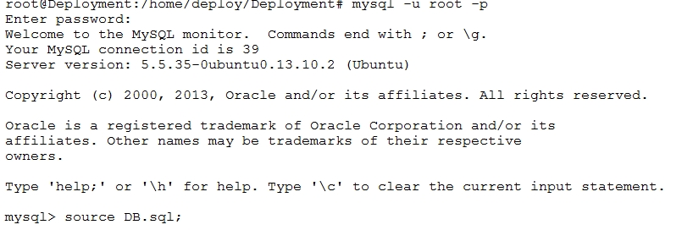

**Figure 76: Deploy database**

#### Deploy web application on server

* Run tomcat server by script: startup.sh



**Figure 77: Run tomcat server**

* Copy 2 War file TrafficService.war, TrafficWeb.war to webapps folder of tomcat and wait to tomcat auto deploy the war file.



**Figure 78: Copy war file to tomcat server**

* Edit the console app path in config.properties file this case: /home/deploy/Deployment/TSRT/



**Figure 79: Set console application path**

* Edit the web service address in the config.properties of TrafficWeb: http://yourwebaddress/TrafficService/



**Figure 80: Set Web service address**



**Figure 81: Restart tomcat**

### Setting up the environment at client side

#### Setting up for computer

* The client devices need to have one of the following browsers to access the website:
* Google Chrome 34.
* Firefox 27.

#### Setting up for Android devices

* Change setting to install unknown source apk.

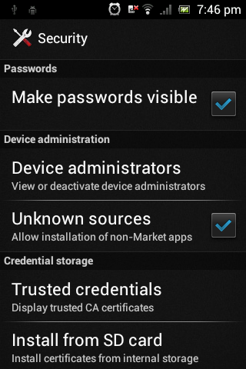

**Figure 82: Change Settings**

* Copy file TrafficSignRecognition.apk into mobile device.
* Use mobile device to open file above.
* Click Install to install the app.

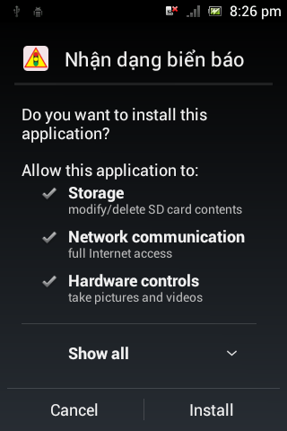 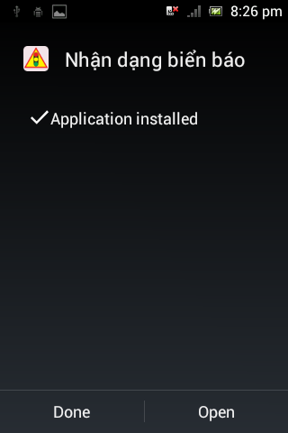

**Figure 83: Install App**

## User Guide

The user guide is based on the normal workflow of the system

### Login

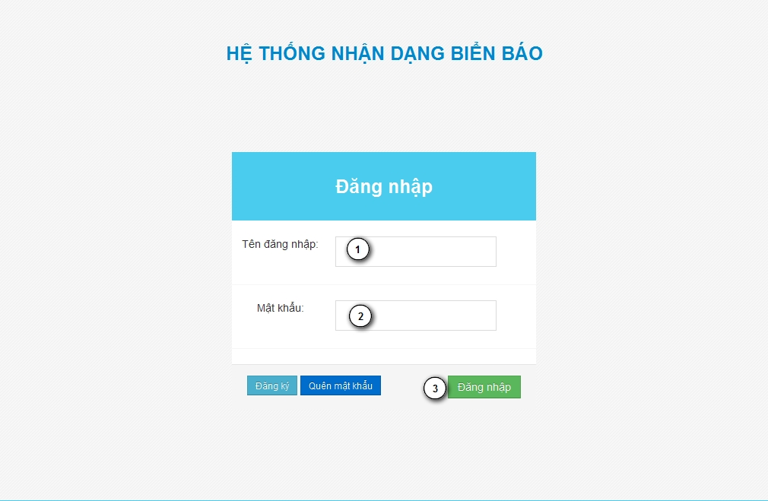

**Figure 84: Login Page**

|  |  |
| --- | --- |
| **Step** | **Description** |
| 1 | Fill UserID to “Tên đăng nhập” textbox |
| 2 | File password to “Mật khẩu” textbox |
| 3 | Press “Đăng nhập” button to login. |

**Table 47: Login Step**

### Admin

#### Set staff

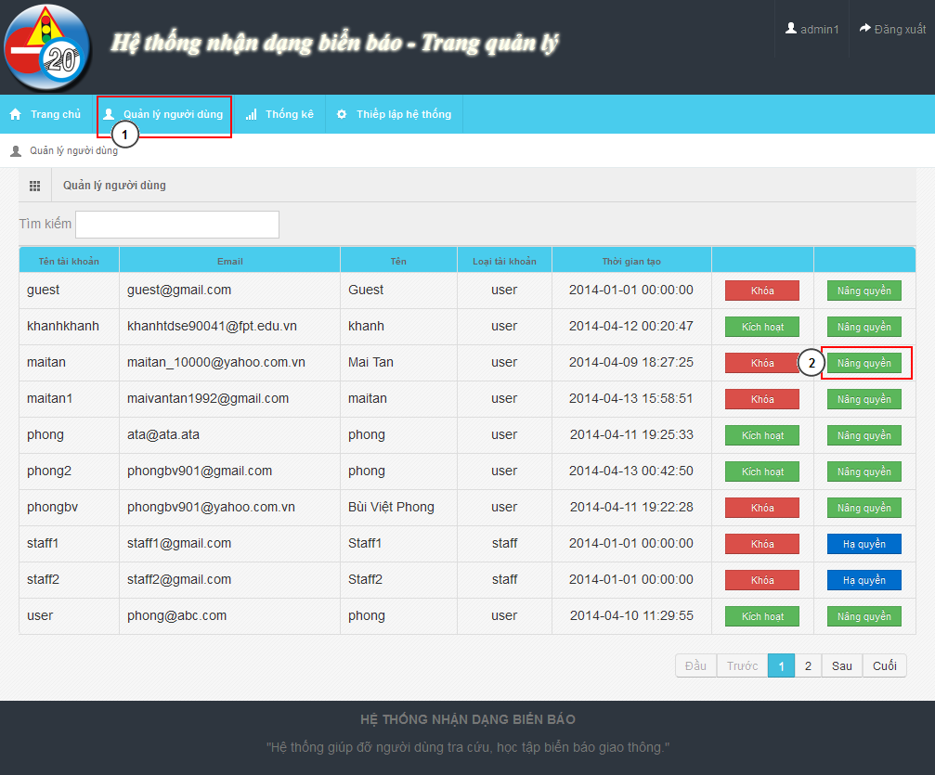

**Figure 85: Account Manage Page**

|  |  |
| --- | --- |
| **Step** | **Description** |
| 1 | “Quản lý người dùng” menu |
| 2 | Find user want to set staff. Click “Nâng quyền” |

**Table 48: Set staff**

### Staff

#### Add new traffic sign

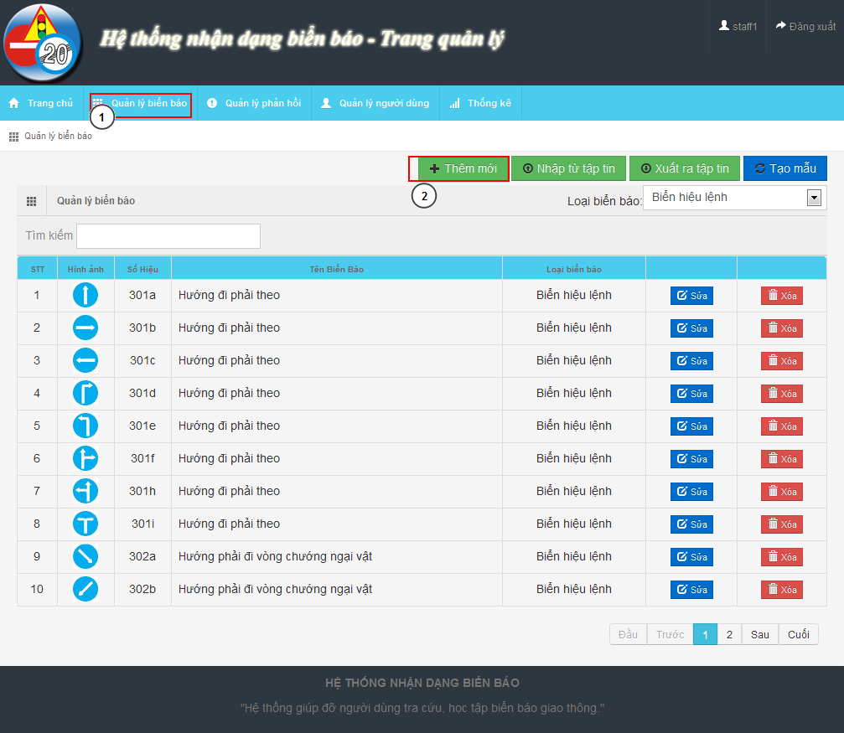

**Figure 86: Traffic Sign Manage Page**

|  |  |
| --- | --- |
| **Step** | **Description** |
| 1 | “Quản lý biển báo” menu |
| 2 | Click on “Thêm mới” button to show Add new modal |

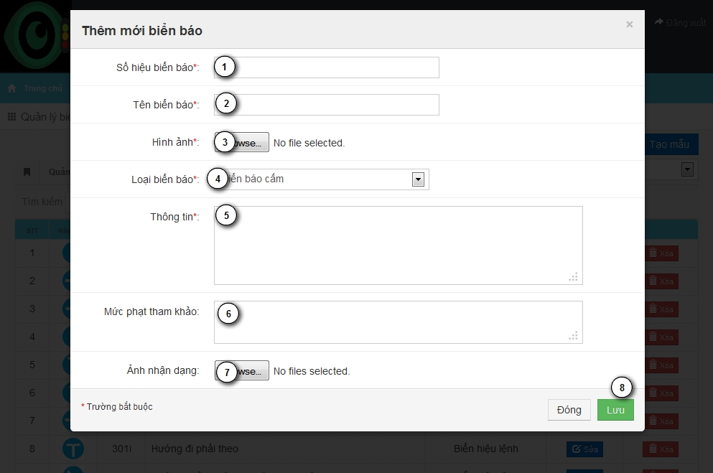

**Figure 87: Add New Traffic Sign Modal**

|  |  |
| --- | --- |
| **Step** | **Description** |
| 1 | Input traffic sign label |
| 2 | Input traffic name |
| 3 | Input traffic image |
| 4 | Select traffic type |
| 5 | Input traffic sign information |
| 6 | Input traffic sign penalty fee |
| 7 | Input train image for traffic sign |
| 8 | Press “Lưu” button to save traffic sign |

#### Fix wrong recognition from report

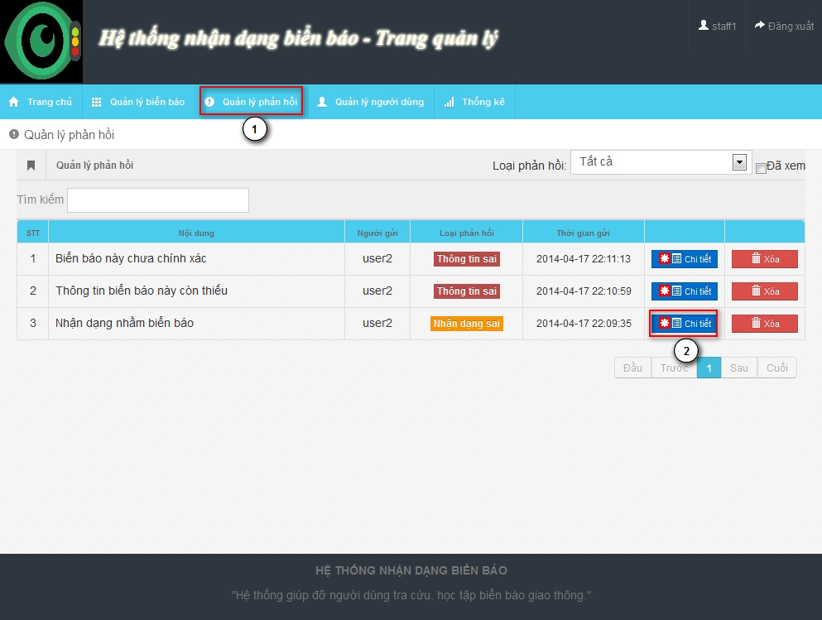

**Figure 88: Report Manage Page**

|  |  |
| --- | --- |
| **Step** | **Description** |
| 1 | “Quản lý phản hồi” menu |
| 2 | Find the report and click “Chi tiết” to show detail of report |

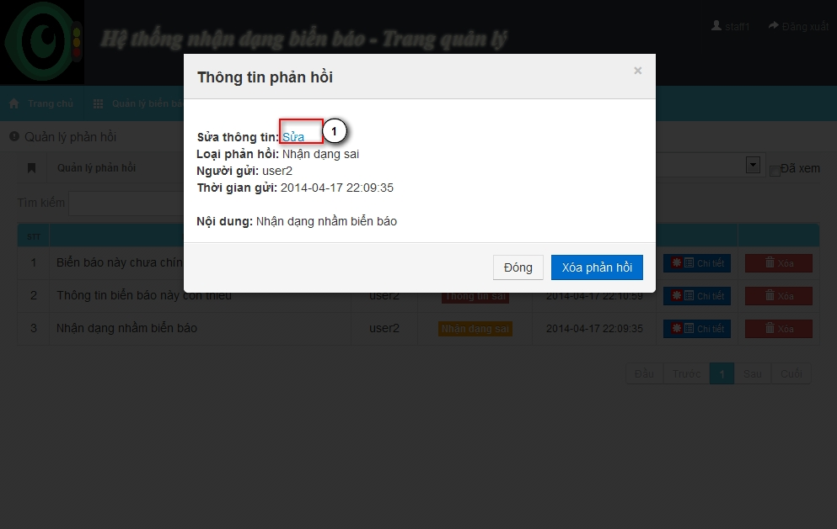

**Figure 89: Report Detail Modal**

|  |  |
| --- | --- |
| **Step** | **Description** |
| 1 | Click “Sửa” to edit the result |

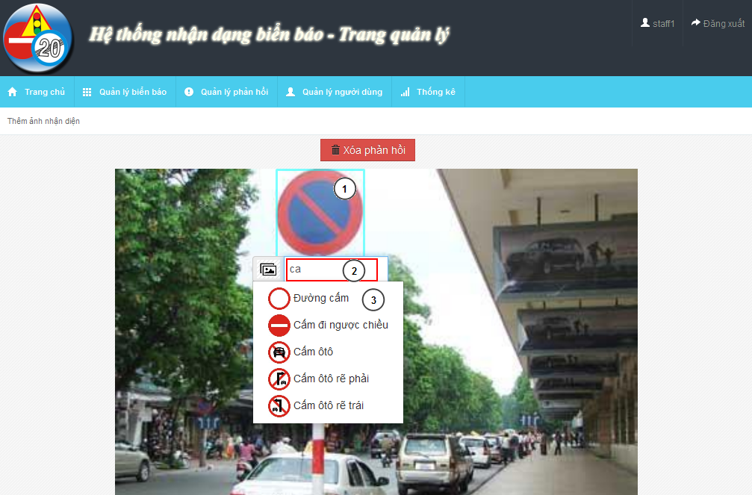

**Figure 90: Edit Wrong Recognition Page**

|  |  |
| --- | --- |
| **Step** | **Description** |
| 1 | Move mouse to the detected area |
| 2 | Input text to find the right traffic sign name |
| 3 | Select traffic sign name match with the image |

### User – Mobile

#### C:\Users\phongbv\Desktop\Do an\screen chot\login.pngLogin

**Figure 91: Login Screen**

|  |  |
| --- | --- |
| **Step** | **Description** |
| 1 | Fill Username. Example: phongbv |
| 2 | Fill Password. Example: 123456 |
| 3 | Click “Đăng nhập” button |

**Table 49: Login Step**

#### Register

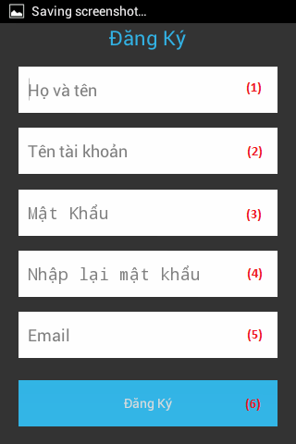

**Figure 92: Register Screen**

|  |  |
| --- | --- |
| **Step** | **Description** |
| 1 | Fill fullname. Example: Bùi Việt Phong |
| 2 | Fill account name. Example: phongbv |
| 3,4 | Fill password. Example: 123456 |
| 5 | Fill email. Format email: abc@example.com |
| 6 | Press “Đăng ký” button |

**Table 50: Register Step**

#### Search Auto

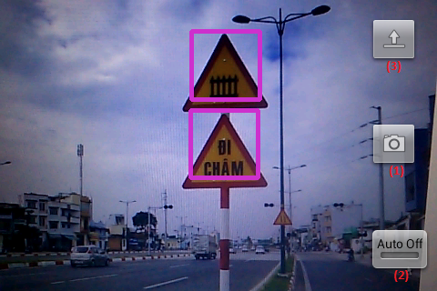

**Figure 93: Search Auto Screen**

|  |  |
| --- | --- |
| **Step** | **Description** |
| 1 | Press button to take picture and wait for result. |
| 2 | Click button switch on or off auto take picture mode. |
| 3 | Press button to select picture from mobile instead of take a picture by camera. |

**Table 51: Search auto step**

#### Search auto result



**Figure 94: Search auto result screen**

|  |  |
| --- | --- |
| **Step** | **Description** |
| 1 | Picture was taken by user before. |
| 2 | List result, position match with number in the image. Select one item to view traffic sign detail |

**Table 52: Search auto result step**

#### Search manual



**Figure 95: Search manual Screen**

|  |  |
| --- | --- |
| **Step** | **Description** |
| 1 | Fill search key. Example: “đường cấm”. |
| 2 | Click button to search by traffic sign’s name. |
| (3) | Select one category to view list traffic sign by category. |

**Table 53: Search manual step**

#### C:\Users\phongbv\Desktop\Do an\screen shot\list traffic.pngSearch manual result

**Figure 96: Search manual result Screen**

|  |  |
| --- | --- |
| **Step** | **Description** |
| 1 | Select one traffic sign to view detail. |

**Table 54: Search manual result Step**

#### View traffic detail



**Figure 97: View traffic detail screen**

|  |  |
| --- | --- |
| **Step** | **Description** |
| 1 | Press this button to report wrong information |
| 2 | Press this button to add or remove traffic sign to favorite |
| 3 | Traffic sign’s image |
| 4 | Traffic sign’s information |

**Table 55: View traffic detail step**

#### C:\Users\phongbv\Desktop\Do an\screen shot\favorite.pngView favorite

**Figure 98: View favorite screen**

|  |  |
| --- | --- |
| **Step** | **Description** |
| 1 | Select one traffic sign to view detail. (Or hold for 1 second, then select “Xóa” to delelte traffic sign from favorite list) |

**Table 56: View favorite step**

#### View history



**Figure 99: View history screen**

|  |  |
| --- | --- |
| **Step** | **Description** |
| 1 | Select one row to view search auto result detail. (Or hold for 1 second, then select “Xóa” to delelte result from history list) |

**Table 57: View history step**

#### C:\Users\phongbv\Desktop\Do an\screen shot\feedback.pngSend Report

**Figure 100: Send report screen**

|  |  |
| --- | --- |
| **Step** | **Description** |
| 1 | Enter report content. |
| 2 | Press this button to send report |

**Table 58: Send report step**

#### Setting

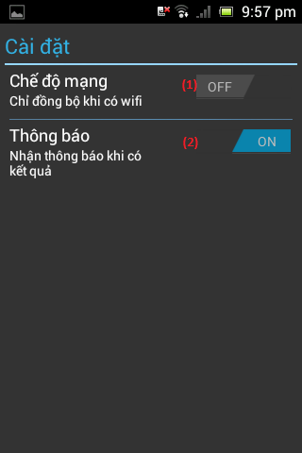

**Figure 101: Setting screen**

|  |  |
| --- | --- |
| **Step** | **Description** |
| 1 | Press this button to turn on or off “synchronize when on wifi only” mode. |
| 2 | Press this button to turn on or off notification when have search auto result. |

**Table 59: Setting step**

### User - Website

#### Search auto



**Figure 102: Search auto page**

|  |  |
| --- | --- |
| **Step** | **Description** |
| 1 | Click button “Chọn tệp tin” to select image for upload and wait for a few seconds. |
| 2 | List result, position match with number in the image. Select one item to view traffic sign detail |
| 3 | Picture was uploaded by user before |
| 4 | Click button “Sai kết quả” to report if the result is wrong. |

**Table 60: Search auto step**

#### Search manual

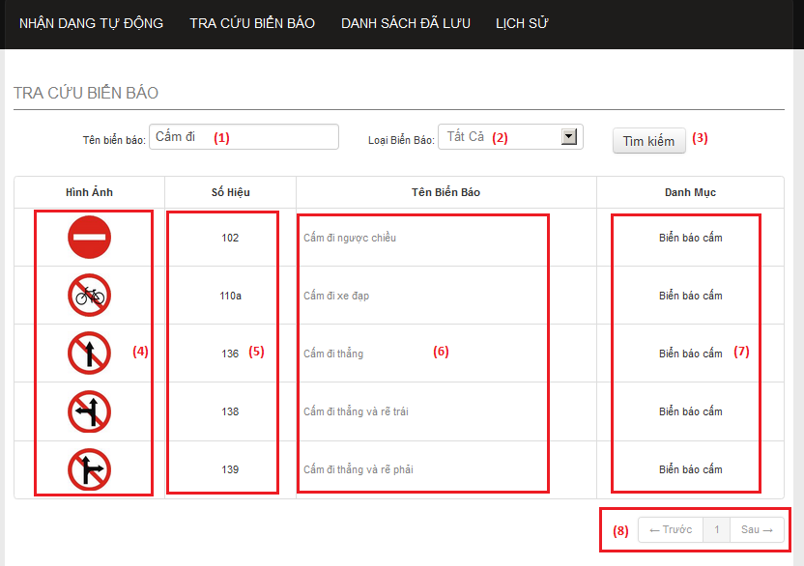

**Figure 103: Search manual page**

|  |  |
| --- | --- |
| **Step** | **Description** |
| 1 | Enter traffic sign’s name. Example: “cấm đi”. |
| 2 | Select one item to choose traffic sign category. |
| 3 | Click button “Tìm kiếm” to search traffic sign. |
| 4 | This column display traffic signs’ image. Click image to view traffic sign detail. |
| 5 | This column display traffic signs’ ID number. |
| 6 | This column display traffic signs’ name. Click traffic sign’s name to view traffic sign detail. |
| 7 | This column display traffic signs’ category. |
| 8 | Select number or “Trước”, “Sau” to view others records in the table. |

**Table 61: Search manual step**

#### View list favorite

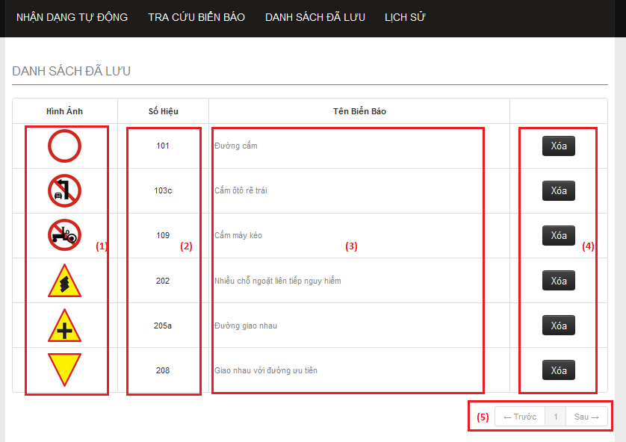

**Figure 104: Favorite page**

|  |  |
| --- | --- |
| **Step** | **Description** |
| 1 | This column display traffic signs’ image. Click image to view traffic sign detail. |
| 2 | This column display traffic signs’ ID number. |
| 3 | This column display traffic signs’ name. Click traffic sign’s name to view traffic sign detail. |
| 4 | Click button “Xóa” to remove one traffic sign from favorite list. |
| 5 | Select number or “Trước”, “Sau” to view others records in the table. |

**Table 62: View favorite step**

#### View list history

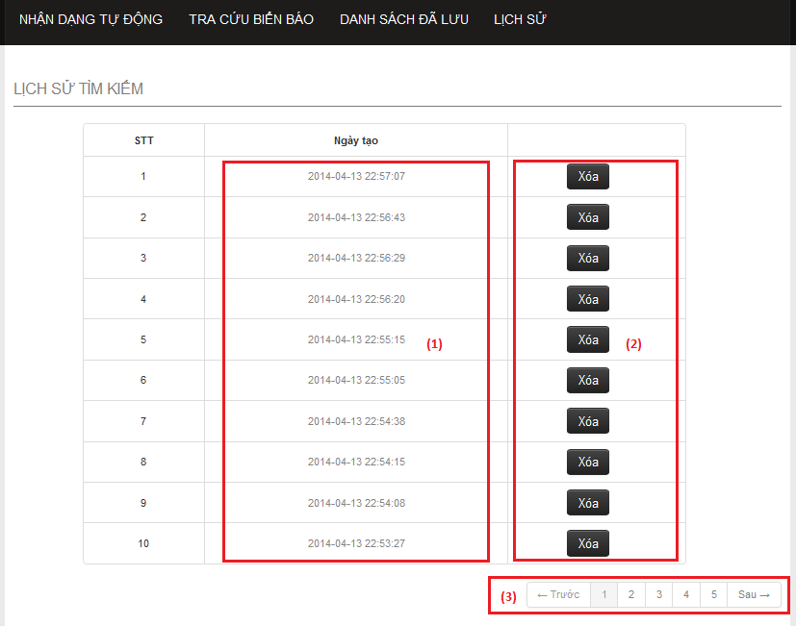

**Figure 105: History page**

|  |  |
| --- | --- |
| **Step** | **Description** |
| 1 | This column display the times when the history was created. Click link to view history detail. |
| 2 | Click button “Xóa” to remove one history from history list. |
| 3 | Select number or “Trước”, “Sau” to view others records in the table. |

**Table 63: View list history step**

#### View history detail

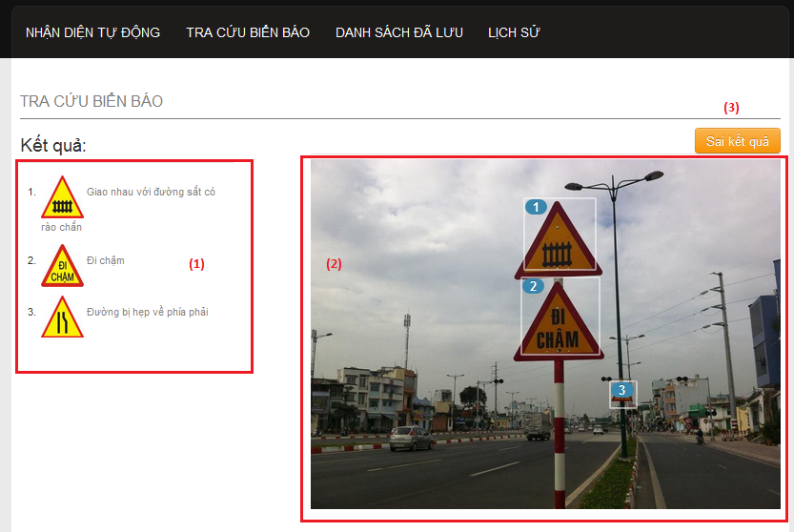

**Figure 106: History detail page**

|  |  |
| --- | --- |
| **Step** | **Description** |
| 1 | List result, position match with number in the image. Select one item to view traffic sign detail |
| 2 | Picture was uploaded by user before |
| 3 | Click button “Sai kết quả” to report if the result is wrong. |

**Table 64: View history detail step**

#### View traffic sign detail

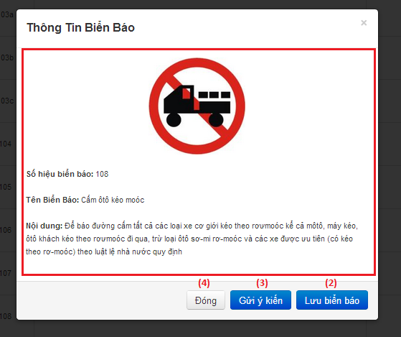

**Figure 107: Traffic sign detail popup**

|  |  |
| --- | --- |
| **Step** | **Description** |
| 1 | Traffic sign’s detail information. |
| 2 | Click “Lưu biển báo” to add traffic sign to favorite list. |
| 3 | Click button “Gửi ý kiến” to report if the information is wrong. |
| 4 | Click button “Đóng” to close popup. |

**Table 65: View traffic sign detail step**

#### Send report



**Figure 108: Send report popup**

|  |  |
| --- | --- |
| **Step** | **Description** |
| 1 | Enter report content. |
| 2 | Click button “Gửi ý kiến” to send report. |
| 3 | Click button “Đóng” to close popup. |

**Table 66: Send report step**

## User Notice

### Image Data Notice

* Each traffic sign should have at least 5 images for train image.
* The image should be in good condition, not have too much noise, or hide by another object.

Example of good image data:



Sample data of a traffic sign about 5-10 images:

* 60% taken from front of traffic sign.
* 40% taken from to side of traffic sign about 30 degrees side long.

Example of a good sample data set:



Avoid using not clear images like these:



### Take image to search

The below is recommend for the best image when search auto:

* Position and angle:

The best position and angle is font up the traffic sign. In the worst case, make sure you have an angle about 30 degree in front up the traffic sign.

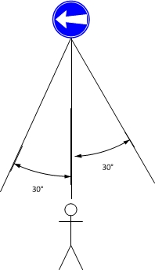

**Figure 109: Position and angle 1**

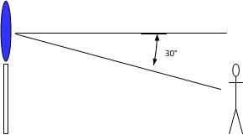

**Figure 110: Position and angle 2**

* The size of traffic sign in image:

By default the best size of traffic image is from 1/10 to ¼ of the width of image.

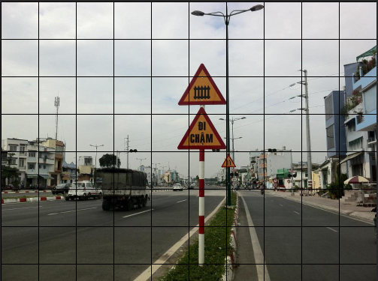

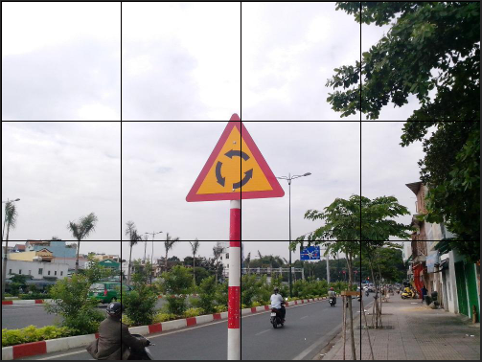

# Appendix

1. Viola-Jones Wikipedia: <http://en.wikipedia.org/wiki/Viola%E2%80%93Jones_object_detection_framework>
2. Method for classification: <http://sundog.stsci.edu/rick/SCMA/node2.html>
3. SVM Wikipedia: <http://en.wikipedia.org/wiki/Support_Vector_Machine>
4. SVM multiclass library: <http://www.cs.cornell.edu/people/tj/svm_light/svm_multiclass.html>
5. HOG Wikipedia: <http://en.wikipedia.org/wiki/Histogram_of_oriented_gradients>